New Developments in Laser Driven Inertial Confinement Fusion

Heinrich Horaª and George H. Miley^{b}

ªDepartment of Theoretical Physics, University New South Wales, Sydney 2052, Australia
^{b}Fusion Studies Laboratory, University of Illinois, Urbana, IL, USA

ABSTRACT

Since the discovery of the laser in 1960 hopes were based on using its very high energy concentration within very short pulses of time and very small volumes for energy generation from nuclear fusion as “inertial fusion energy” (IFE), parallel to the efforts to produce energy from “magnetic confinement fusion” (MCF), by burning deuterium-tritium (DT) in high temperature plasmas to helium. Over the years the fusion gain was increased by a number of magnitudes and has reached nearly break-even after numerous difficulties in physics and technology had been solved. After briefly summarizing laser driven IFE, we report how the recently developed lasers with pulses of petawatt power and picosecond duration may open new alternatives for IFE with the goal to possibly ignite solid or low compressed DT fuel thereby creating a simplified reactor scheme.

1. INTRODUCTION

Since the controlled generation of clean, safe, virtually inexhaustive, and everywhere accessible fusion energy at sufficiently low cost in power stations using nuclear fusion reactions is an extremely important goal to overcome the problems inherent in the present energy sources, an enormous budget has been and will further be spent into research to solve this problem. A summary of this work can be found in a special issue of the IAEA based journal “Nuclear Fusion” [1] which shows how many of the new physics problems have been solved and break-even has almost been reached.

The main effort has been devoted to the reaction of DT at temperatures between 10 and 100 Million degrees centigrade where the reacting fuel, a high temperature plasma, has to be confined by magnetic fields (MCF). A review of the forthcoming ITER project and the complementary stellarator program is given in this volume by G. Janeschitz [2] and R. Wolf [3]. So far, the highest fusion gain has been achieved in JET (Joint European Torus) [4] where a magnetically confined plasma torus (D:T ratio of 40:60), heated by 21 MW of neutral beam and 3 MW of electromagnetic wave power, has, for 2 seconds, produced 16 MW of fusion power representing a fusion gain of 66%.

The extensive work on IFE and its success, with fusion gains not far below break-even [1], is traditionally based on lasers with pulses in the ns range and, for the last few years, on the new direction of fast igniters with ps laser pulses as reviewed in the following section 2. These broad stream IFE developments are modified by a few new experiments which arrived at results significantly different form the broad stream observations. These anomalous results were reported by Sauerbrey [5], by Jie Zhang et al. [6], and by Badziak et al. [7] and could be understood only by realizing ([8], see p. 14 of Ref. [9]) that theses authors used laser pulses of very high quality with suppression of pre-pulses. The main motivation for this explanation was guided by the knowledge of earlier computations shown in the following Fig. 1 (from [10]). A consequence is that a modification of the fast ignition is possible, which may lead to a very simplified and therefore lower cost fusion reactor using plasma blocks with extremely high ion beam current densities. More details of these new aspects are described in section 3.

2. FUSION ENERGY BY LASERS

It was underlined at the time of the discovery of the laser, that irradiation ignition for fusion reactions may be considered using laser radiation (see p.85 of Ref. [9]). This is based on the fact that Planck radiation of 1 keV temperature has an emission of 10¹⁷ W/cm², an intensity which is well available from lasers. In the following we describe how some developments to these aims went along three different lines which finally merged in schemes with mutual support.

2.1 Volume Ignition

These studies started with the laser fusion computations using the adiabatic self-similarity model ([11], see Sect. 5 of Ref. [10]) as it was used initially in the computations by Basov and Krokhin, Dawson, Engelhard, and Hora. If an energy E_{o} is uniformly deposited into a volume V_{o} (with radius R_{o}) of DT of maximum density n_{o} related to the solid state density n_{s}, with a break-even energy E_{BE}, at an initial zero expansion velocity and an optimum temperature of 17 keV, the subsequent adiabatic expansion results in a fusion gain G (DT fusion energy per E_{o}, with a break-even energy E_{BE} of 6 MJ)

G = (E_{o}/E_{EB})^{1/3}(n_{o}/n_{s})^{2/3} (1)

= const n_{o}R_{o} (2)

Formula (1) is based on computations of 1964, published by Hora and Pfirsch in 1970 [12], and the algebraically identical formula (2) by Kidder in 1974 [13]. When in these computations the alpha self-heat, the x-ray re-absorption and the fuel depletion were included, the volume ignition was discovered [14] resulting in very high gains up to 2000 and low ignition temperatures down to keV and less at compressions to higher than 1000 times the solid state density [10, 15]. This volume ignition was later confirmed by Kirkpatrick and John Wheeler, by Lackner, Colgate et al. and by others, see [15]. The most detailed computations by Xiantu He et al. and Martinez-Val et al. (see [15]) included reheat by neutrons and followed the thermal non-equilibrium between electrons, ions and the Planck-radiation during the very short times of the ignition process such that the very high fusion gains were confirmed.

Initial experiments (see Fig. 1.4 of [10]) clearly showed that at laser interaction with irradiated solid spheres most of the laser energy uniformly went into a spherical core fully following the self-similarity expansion (a part of the laser energy went into a nonlinear (ponderomotive) force driven fast plasma ablation). It is remarkable that the later measured highest DT neutron generation at direct laser drive exactly followed the self-similarity model [15]. Any shock generation had to be avoided (stagnation free Yamanaka compression) in contrast to the shock waves at the fast pusher with much lower gains. The highest gain fusion reactions followed volume burn on the way to volume ignition where the physics is “robust” based on the ideal adiabatic dynamics as it was underlined by Lackner, Colgate et al., see [15].

2.2 Radiation Ignition and Spark Ignition

The motivation for this line came from two arguments. First it was the enthusiasm that the laser irradiation may arrive at similar conditions of radiation ignition in solid or moderately compressed DT fuel as envisaged from the beginning by John Nuckolls [16] based on the radiation ignition or propagating thermonuclear burn in uncontrolled reactions. The second argument was that the gains of Eq. (1) were terribly low before the very high gains for volume ignition were discovered [14]. The ingenious approach to solve both questions was the introduction of the spark ignition scheme not long after 1960 (see Lindl, p. 121 of Ref. [9]).

The question of directly igniting solid DT by a laser pulse was answered negatively [17] when computations indicated that the fusion flame needs to have an energy flux density of

F > F* = 10⁸ J/cm² (3)

or an irradiation corresponding to an ion current density

j > j* = 10¹⁰ Amp/cm² (4)

The condition for beam fusion (4) was by more than five orders of magnitude out of possibilities for ion beams. For achieving condition (3), Nuckolls proposed the spark or central core ignition where the laser radiation (or after conversion into x-rays as “indirect drive” (see Lindl, p. 121 of Ref. [9])) compressed the DT in a very sophisticated way. Isobaric compression should result in a very hot but low density central core whose fusion reaction was then to ignite a very high gain fusion detonation wave into the surrounding low temperature high density mantle (see Fig. 6 of Ref. [15]). The reaction in the core was shown [15] to be an ideal volume ignition and the energy flux density for driving the fusion detonation wave was in the range of F = 7x10⁸ J/cm², fulfilling condition (3). The detailed computation based on otherwise known realistic conditions arrived at generation of 1000 MJ fusion energy produced by a laser pulse of 10 MJ (see Storm et al. in Ref. [15]). The problem remains how to achieve such exclusive temperature and density profiles as indicated in Fig. 6 of Ref. [15] and how to achieve the necessary orbital symmetry. The study of this spark ignition by indirect drive laser fusion is the aim of the big laser NIF at the Lawrence Livermore National Laboratory.

It should be mentioned that parallel to this spark ignition scheme, a pure volume ignition scheme (Section 2.1) leads up to 200 times higher fusion energy per input laser energy by using few MJ ns laser pulses with volume compression to a few thousand times the solid state density and ignition temperatures of 1 keV or even less [18]. This may be considered at least as a very conservative solution for laser driven IFE with the technical task to reduce the size and costs of lasers by many orders of magnitudes. This solution may be possible by physics similar to the reduction of the size of transistors.

2.3 Fast Ignition

When spherical laser irradiation did compress polyethylene-like polymers to 2000 times the solid state density [19], only a temperature of about 300 eV was measured. In order to reach fusion conditions it was considered [20] to deposit an additional laser pulse of PW power and ps duration at the centre of the compressed plasma. These pulses were just becoming available by chirped pulse amplification (CPA) or the Schäfer technique (see [5]). However when performing the first experiments with these pulses, all kinds of relativistic effects were measured: generation of 100 MeV electrons, GeV ions, 20 MeV gammas, exotic nuclear reactions, pair production etc. This was against the initial aim to deposit the pulse energy at the centre of the 1000 times solid pre-compressed plasma for spark ignition.

Modifications of the fast igniter line were developed [1] of which we mention the laser generation of 5 MeV intense proton beams [21] for depositing energy into the centre of pre-compressed DT fuel for spark ignition.

Another modification by Nuckolls and Wood [22] opens the possibility of the initial aim to ignite nearly uncompressed solid DT fuel. Based on the before mentioned PW-ps laser pulses in 1000 times pre-compressed plasma, Nuckolls et al. [22] expected that 5 MeV electron beams can be generated with such an intensity that the before mentioned 100 MJ fusion energy may be produced by a 10 kJ laser pulses (see p. 13 of Ref. [9]). The requirement to produce these fusion gains above 10,000 in a fully controlled way is then fulfilled by using “a large mass of low density DT compressed fuel”. The advantage to use the pre-compression to only 10 times the solid state DT fuel is explained (see section 2, paragraph 5, of Ref. [22]) and also how even lower pre-compression is of an advantage. The use of uncompressed solid state fuel was elaborated in the same sense [22] by using ion beams instead of electrons based on a new scheme where a laser driven plasma block (or piston) ignites the fusion flame. This scheme is described in the next section.

3. LASER DRIVEN ION BEAMS FOR CONTROLLED IGNITION OF SOLID DT

With TW-ps laser pulses a very anomalous new phenomenon was measured, in contrast to the broad stream of observations. This new phenomenon is based on the few interaction measurements [5-7] which avoid relativistic self-focusing, in contrast to the usual experiments where self-focusing results in all kinds of relativistic effects, see above.

The essential condition is to use laser pulses with extreme suppression of pre-pulses, needing a contrast ratio of 10⁸ or better. The measured [5-7] and theoretically understood and numerically reproduced [8,23] nonlinear force driven plasma blocks with space charge neutralized ion current densities surprisingly reached 10¹¹ Amps/cm² fulfilling condition (4) for igniting nearly uncompressed solid DT similar to the Nuckolls-Wood scheme [22] with electron beams.

3.1 Unique Interaction Without Relativistic Self-Focusing

We summarize the essential aspects of these new phenomena. The key question is whether there are conditions under which the interaction of a focussed laser beam at the surface of a solid target in vacuum follows the conditions of a plane wave interaction described in one dimension, or whether the laser beam – as in most of the usual cases – produces a pre-generated plasma in front of the target, performing relativistic self-focusing and undergoing a shrinking of the laser beam to diameters of a wavelength with subsequent enormous intensities resulting in the relativistic effects. The plane wave interaction was studied by hydrodynamic computations including nearly all realistic and general plasma properties (see Chap. 10.3 of Ref. [10]) of which one of the numerous cases is shown in Fig. 1.

Within about a ps interaction of a 10¹⁸ W/cm² neodymium glass laser pulse on a deuterium target with an initially very low reflection (bi-Rayleigh) density profile, the nonlinear (pondermotive) force is generating blocks of plasma of about 15 vacuum wave lengths thickness moving with velocities exceeding 10⁹ cm/s against the laser light and a similar block moving into the target interior.

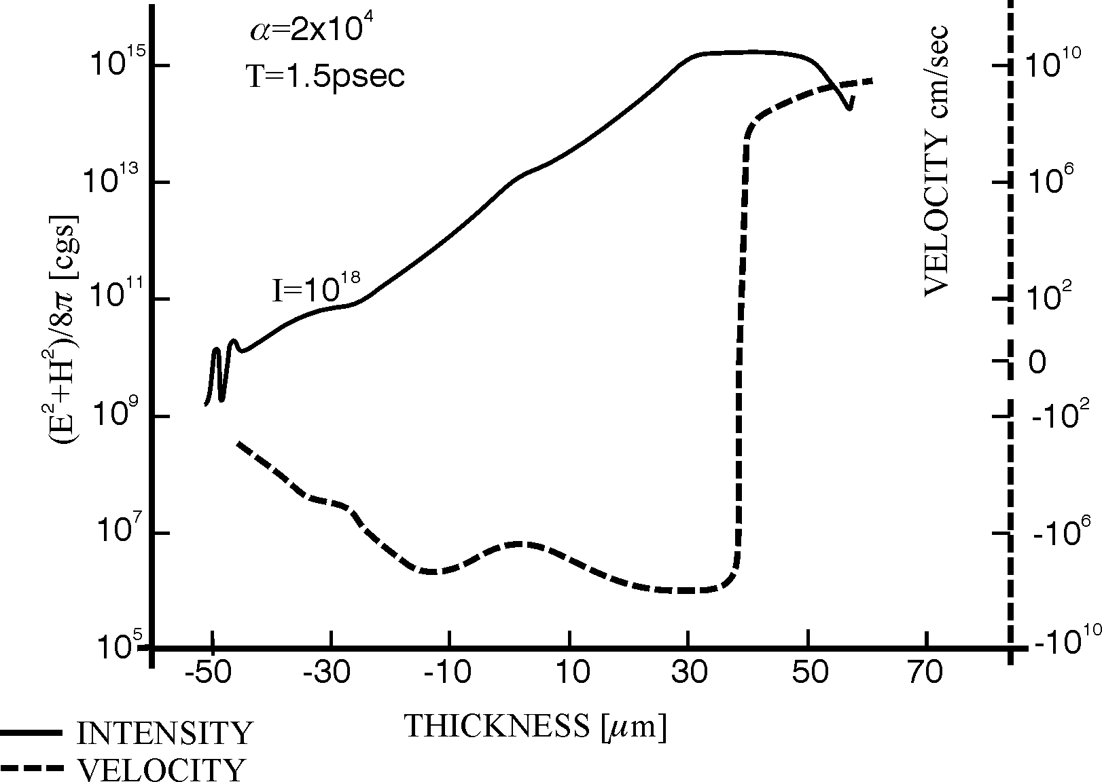

Fig. 1: Generation of blocks of deuterium plasma moving against the neodymium glass laser light (positive velocities v to the right) and moving into the plasma interior (negative velocities) at irradiation by a neodymium glass laser of 10¹⁸ W/cm² intensity onto an initially 100 eV hot and 100 μm thick bi-Rayleigh profile (Fig. 10.17 of [10]) with minimum internal reflection. The electromagnetic energy density (E²+H²)/(8π) is shown at the same time of 1.5 ps after start of the constant irradiation.

It was many years later only that these plane geometry conditions were available in experiments, showing such velocities gained by irradiation of similar excimer laser intensities at less than a ps duration, as measured by Sauerbrey [5]. The resulting accelerations of 10²⁰ cm/s² were in full agreement with the expectation from the nonlinear force interaction. Another key experiment was that by Zhang et al. [6] where 100 fs TW laser pulses of about 30 wave lengths diameter hit a target and the x-ray emission was measured. The laser pulses produced very much lower x-rays than usually known from other experiments with the same intensities. The uniqueness of this experiment was recognized and checked by the procedure, that additionally a lower intensity similar pulse was irradiated on the target at varying times between 10 to 100ps before the main pulse. At short time pre-irradiation, no change of the low x-ray emission was seen, but as soon as the pre-pulse time reached 70 ps and more, suddenly the very high x-ray emission appeared as known from all the usual main stream experiments. The later given explanation [8] was evident: it was thanks to the clean laser pulse technique [6] where the contrast ratio (ratio of suppression of any pre-pulse) for the main pulse was 10⁸. When the 70 ps pre-pulse was incident, a plasma plum was generated of a depth about two times the focus diameter. This was sufficient for the main pulse to shrink to about one wave length diameter by relativistic self-focusing (see Sect. 10.2 and 10.6 of Ref. [10]) so that the very high x-ray intensities resulted as in the usual cases, Fig. 2.

The skin layer acceleration (SLA) of the plasma block (Fig. 2b) was just what Sauerbrey [5] observed earlier confirming in retrospect that his 350 fs TW laser pulses were sufficiently clean. The pulses were produced by the Schäfer-method amplifying the 350 fs dye-laser-pulses through an activated KrF laser medium not needing gratings or pulse compression as with Mourou’s chirped pulse amplification (CPA). Sauerbrey [5] measured (by Doppler effect) an acceleration A in a carbon plasma front moving against the laser being produced by a 350 fs TW KrF laser pulse at 3.5x10¹⁷ W/cm² of

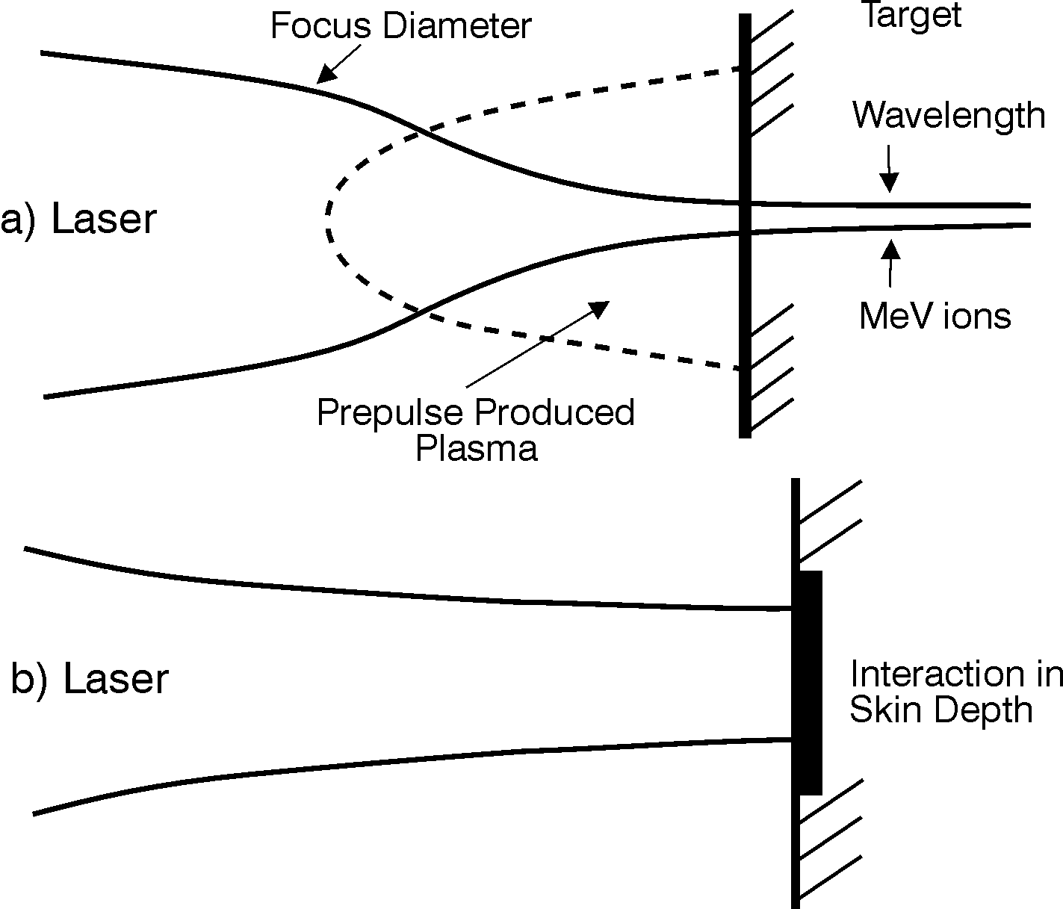

Fig. 2: Laser interaction with a target, (a) if the laser pulse produced a plasma plume in front of the target by a pre-pulse causing shrinking of the beam to less than one wave length diameter due to relativistic self focusing (Sect. 12.2 and 12.6 of Ref. [10]), and (b) avoiding the pre-pulse for plane geometry interaction within the skin layer [8].

A_{exp} = 10²⁰ cm/s² (4a)

This corresponds to an electric field E² = 2.9x10¹⁵ erg/cm³ and a densiy n_{i}m_{i} of the accelerated plasma layer of 5.4x10⁻³ g/cm³ at the critcal density n_{i} = 1.6x10²¹cm⁻³ for C⁺⁶ ions. The nonlinear force for the simplified plane geometry [10] is
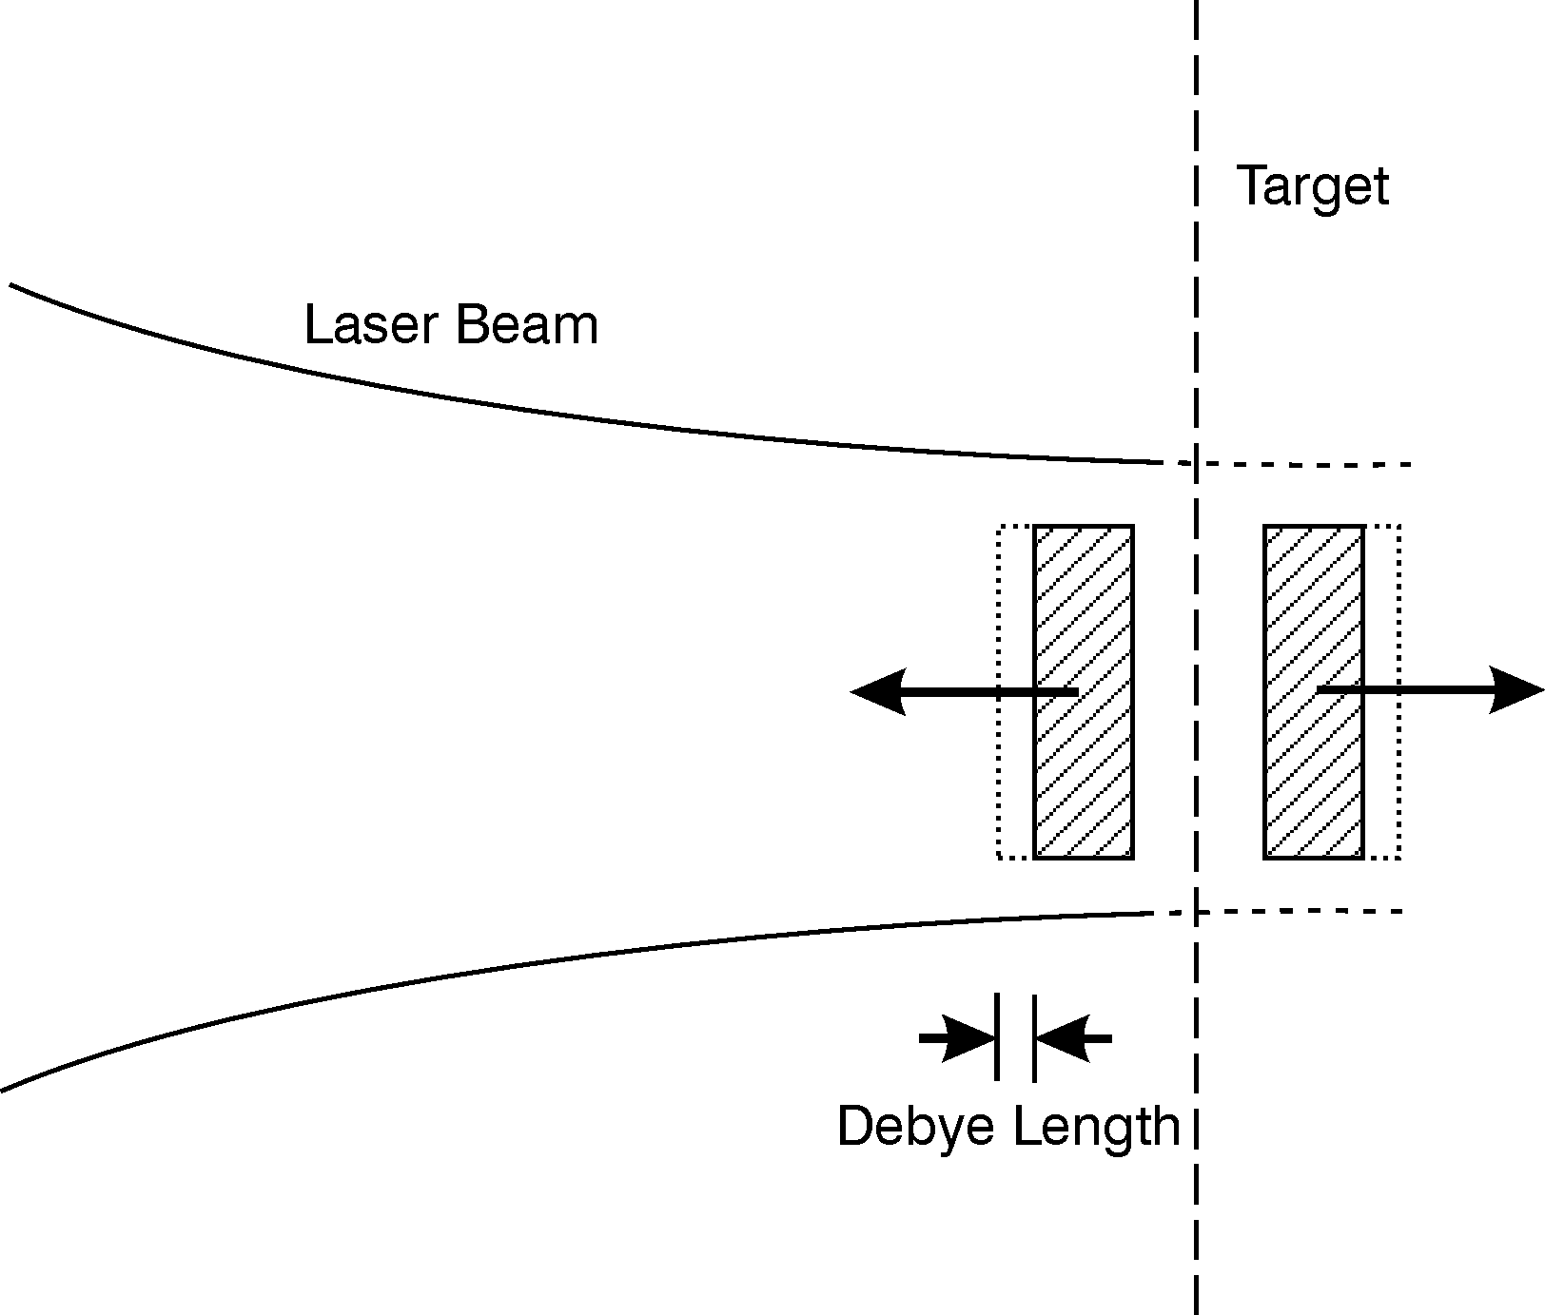

Fig. 3: Scheme of skin depth laser interaction where the non-linear force accelerates a plasma block against the laser light and another block towards the target interior. In front of the blocks are electron clouds of the thickness of an effective Debye length of less than 500 nm [8].

f_{NL} = - (∂/∂x) (E² + H²)/(8π) = n_{i}m_{i}A = - (1/16π)(ω_{p}/ω)² (d/dx) E² (4b)

Assuming for simplification dx = Δx = 10 μm and a swelling S = 2 (the experiments of Badziak et al. [7, 23] for ps pulses resulted in S = 3.5) we find the theoretical value

A_{NL} = 1.06x10²⁰ cm/s² (4c)

Both experiments [5, 6] were a clear confirmation of the plane wave plasma interaction, in agreement with the plane wave interaction theory and computation, Fig. 1, and under exclusion of self-focusing. The anomaly was fully realized by the experiments by Badziak et al [7] from ion emission with high contrast ratio ps-TW laser pulses. This mutually confirmed the high contrast ratio of the excimer laser pulses [5] as well as the very clean techniques of the other experiments [6]. Irradiation of TW-ps neodymium glass laser pulses [7] on copper targets should have led to Cu⁺¹³ ions of 22 MeV energy due to relativistic self-focusing, but only 0.5 MeV ions were detected. Furthermore it was strange that the number of the fast ions did not change at all when the laser intensity was varyied by a factor 30 (Fig. 5 of Ref. [7]). The energy of the fast ions was fully linear with the laser intensity as expected from a nonlinear force acceleration. The measured x-ray emission leading to a quiver energy swelled dielectrically by a factor three fully satisfactorily [8] agreed with the measured ion energies from a plane wave interaction which happened within the skin depth. The volume of the skin layer was not intensity dependent. This confirmed the observation of the intensity independence of the number of fast ions. These experiments were repeated with gold targets confirming all the details of the skin layer mechanism [23] including the generation of the plasma block, Fig. 3, moving into the target as experimentally confirmed from thin irradiated films and confirming an ion current density in the blocks above

j > 10¹⁰ A/cm². (5)

The measurements confirmed also [23] that the ps-TW interaction resulted only in one narrow ion beam accelerated against the laser light as expected from the nonlinear force acceleration while the use of longer laser pulses as usually resulted in several groups of ions moving into a wide angle against the laser light.

Now we report some details including recent numerical results for deuterium plasmas. The computations are based on the fact that before the ps main pulse, a less than 50 ps earlier acting laser pre-pulse produces a pre-plasma layer of thickness L_{pre} at least several times smaller than the laser focal spot diameter d_{f}. The main laser pulse interacts most intensively with the plasma in the skin layer near the surface of the critical electron density n_{ec} = m_{e}ω²/4πe² (ω is the laser frequency) and the geometry of the interaction is almost planar (L_{pre} << d_{f}). The high plasma density gradient in the interaction region produces non-linear ponderomotive forces acting – at the laser beam incidence perpendicular to the target surface – nearly parallel to the target normal. The force density f_{NL} can be expressed as the one-dimensional negative gradient of the electromagnetic energy density of the laser field given by its (dielectric modified) electric and magnetic vectors E and H [10]:

f_{NL}= -(∂ /∂x) (E² + H²) /8π. (6)

The gradients of the energy density near the critical surface result in two opposite non-linear forces which break the plasma and drive two thin (~ few λ) plasma blocks towards the vacuum and towards the plasma interior, Fig. 3, respectively (λ is the laser wavelength). The density of the plasma blocks is high (the ion density n_{i} ≈ n_{ec}/z, where z is the ion charge state) but the electron temperature is fairly moderate at sub-relativistic laser intensities. Thus the Debye length, λ_{D}, is small (λ_{D} << λ) inside the block and ions – being closely attached to electrons – move together with the electron cloud driven directly by the ponderomotive force. Since n_{i} ~ 10²¹ – 10²²cm⁻³ at λ ~ 0.3 – 1μm, even at moderate ion velocities v_{i} ~ 10⁷ – 10⁸ cm/s, the ion current densities can be very high (~ 10⁹ – 10¹⁰ A/cm² or higher).

The computations used the genuine two-fluid model [10] and were performed for a 20-μm hydrogen, inhomogeneous plasma layer of initial density increasing in the direction of the laser beam propagation. Both the linear plasma density profile and the profile described by the function n_{e}(x) = 2xn_{ec}{1+exp[(x-x_{c})/05.L_{n}]}⁻¹ were considered as initial values. For both profiles the boundary plasma densities were chosen in such a way that the critical plasma density n_{ec} was placed near the middle of the layer. The initial inhomogeneity of the plasma was characterised by the (relative) plasma density gradient scale length, L_{n}/λ, where L_{n} = n_{ec}(∂n_{e}/∂x)⁻¹. The initial temperatures of both electrons and ions were assumed to be of 30eV. Most of the calculations were carried out for laser pulses of a Gaussian shape and for a laser wave length λ = 1.05 μm. Our numerical studies were focused on the influence of the initial plasma inhomogeneity and the laser pulse parameters (intensity, duration) on the plasma characteristics and, particularly, on the current densities and velocities of ion fluxes produced by the laser-plasma interaction. 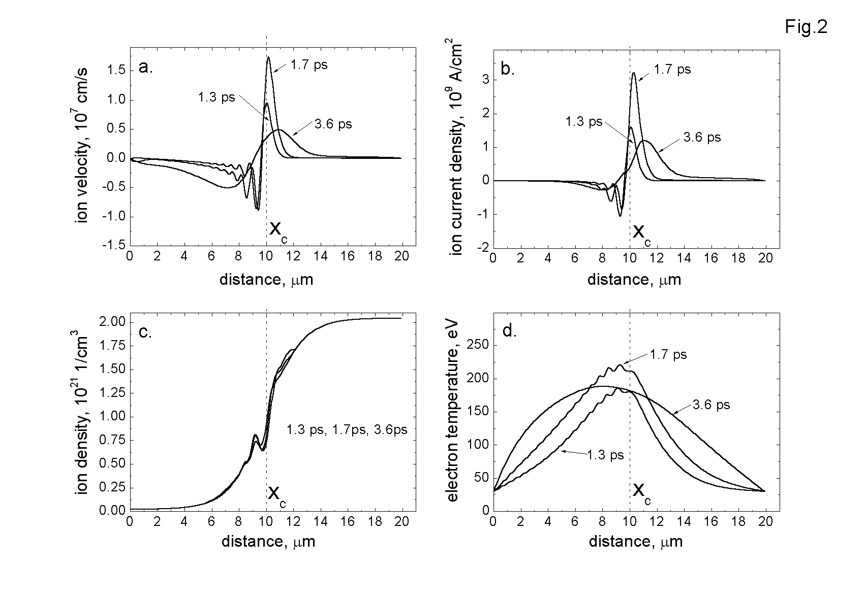
Fig. 4: Spatial distributions of the ion velocity (a), the ion current density (b), the ion density
(c) and the electron temperature (d) of plasma for various times measured from the
beginning of the laser-plasma interaction. τ_{L} = 1 ps, I_{L} = 10¹⁶W/cm², L_{n}/λ = 2.5 [23].

The following results are for the non-linear initial plasma density profile (the results for the linear profile were qualitatively similar). Fig. 4 represents spatial distributions of the ion velocity, the ion current density, the ion density and the electron temperature of plasma for the three time intervals after the beginning of the laser-plasma interaction. We see the generation of the under dense plasma block moving against the laser (negative velocities and current densities) and the over dense plasma block behind the critical surface moving in forward laser direction (positive velocities and current densities) in accordance with the simple physical picture. The plasma density profile is significantly disturbed near the critical surface and the electron temperature is the highest there.

The effect of the plasma density gradient scale length on the maximum ion current densities and the maximum ion velocities of backward- and forward-emitted ion fluxes can be seen in Fig. 5. For both fluxes there exist optimum values of L_{n}/λ but they are located in essentially different regions of L_{n}/λ: the highest current densities and velocities for the backward flux are attained at the small density gradients and for the forward flux – at the high density gradients.

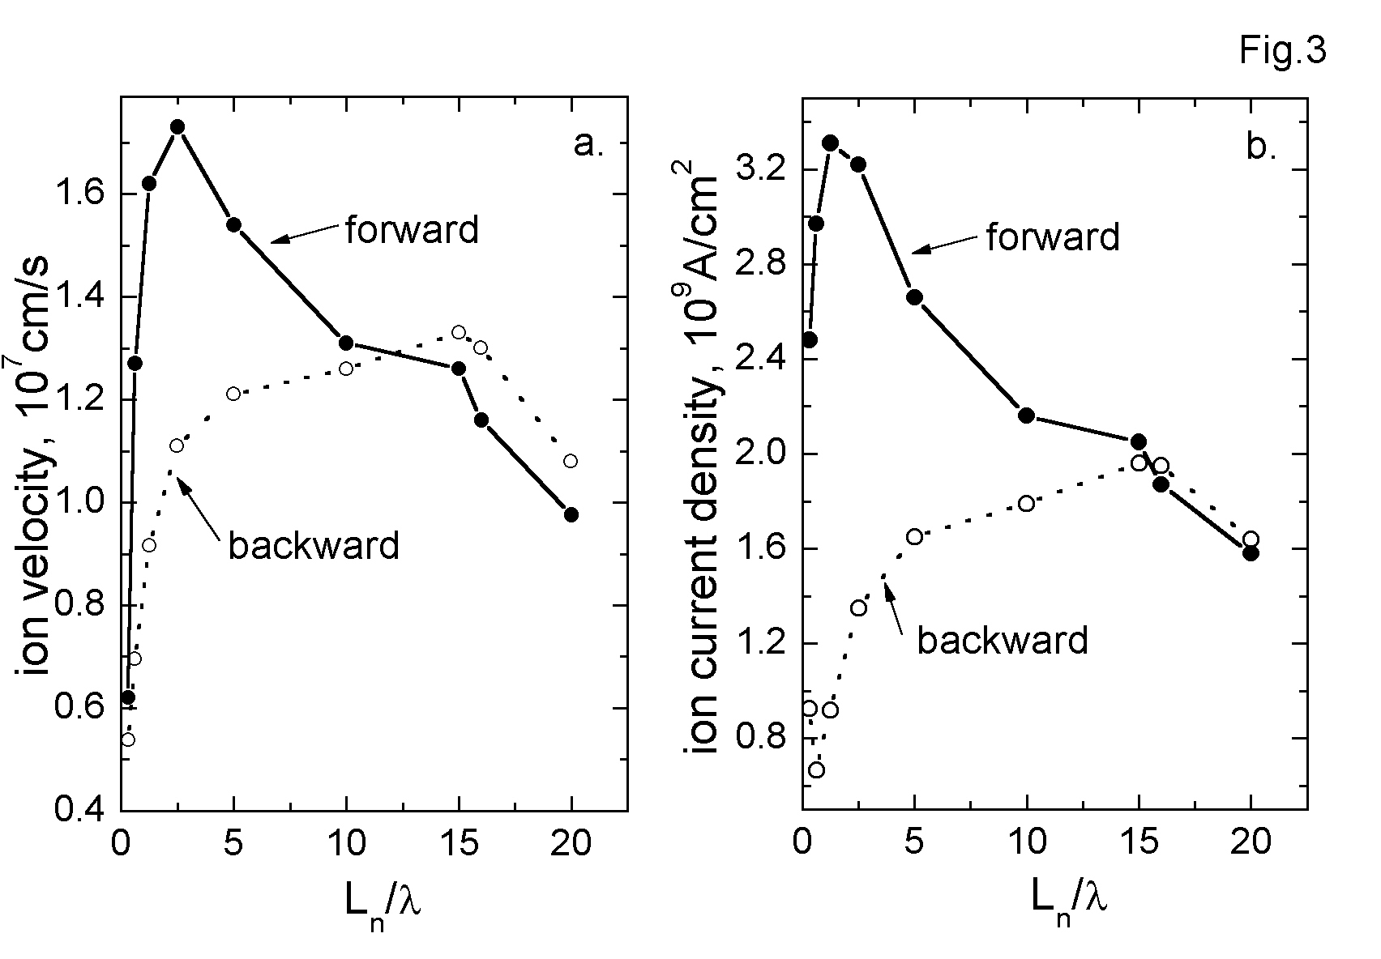
Fig. 5: The dependencies of the maximum ion velocities (a) and the maximum ion current
densities (b) on the plasma density gradient scale length. τ_{L} = 1 ps, I_{L} = 10¹⁶ W/cm²

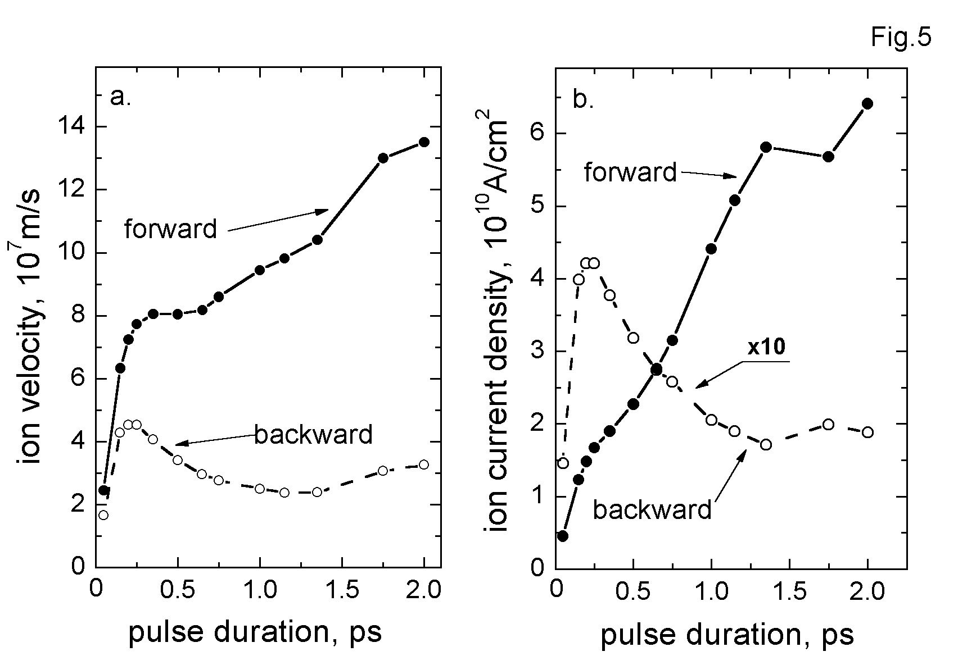

Fig. 6: The maximum ion velocities (a) and the maximum ion current densities (b) as a function of the laser pulse duration. I_{L} = 10¹⁷W/cm², L_{n}/λ = 1.

Fig. 7: Ion velocity profiles at times 2, 4, 5 and 6 ps after irradiation of a 4 ps neodymium glass laser pulse on a deuterium plasma of initial density of a linearly increasing ramp (abscissa in micrometer of the depth, with critical density at 13) of 30 eV temperature, confirming the generation of an ablating plasma block (negative velocity) and a compressing plasma block (positive velocity) [23].

The influence of laser pulse duration, τ_{L}, on characteristics of ion fluxes is illustrated in Fig. 6. For the forward-emitted ions, the maximum ion velocity and the maximum ion current density continuously increase with an elongation of the laser pulse. Contrary to that, in the case of backward-emitted ions, distinct maxima of these quantities occur at τ_{L} sub-ps ranges.

One of the characteristic features of the dependencies presented in Figs. 5 and 6 are the essential differences in the run of these dependencies for forward- and backward-emitted ion fluxes. These differences can be understood better when we consider the dielectric swelling factor S=1/|n| which is a measure of increase in the electromagnetic energy density of the laser field in plasma in relation to its vacuum value (n is the plasma refractive index). The necessary condition for the acceleration of plasma (ions) by the ponderomotive force in the backward direction is S >1 and, usually, the higher S, the higher the backward-directed ponderomotive force. The swelling factor depends not only on the plasma density gradient but also on parameters of a laser pulse and particularly on its intensity and the pulse duration. As it results from our numerical simulations, the swelling factor (its maximal value) decreases when the plasma density gradient λ/L_{n}, the intensity or the pulse duration increase (within the ranges of these parameters shown in the figures). For instance, at L_{n}/λ = 1, I_{L} = 10¹⁷W/cm², the swelling factor decreases from S ≈ 2 for τ_{L}= 0.2 ps down to S ≈ 1.3 for τ_{L}= 2. Thus, at high values of the above three parameters (λ/L_{n}, I_{L}, τ_{L}), the forward-directed force from the usual light pressure predominates the backward-directed one and, as a result, the velocities and current densities of forward-emitted ions are considerably higher than the ones for backward-emitted ions. The decreasing swelling factor is also the main reason for the faster increase in υ_{f} and j_{f} (than υ_{b} and j_{b}, respectively) when the laser intensity increases. The block generation was reproduced also by an essentially different genuine two-fluid computation, Fig. 7.

In conclusion, the numerical simulations based on the two-fluid hydrodynamic plasma model confirmed both qualitatively and quantitatively the idea of production of ultrahigh- current-density ion beams with the use of ponderomotive forces induced at the skin layer interaction of a short laser pulse of sub-relativistic intensity with a thin inhomogeneous plasma layer. The results of the computations were found to be consistent with the simplified theory and measurements.
.
3.2 Application for Controlled Ignition

Since the ion current densities, Eq. (5), in the laser driven plasma blocks from the skin layer or corona area of the irradiated plasma fulfilled the condition (4) for ignition of solid DT, we evaluated what has been achieved experimentally with respect to the energy flux density F, Eq. (3). The measurements [7, 23] included values of F up to 10⁶ J/cm². If the ignition of DT has to use ion energies of 80 keV for the optimum resonance conditions this gives an upper limit for the laser intensity while simultaneously a minimum of F is necessary. The values of F* = 10⁸ J/cm² may be not the final answer. It has been discussed before [23] that the detailed evaluation of the interpenetration of the energetic blocks with the cold solid DT may result in 20 times lower values
- if the increased collision frequency based on the quantum correction is included,
- if the modification of the stoping power by collective effects is included, and
- if the double layer caused reduction of the thermal conduction is taken into account.
But even with the pessimistic aim to work with F* values above 10⁸ J/cm², this can be reached with short wave length lasers, e.g. the double frequency of KrF [23].

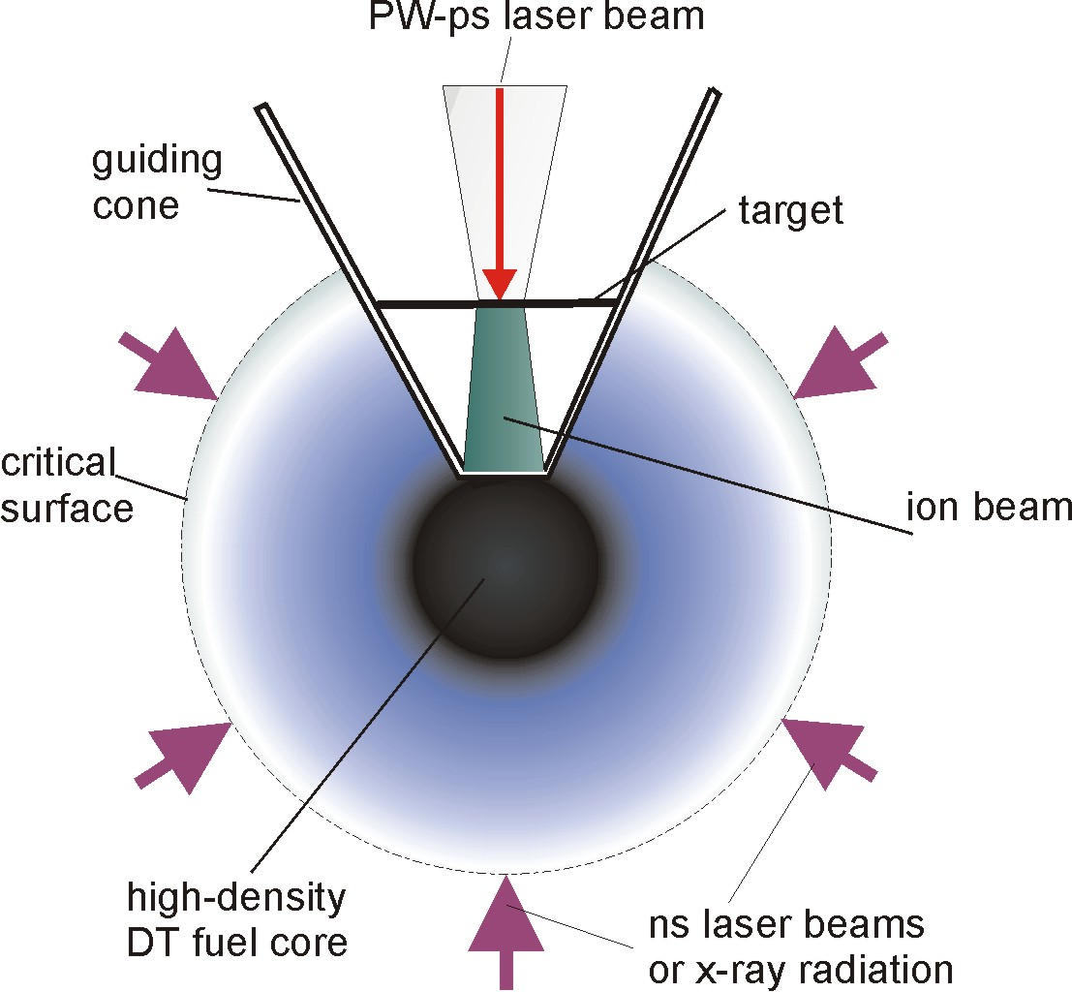

Fig. 8: Application of plasma block acceleration of for improving the proton-fast-igniter fusion scheme [21] with 1000 times higher ion current densities from the block acceleration [23].

The remaining problem is only whether the interaction mechanisms of the plasma block of sufficient thickness is comparable to the interaction process as in the case of the electron beam in the Nuckolls-Wood scheme [22]. Otherwise there is the similarity to the spark ignition at the interaction of the hot core with the surrounding plasma at spark ignition. For achieving the necessary thickness of the block, one has to produce it by irradiating a solid thin DT layer of spherical shape where the compressing part is then ballisticly moving into a focus for the interaction with the main solid DT fuel. During this motion there is an increase of the density of the fast shell. Sine a minor heating is unavoidable apart from the nonlinear force driven directed motion, the shell is a little expanding thermally. But in view of the spherical shrinking of the shell, the final interaction occurs with the same high ion current density needed for conditions (4) however in a block of increased thickness needed for the ignition.

This ballistic increase was mentioned before for the proton ignition generated by PW-ps laser pulses in pre-compressed DT fuel. It was shown [23] that the ion current densities in plane geometry can be 1000 times higher than known before [21] from measurements without the plasma block acceleration. With this result alone the scheme of proton-fast-ignition should reach the conditions of high gain fusion reactions. If then the ballistic layer acceleration is used to be focused into the main fuel, the conditions for ignition again will be improved. In this case indeed the ion energy for the ignition is not in the range of 80 keV as in the before mentioned ignition of solid DT fuel, but the ion blocks have to be relativistic with ion energies in the 5 MeV range. The details of this block acceleration have been evaluated numerically.

In all our computations we used the genuine two fluid hydrodynamics [10] including collisions. It is remarkable that the very different collisionless treatment with PIC methods resulted in very similar results at comparable conditions [24]. The plasma block interaction for highly relativistic laser intensities was studied also in view of fusion ignition and further applications [25].

4. CONCLUSIONS

In conclusion, interaction of TW-ps laser pulses with plasma results in a skin layer mechanism for nonlinear (ponderomotive) force driven two dimensional plasma blocks (pistons). This mechanism relies on a high contrast ratio for suppression of relativistic self-focusing. Space charge neutral plasma blocks are obtained with ion current densities larger than 10¹⁰ Amp/cm². Using ions in the MeV range results in 1000 times higher proton or DT current densities than the proposed proton fast igniter requires. This should result in better conditions of this fast ignitor scheme. The ballistic focusing of the generated plasma blocks and then short time thermal expansion increases their thickness but keeps the high ion current densities. As shown here, this approach then provides conditions that are very favorable for efficient fast ignition of a fusion target. If successful, this approach to fast ignition could significantly simplify operation of an IFE plant, allowing very attractive energy production costs.

ACKNOWLEDGEMENT

Special thanks are expressed to Prof. Dr. Martin Keilhacker for his helpful attention in the preparation of this paper. We also acknowledge continuous cooperation with our co-authors listed in Ref. [24].

References
- P.A. Kaw, Nuclear Fusion 45 (No. 10A, October), 1 (2005).
- G. Janeschitz, this volume, p. 9
3. R. Wolf, this volume, p. 69
4. M. Keilhacker, Phil. Trans. Royal Soc. London A 357, 415 (1999); M. Keilhacker and the JET Team, Nuclear Fusion 39, 209 (1999).
- R. Sauerbrey, Physics of Plasmas 3, 4712 (1996).
- P. Zhang, J.T. He, D.B. Chen, Z.H. Li, Y. Zhang, Lang Wong, Z.L. Li, B.H. Feng, X.L. Zhang, D.X. Zhang, X.W. Tang, and J. Zhang, Phys. Rev. E 57, R3746 (1998).
- J. Badzziak, A.A. Kozlov, J. Makowski, P. Parys, L. Ryc, J. Wolowski, E. Woryna, and A.B. Vankov, Laser and Particle Beams 17, 323 (1999).
- H. Hora, J. Badziak, F. P. Boody, R. Höpfl, K. Jungwirth, B. Králikova, J. Krása, L. Láska, P. Parys, V. Perina, M. Pfeifer, K. Rohlena, J. Skála, J. Ullschmied, J. Wolowski, E. Woryna, Opt. Comm. 207, 333 (2002); H. Hora, Laser and Part. Beams 23, 441 (2005).
- Edward Teller Lectures: Lasers and Inertial Fusion Energy, H. Hora and G.H. Miley eds., Imperial College Press, London (2005).
- H. Hora, Plasmas at High Temperature and Density (Springer, Heidelberg 1991).
- H. Hora and G.H. Miley, Laser Focus 20, 259 (1984).
- H. Hora and D. Pfirsch, 6th International Quantum Electronics Conference, Kyoto, Sept. 1970, Conference Digest p. 10-12.
- R.E. Kidder, Nucler Fusion 14, 797 (1974).
- H. Hora and P.S. Ray, Zeitschrift f. Naturforschung 33A, 890 (1978).
- H. Hora, H. Azechi, Y. Kitagawa, K. Mima, M. Murakami, S. Nakai, K. Nishihara, K. Takabe, M. Yamanaka, and C. Yamanaka, J. Plasma Physics 60, 737 (1998).
- J.H. Nuckolls, see [9] p. 85
- J.L. Bobin, Laser Interaction and Related Plasma Phenomena, H. Schwarz et al. eds., (Plenum, New York 1974) Vol. 3B, p. 465; Phys. Fluids 14, 2341 (1971); M.S. Chu, Phys. Fluids 15, 413 (1972)
- G.H. Miley, H. Hora, F. Osman, P. Evans, P. Toups, Laser and Part. Beams 23, 453 (2005).
- H. Azechi, T. Jitsuno, T. Kanabe, M. Katayama, K. Mima, N. Miyanaga, M. Nakai, S. Nakai, H. Nakaishi, M. Nakatsuka, A. Nishiguchi, P.A. Norrays, Y. Setsuhara, M. Takagi, M. Yamanaka, C. Manaka, Laser and Particle Beams 9, 193 (1991).
- M. Tabak, M. N. Glinsky, W.L. Kruer, S.C. Wilks, J. Woodworth, E.M. Campbell, M.D. Perry, R.J. Mason, Physics of Plasmas 1, 1626 (1994).
- M. Roth, T. E. Cowan, M. H. Key, S. P. Hatchett, C. Brown, W. Fountain, J. Johnson, D. M. Pennington, R. A. Snavely, S. C. Wilks, K. Yasuike, H. Ruhl, F. Pegoraro, S. V. Bulanov, E. M. Campbell, M. D. Perry, H. Powell, Phys. Rev. Lett. 86, 436 (2001).
- J.H. Nuckolls, L. Wood, LLNL Preprint UCRL-JC-149860 (2002); J.H. Nuckolls, L.L. Wood, Proceed. 11th ICNES 2002, T.A. Mehlhorn ed. (Sandia Nat. Lab., 2002), p. 171.
- J. Badziak, S. Glowacz, S. Jablonski, P. Paris, J. Wolowski, J. Kraska, J. Laska, R. Rohlena, H. Hora, Plasma Physics and Controlled Fusion 46, B541 (2004); H. Hora, J. Badziak, S. Glowacz, S. Jablonski, Z. Sklandanowski, F. Osman, Yu Cang, Jie Zhang,. G.H. Miley, Hansheng Peng, Xiantu He, Weiyan, Zhang, K. Rohlena, J. Ullschmied, K. Jungwirth, Laser and Particle Beams 23, 423 (2005).
- O. Klimo, J. Limpouch, Laser and Particle Beams 24, 107 (2006).
- T. Esirkepov, M. Borghesi, S.V. Bulanov, G. Mourou, T. Tajima, Phys. Rev. Letters 92, 175003 (2004); Wei Yu, H. Xu, F. He, M. Y. Yu, S. Ishiguro, J. Zhang, A.Y. Wong, Phys. Rev. E 72, 046401-1 (2005).

