DPG2006_AKE8.3_Czisch_RE-Strom-fuerEuropa-undNachbarn.doc
Low Cost but Totally Renewable Electricity Supply for a Huge Supply Area
– a European/Trans-European Example –

Dr.-Ing. Dipl.-Phys. G. Czisch

IEE-RE, Universität Kassel, Germany
Phone: (+49) 561-804-6377, E-Mail: gczisch@uni-kassel.de

- Abstract

Diminishing natural resources and global climate change are threatening the peaceful course of human development. A fundamental prerequisite for alleviating these dangers is to convert our energy system to renewable generation technologies that neither consume exhaustible resources nor degrade environmental quality despite continuous operation. Therefore also the questions have to be answered how the future electricity system should be structured, which techniques should be used and, of course, how costly the shift to a renewable electricity might be. This also raises the question how far we can get with the existing technologies and what costs are to be expected if one applies them at their today's costs, as a worst case assumption. It is apparent, however, only taking into account currently available technologies at their actual costs would constitute a worst-case cost assumption, since future developments will unquestionably improve economic performance. But on the other hand it is a conservative approach not overstressing the phantasy with optimistic cost assumptions and therefore it is resulting in a sound basis for further considerations. These questions have constituted the focus of a study to determine the optimum cost of an electricity supply realized for Europe and near-proximity Asian and African regions [Czi 05]. In the supply area considered currently are living about 1.1 billion inhabitants with a total annual electricity consumption of about 4000 TWh. The approach includes the option of supplying electrical energy to national economies not only or mainly from domestic resources but likewise in cooperation with neighbouring countries and distant regions using transmission systems to interconnect all participants within a wide-supply area containing huge renewable energy resources. The freedom for international cooperation between the nations opens up for synergetic benefits. Many of the nations within the area of consideration are emerging nations bounding on Europe with renewable potentials far in excess of national demand. Due to this circumstance, the possibilities of wide-area interconnection promise unprecedented economic and technical benefits for all participating nations. The investigations have confirmed that a totally renewable electricity supply is well within the range of current technology, delivering the electricity at costs if at all only slightly above the current cost of electricity even if future equipment cost reductions are neglected.

These findings have resulted from a computational optimisation process determining the system configuration as well as the temporal dispatch (on a annual three-hourly basis) of all power plants and other components, thus establishing a minimum-cost system on a very detailed basis. The resulting optimal configuration is a system dominated by wind power that incorporates generation at good wind sites throughout the entire supply area. A HVDC (High Voltage Direct Current) transmission system connects these wind sites with the centres of demand while also integrating existing hydropower storage facilities, thus providing backup capacities that are enhanced by regional biomass power and given additional support by solar thermal electricity production.

Other system configurations have been determined for scenarios with reduced investment costs for various technologies (e.g. Photovoltaics). Further scenarios demonstrate the influence of possible new technologies or of particular restrictions imposed, for example, on transnational electricity exchanges. The purpose of these additional scenarios is to obtain a broader view of various possibilities for a future electricity supply employing renewable energies and thus to provide a basis for political decision. The scenarios show that the shift towards a totally renewable electricity system is much less a technical or economic problem, but instead almost entirely a matter to be resolved by the necessary evolution of political attitudes and subsequent political decisions.

The most important insights derived from this study is that an entirely renewable electricity supply is possible using current technologies while the cost of electricity does not need to be much above today’s costs of electricity or may even be lower. The scientific results of the scenarios make it quite clear that it is now the responsibility of the political sector to take appropriate measures. From the scenarios one can also conclude that a Trans-European renewable electricity supply would open up interesting development strategies for poorer neighbouring states of Europe and in Europe. Furthermore it can be anticipated that the results, in principle, can be transferred to other world regions.
- 1 Overview

The renewable energy potential within Europe’s borders would actually be almost capable of satisfying current electrical energy demand. Wind energy is already close to being economically competitive and exhibits a huge technical potential throughout the continent. Due to high population densities, however, any major expansion of wind capacities within the European Union would be confronted with far greater impediments than those encountered in deserts, steppes, tundra, and other regions largely devoid of human settlement.

For example, the available wind energy potentials on land sites in Germany are theoretically adequate for replacing 17% of existing electricity generation, yet implementation is becoming increasingly more expensive, since the most favourable sites are already being employed. The use of local photovoltaic (PV) installations appears very costly at current prices. An additional major energy source of the future will be offshore wind power, the potential of which is frequently underestimated. It would generally be advisable to exploit the wind resources of all EU member states. Remarkably, however, areas with the greatest wind potential such as Great Britain and neighbouring Norway have achieved only modest growth in the past [IEA 03] [WpM 03]. Even if capacities were appreciably expanded, the effects of fluctuating output could be accommodated by existing power stations in those countries for many years up to relatively high proportions of the total electricity production, as is already being experienced in Denmark, Germany and Spain. As long as the total contribution from wind energy lies below 20%, no insurmountable problems may be anticipated (s. e.g. [Gie 00]). If the power industry is dominated by storage hydropower plants, such as in the case of Norway, even greater contributions of wind energy may be easily tolerated. Yet exceeding inherent system limitations would ultimately necessitate major grid reinforcement to smooth regional fluctuations, thereby combining the characteristics of production within different regions, supplanting the low capacities generally encountered in thinly populated regions, and consequently allowing a much greater contribution of renewable energies to be achieved. Until neighbouring countries become interested in exchanging significant amounts of wind electricity to achieve the mutual benefits of smoother temporal characteristics, and until the huge potentials in distant foreign countries are tapped, however, the contribution of wind power in countries such as Germany, which is already approaching its installation limits, cannot be expected to grow significantly.

The most interesting additional resources are therefore the huge potentials of wind and solar energy beyond the borders of the EU. Both can complement varying seasonal capacities elsewhere. In the case of wind power, for instance, the coastal regions of Morocco and Mauritania are particularly advantageous due to their summer peaks in production, which are the reverse of seasonal conditions in Europe. Solar electricity from concentrating parabolic arrays could likewise complement the output of wind farms in Germany, both inland and offshore. Since electricity demand is growing more rapidly in Morocco than in EU countries, wide-area utility services could be initiated using environmentally benign technologies for local generation [DOE 02]. The immediate EU neighbour Spain is likewise experiencing above-average growth of electricity consumption and would thus be the predestined partner for initiating transnational trade in renewable energies. Even after the costs and losses of currently available transmission equipment had been imputed, wind and solar electricity could be conveyed in a cost-effective manner over distances of more than 5000 km to central Europe. The price of wind power would be significantly lower than if produced e.g. in Germany at typical generation sites, while the price of concentrated solar electricity generation could still be competitive with domestic inland wind power if the entire range of German wind sites on land were being employed. In addition, a supply system extending beyond the EU would permit a full renewable energy supply to be realized for the EU and its cooperating partners. By embarking onto such a large-scale renewable energy strategy, a new form of economic cooperation with developing nations could be achieved to the advantage of all parties (s. also [Czi 99] and [BBB+ 03]).

- 2 Electricity Transmission

Transmission technologies will play a key role in any system employing widespread renewable resources for a common supply. Current transmission capacities between EU countries and to adjacent regions are entirely inadequate for transferring the quantities of electricity required for a complete renewable electricity supply. For example, the northern German grid would already be overloaded in the near future, if current plans for a massive realization of offshore wind farms would be realised without grid enforcements [IGW 01] [NDN 01] [BDH+ 03]. Capacity expansion should thus take into account the prospect of transmission over thousands of kilometers using the particularly appropriate high-voltage DC (HVDC) grid technology (s. also [ABB 01]).

The following treatment of transmission costs and losses assumes a HVDC capacity of about 5 GW for a single line. For the purpose of analysis, the city of Kassel near the geographical centre of Germany has been selected as the terminal point of the HVDC line. Costs of 60 €/kW for each of the converter stations at both ends of the line as well as 70 €/(kW 1000 km) for (double bipol) HVDC overhead transmission lines and 700 €/(kW 1000 km) for ocean cable have been assumed (s. also [Häu 99]). The relative transmission losses at full load are 4%/1000 km in the lines and 0.6% at each converter. The losses are greatly dependent on electrical loading and have been treated accordingly. The life expectancy has been conservatively estimated at 25 years for cost calculation purposes (more than 100 years lifetime is realistic for overhead lines [Wan 03]). A real interest rate of 5% has been assumed, and the annual operating costs have been set at 1% of the initial investment costs. With transmission line lengths assumed to require extended distances due to the inevitable geographic limitations of direct routes, a rated transmission capacity equal to the rated power of the wind and solar generators is employed. (The rated power of the transmission lines is about 50% below the thermal transmission limit, which is worth to be mentioned since it involves an inherent technical immunity against faults.) The same specific cost figures for the converters and the transmission lines as well as the interest rate and the computational lifetime are used for the individual scenario calculations.

- 3 Potentials of Wind and Solar Energy

The potentials of wind power and solar electricity production from PV and concentrating solar power stations are discussed in the following. Except where otherwise indicated, the calculations are based on meteorological data of the European Centre for Medium-Range Weather Forecasts (ECMWF) and, in the case of solar energy, also on data of the National Center for Environmental Prediction (NCEP) and the National Center for Atmospheric Research (NCAR) [ERA-15] [NCEP 99].

- 3.1 Potentials of Wind Energy

The potentials of national wind energy are dependent not only on prevailing wind conditions but also on factors such as population density or nature preserves and other restrictions. According to [Qua 00], for instance, the realizable wind power capacity on land sites in Germany can correspondingly be estimated at 53.5 GW. A total annual wind power production of about 85 TWh is assumed to be achievable as a result. This figure represents about 17% of total consumption (approx. 490 TWh) and is equivalent to 1600 full-load hours (FLH) of wind power per year. The additional offshore wind potential is taken to be about 79 TWh at nearly 3400 FLH [Qua 00]. In another study, the German offshore wind potential is given as approx. 240 TWh [GMN 95], even though a maximum distance of 30 km has been assumed between the offshore wind turbines and the coastline. This limitation has been rendered superfluous by more recent planning (s. e.g. [BSH 04]), so that a far greater potential may be assumed. If only locations are considered where the water is not deeper than 40 meters, with offshore turbines erected entirely at locations not previously declared nature preserves, military zones, or otherwise unavailable, a “conflict-free” potential of about 67 TWh results according to [IGW 01]. These assumptions may be considered particularly conservative. Permit applications have already been made for water depths of 45 meters [BSH 04], opening the way to a high multiple of “conflict-free” sites compared with the above considerations. Nature preserves and areas used by the military have also come under consideration [BSH 04]. Consequently, the yearly production of several hundred TWh is easily imaginable. In addition, the German portion of potential wind power sites in the North Sea makes up only about one-eighth of the total area with a depth of less than 50 meters (s. also [Czi 00]). Considering the use of the southern North Sea with Denmark’s northern tip as the northernmost point, an area of roughly 200’000 square kilometers with sea floor depths less than 45 meters can be found [Czi 00]. Here theoretically, neglecting all restrictions, an area sufficient for 1600 GW of rated offshore wind power would be available for generating up to 6000 TWh of electricity. This is roughly three times EU consumption, thus demonstrating that even after taking major restrictions into account a huge North Sea potential might still be realisable. Furthermore, shallow areas in other European seas with abundant wind resources would cover more than two times the area of the southern North Sea [Czi 00]. Greenpeace has recently published a scenario in which a capacity of 237 GW offshore wind power would be installed in EU coastal regions by 2020 to produce more than 720 TWh, while covering only 3.4% of the area available after all constraints had been taken into account [Gre 04]. Notwithstanding differing estimates of potential, a significant contribution to electricity production is harnessable. The full use of offshore wind energy necessitates a wide spectrum of cooperative measures among European countries for arriving at the most favourable scheme of implementation.

According to conservative estimates of the Danish company BTM Consult, the technical wind power potential of land sites within the EU and Norway is 630 TWh, corresponding to 315 GW of installable wind capacity [EWEA 99]. The very simplified assumption has been made in this case that all turbines would be delivering 2000 FLH a year, meaning they would operate at an effective average capacity of roughly 23% at each site. In relation to the total electricity consumption within the EU of about 2350 TWh (with Norway, 2450 TWh), this technical potential could thus be harnessed to fulfil about one-fourth of electrical energy demand [DOE 02]. Another particularly detailed analysis of the wind conditions at a relatively narrow strip of land along the Norwegian coastline determined a technical potential of 1165 TWh at an average turbine load of 2900 FLH, not considering any possible restrictions, with the most favourable sites producing 156 TWh from turbines delivering an average of 4100 FLH [Win 03]. According to conservative estimates drawn from meteorological data of the ECMWF ([ERA-15]) used for calculations providing the data base of the scenarios, a selection of wind sites within the European Union could generate about 400 TWh of wind energy with an average turbine performance of 2670 FLH using about 150 GW of total installed capacity, taking into account restrictions due to densely populated areas. Under the particularly favourable meteorological conditions prevailing in Ireland and Great Britain, far more electricity from wind power could be produced than estimated here. Due to the conservative assumptions adopted, however, their contribution has been limited to 25% of the total capacity installed in the EU and Norway. The respective electricity generation under these conditions would equal 32% of the electricity consumed in Ireland and Great Britain. In other countries, by contrast, the corresponding figure lies below 10% of domestic consumption. As previously mentioned, an annual average turbine operation of roughly 2700 FLH can thereby be achieved, whereas an even distribution of wind generators within the EU would only allow approx. 2000 FLH to be realized [Gie 00]. If in fact the total achievable potential for Great Britain and Ireland could be exploited, the generated electricity would slightly exceed their current demand. To insure that these possibilities may be realized, the transmission grid to neighbouring countries should be expanded in response to the growing use of wind energy to anticipate and stimulate the multilateral integration of wind power capacities.

The land-based wind power potentials in the EU are limited to the estimated levels identified above, due less to technical and meteorological restrictions than to the population densities of particular regions. If it were possible to use land areas freely, electrical energy requirements could be fulfilled many times over with wind power alone (s. figure 1). Restrictions due to the high population density are of secondary importance in many distant windy regions surrounding Europe. The population densities of northern Russia and western Siberia, northwestern Africa, and Kazakhstan lie between 0 – 2 inhabitants/km² and are thus at least two orders of magnitude below those of Germany with its 230 inhabitants/km² (s. e.g. [Enc 97]). In addition, these areas are steppes, deserts, semi-arid regions, or tundra of practically no inherent economic value, so that wind electricity generation may be instituted as a beneficial means of “farming in the desert”.

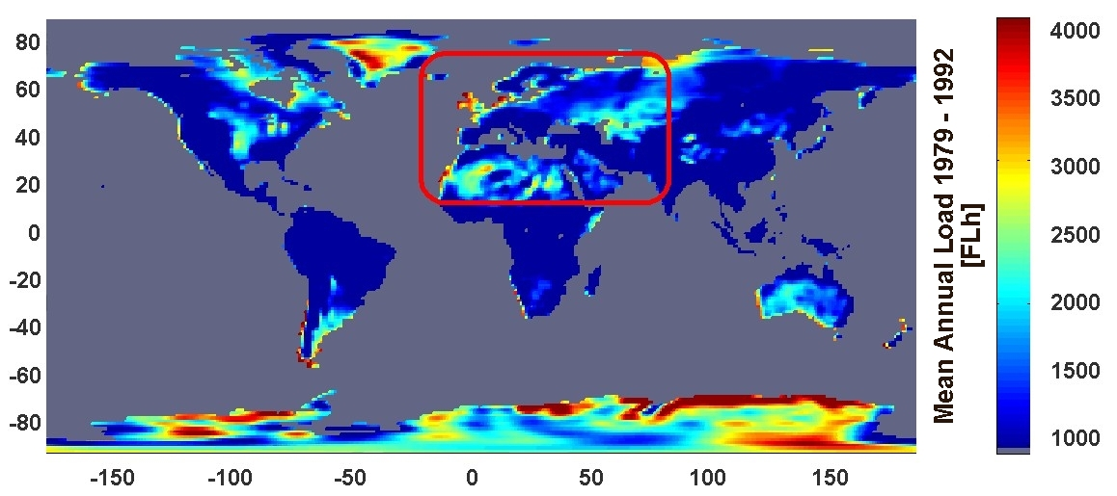
Figure 1 Potential of average annual electricity production from wind energy of the years 1979 – 1992; meteorological data: ECMW. The theoretical generation potential of wind energy, shown in the red quadrangle when land areas are used with over 1500 FLH, is between 120,000 and 240,000 TWh (turbine placement 4 – 8 MW/km²).

The potential electricity production from wind power is shown in figure 1. Even considering only land sites at which more than 1500 FLH can be achieved (within the rectangle roughly 40% of the land area), and without further restrictions, the area shown within the rectangle comprising Europe and its neighbours could deliver 120’000 – 240’000 TWh of electricity from wind power at a installation density of 4 – 8 MW/km². This result constitutes a maximum of about one hundred times the current electricity demand of the EU or fifty times the electricity consumption of all countries within the selected area. If only the best wind sites with the highest production at an installation density of 8 MW/km² were employed, just 4.3‰ of the land area would be required to provide the equivalent of the annual electricity consumption of the entire area within the rectangle shown on the map. About 2.5‰ of the area would be adequate for covering the equivalent of the electricity demands of the EU. Furthermore, the area covered by the turbines and accompanying infrastructure themselves is typically only about 2% of any land dedicated to wind farming. (The figure of 2% applies generally to wind farms consisting of individual turbines of 600 kW rated capacity. The area is reduced if larger single units are employed.) Therefore, the land space required for generating the equivalent of total EU electricity consumption is actually less than 0.05‰ of the entire marked geographical area. By comparison, the roughly 6% of total land area in Germany currently sealed by streets, buildings, and other infrastructure covers a thousand times bigger fraction of space.
The three regions previously mentioned – northern Russia with northwestern Siberia, northwestern Africa, and Kazakhstan – each offer a greater wind energy potential alone than required for meeting EU consumption requirements in their entirety. In the following treatment, therefore, only the areas within these regions with the highest yields have been considered. In table 1, the size of the areas selected for the analysis, the installable turbine capacity for a conservative assumption at a moderate installation density of 2.4 MW/km², the expectable average production of the turbines assuming wide-range turbine placement over the selected area, and the expectable yearly output are given.

Country | Annual Production |  |  | Total area selected | Potential rated Power | Potential production
 | [FLH/a] |  |  | [km²] | [GW] | [TWh/a]
 | Min | Ø | Max
Northern Russia and North-western Siberia | 3000 | 3100 | 3400 | 140.000 | 350 | 1100
North-western Africa
Southern Morrocco | 3200 | 3400 | 3700 | 50.000 | 120 | 400
Mauritinia | 2650  coast | 3000 | 3250  inland | 44.000 | 105 | 320
Kazakhstan | 2500 | 2600 | 2800 | 90.000 | 210 | 550
Table 1. Expectable turbine output for wide-area wind energy deployment in distant regions of high wind yield, total area of the selected regions, assumed installable turbine capacity at 2.4 MW/km², and expectable yearly output. The output varies within partial areas within the regions, as reflected in the specifications Min, Ø and Max (expanse of each partial area roughly 1.125° in NS and EW direction).

Because of the data used, the estimates tend to be conservative. In the case of southern Morocco, for instance, measurements have shown that load factors of far more than 4500 FLH may be assumed directly on the coast at favourable locations [ER 99]. In Kazakhstan, measurements and other investigations likewise indicate that yields significantly over 4000 FLH may be expected [BMW 87] [Nik 99]. The higher the topographical complexity of the terrain, the more significant the underestimation tends to be. Wind potentials in [CGM 03] calculated from Risø for the region at the Gulf of Suez in Egypt represent the most extreme underestimation of wind conditions in any complex terrain known thus far to the author. A comparison of this map and the date with the data depicted in figure 1 indicates a maximal average production of roughly 2200 FLH at low spatial resolution (like the data derived from ECMWF data, which build the basis of the scenarios), while the high-resolution Risø data correspond to 6000 FLH (for better comparison, see also [Czi 01]). Even if this example is particularly extreme, such underestimation is rather typical for complex terrains, making clear that the scenarios represent a very conservative approximation of actual possibilities and thus provide compelling reasons for further argumentation, since - as the example shows - there must be substantially better wind potentials worldwide at many places than can be inferred from the data bases used for the scenarios. This expectation can be convincingly proven by comparing the conditions for electricity production from wind energy shown in Figure 1 with high resolution data for parts of the Chinese mountainous areas [EGH+02] or many other regions, for example, in the Americas or South East Asia (s. e.g. [AWS 01]).It appears certain that high-yield locations would be exploited first if they were known, whereby high potentials could be expected at high quality sites.

- 3.2 Photovoltaic Potential.

The potential for photovoltaic electricity generation has been estimated for Germany to lie at about 190 GW (150 TWh), some 120 GW (95 TWh) of which would be on rooftops [Qua 00]. This figure corresponds to an average yearly full-load capacity of 770 FLH or 780 FLH on roofs. The calculations drawn from meteorological data of the ECMWF and NCEP have shown that good modules employed on rooftops with optimum angular position and unaffected by shadows could produce about 950 FLH.
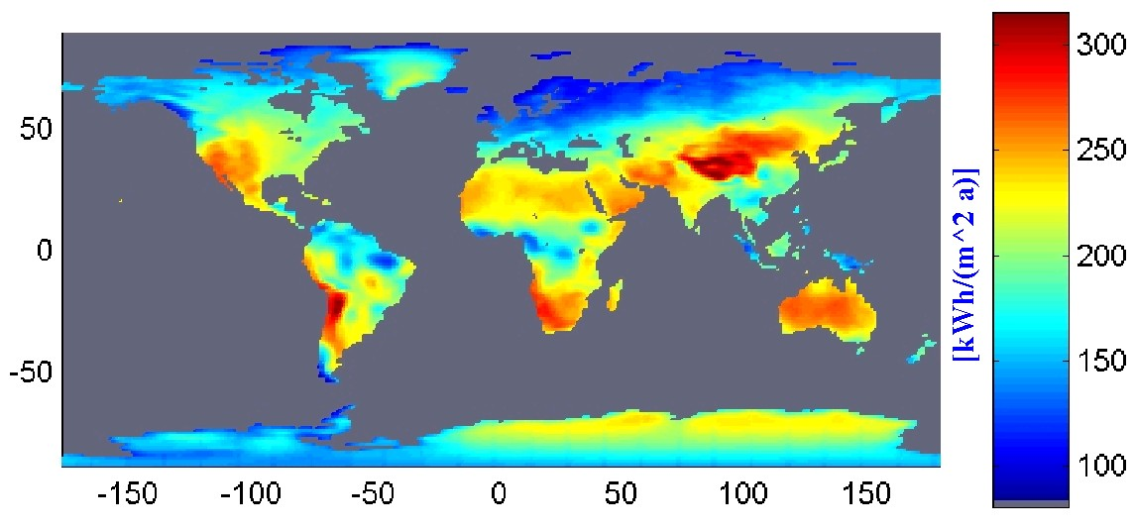
Figure 2 Potentials for average electricity production from photovoltaic generation derived for the years 1983-1992 Module = 14%, System = 11.5%, Orientation East-West with Slope = Latitude; met. data: ECMWF and NCEP.

The difference to the values given in [Qua 00] is due primarily to the inclusion of shadow and disorientation factors. figure 2 shows the potential yearly electricity production from PV. Table 2 contains the potentials and FLH for a number of countries.

 | Rooftop PV Potentials |  | Load
Country or Area | P | EG | L_{Ø} | L_{opt}
 | [GW] | [TWh] | [FLH] | [FLH]
Germany | 120 | 95 | 780 | 950
Portugal | 10 | 14 | 1100 | 1350
Finland | 5 | 4 | 660 | 800
Algeria &Morocco | 81 | 96 | 1200 | 1450
Mauritania & Senegal | 32 | 42 | 1300 | 1700
Total EU 15 | 550 | 470 | 850 | 1050

Table 2 Potential power (P) and electricity generation (EG) from PV (Module = 14%) on roofs as well as simplified assumptions on the expectable average equipment duty factor (L_{Ø}) under consideration of the losses due to shadows and roof disorientation, or under optimum conditions (L_{opt}). It has been assumed that the same roof area per inhabitant is available in all countries as in Germany an that it is distributed in the countries according to the population.

- 3.3 Potentials of Solar Thermal Generation

A second variety of solar electricity generation makes use of linear concentrating of solar radiation in parabolic mirror arrays (s.e.g. [Gre 03]) (Similar configurations, not yet constructed in operational size for power plants, have been realized with linear Fresnel reflector arrays [Sol 03].). With this technology, the desert regions of northern Africa could satisfy 500 times the electricity demand of all EU countries. Since domestic consumption is comparatively low, however, this high solar energy potential could only be realized to a significant extent if solar power were exported outside the northern African region. The output of this solar thermal power plants with parabolic arrays depends crucially on their design. Therefore, the performance characteristics can be stated only with reference to the design parameters. The use of thermal storage units is of major importance in this respect. The quality of the site can be determined by the heat production of the mirror array, independent of the specific parameters of the power plants, as shown in figure 3.

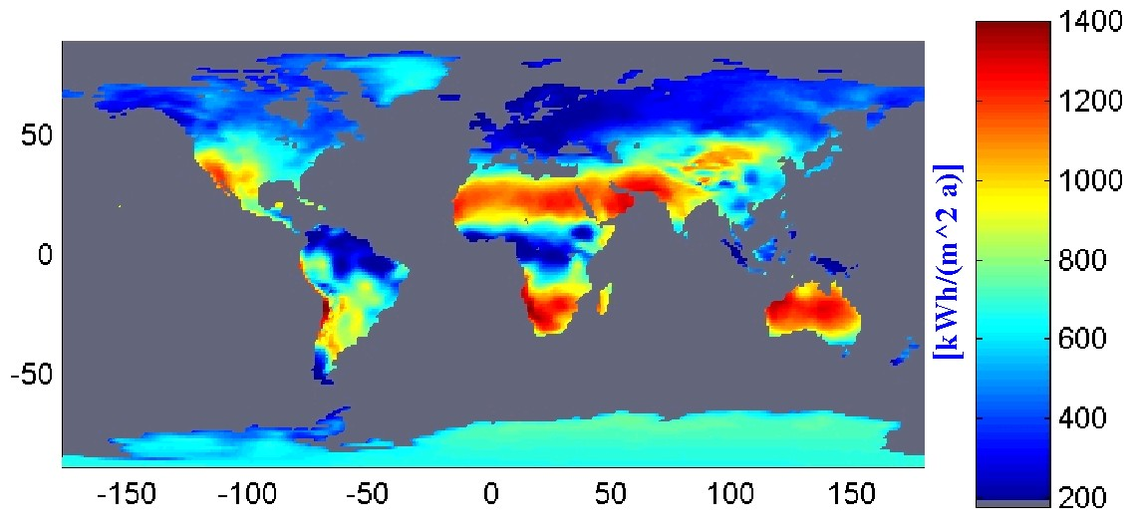

Figure 3 Potentials of average annual heat production from parabolic linear concentrating mirror fields for solar power plants for the years 1983-1992; met. data: ECMWF and NCEP.

The heat may be employed in a conventional thermal power plant to generate electricity at an efficiency of about 35%. If heat storage is included in the overall design, a larger linear mirror array is employed to charge the storage medium during the day. In this way, electricity may be produced throughout the night while supplanting the fossil fuels otherwise necessary for continuous operation of the plant. The storage facility therefore provides greater flexibility and reduces the cost of the solar electricity produced, since the conventional part of the power plant utilizes more solar heat, which during the night is delivered from storage. Therefore, the specific costs of the conventional part are lower, while not entirely compensating for the investment in storage capacities. In order to estimate the achievable electricity generation at certain locations, as an example it is assumed that the storage has been generously dimensioned for 14 FLH, so that the solar heat produced in the mirror field will never be partially wasted due to the limited capacity of the conventional steam power plant section. Such a parabolic trough power plant could attain nearly 5600 FLH in southern Morocco (western Sahara). Farther south in Mauritania, more than 5800 FLH would be possible, while 3000 FLH could be expected at a good location on the Iberian Peninsula.

- 4 Smoothing Effects

If the renewable electricity is delivered with large fluctuations of the generated electricity, the availability of quickly responding power plants becomes increasingly important to avoid bottlenecks of the supply. Storage hydropower stations are among the most interesting technologies for this purpose and already exist with high capacities. This does not hold true for every individual country, however. The currently installed capacity in Germany is only 1.4 GW with a storage volume of 0.3 TWh, which in itself cannot provide any major contribution to long term regulation. The combination of such facilities, however, would play a significant role in a highly interconnected European electricity network. The Scandinavian NORDEL power system currently has an installed capacity of about 46 GW and a storage volume of approx. 120 TWh (s. also [Nor 97a] and [Nor 97b]). In the UCTE grid, to which Germany likewise belongs, the corresponding values are 49 GW and 57 TWh [UCTE 98] [UCTE 00]. The total storage capacity of the NORDEL and UCTE grid systems is thus equivalent to more than a month of average consumption in the EU and Norway combined. Dedicating these plants to the prevention of power shortages from other production would alter their routine operation, but could enable a very efficient system to be realized. It would probably also be worthwhile to increase the installed generating capacities of the storage hydropower plants, thereby increasing the ratio of rated generation capacity to storage volume to permit the compensation of additional fluctuating generation from other renewable sources. Only if the momentary output of resource-constrained power stations exceeds demand, and storage capacities are likewise filled also for all pumped storage facilities, will a portion of the potential renewable electricity generation go unused.

The better the renewable energy generation corresponds with the temporal electricity demand, the smaller the power requirements and the necessary storage capacities of the storage power plants engaged for backup purposes (s. [CDHK 99]). Generation variations may be smoothed by increasing the geographic distribution of the plants delivering fluctuating electricity ([CE 01]). In general, the expanse of the area required for smoothing increases with the length of time required to compensate for changes in production level. Seasonal variations require bridging distances of several thousand kilometers. The temporal smoothing effect differs according to the type of renewable energy and the technology employed as well as a more or less appropriate combination of the various production sites.

- 4.1 Smoothing Effects for Wide-Area Employment of Wind Energy

The most favourable areas for electricity production from wind power in EU countries are dominated by winter winds. For this reason, as is illustrated in figure 4, the major contribution of wind generation occurs during this period.
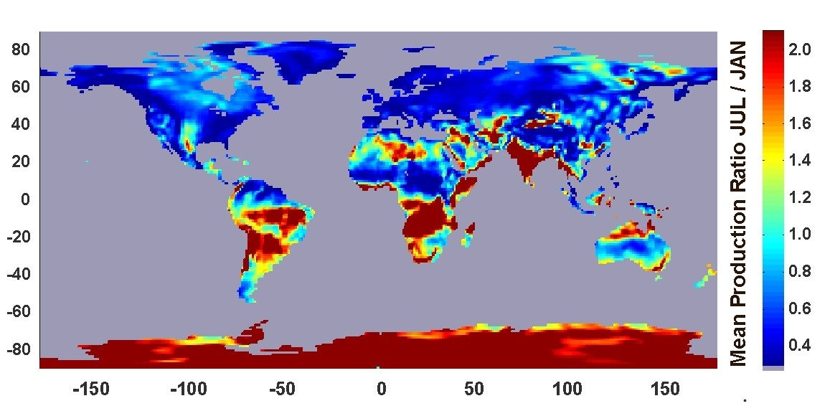

Figure 4 Seasonal comparison of average electricity generation from wind, quotient of average monthly values of July and January production 1979-1992; met. data: ECMWF.

The achievable production - Graph E) - figure 5 varies from month to month significantly more than the electricity demand - Graph G). The trade wind regions of northern Africa (southern Morocco and Mauritania, Graph c) and d))exhibit similarly strong seasonal variations, but their peak production is during the summer months.

Figure 5 Relative monthly average: electricity production from wind turbines (WT) in selected good wind areas and electricity consumption of EU and Norway. a.) to d.) represent Extraeuropean production E.) represents European production and F.) is the combined production of wind power at all regions whereas G.) represents the average consumption in the EU & Norway weighted with the today’s rated power of all power plants installed.

By selecting a combination of certain areas for production, the typical monthly electricity generation may largely be matched to the demand. This fact is illustrated in Graph F), in which one-third of the rated capacities are assumed to lie within the EU, with the rest equally divided among the other regions. In this manner, the area of generation and thus the total potential is greatly expanded, simultaneously accompanied by very beneficial smoothing effects. The variations in the electricity production from wind power diminish by transcending from the simultaneous feed-in from domestic European locations to generation that includes production from outside of Europe. In the case of a high percentage of electricity being produced from wind power, the instances of excessive generation will be significantly reduced as well as the periods of relatively low feed-in from wind power.

- 4.2 Smoothing Effects for Wide-Area Employment of PV Generation
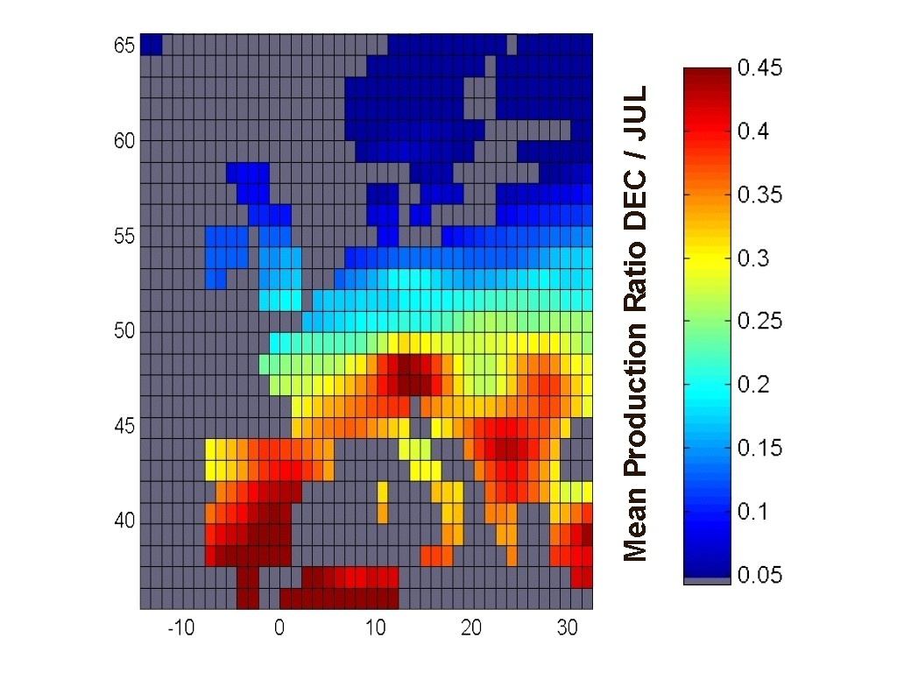
Figure 6 Seasonal comparison of average photovoltaic electricity generation, quotient of average monthly values of July and January production 1979-1992; met. data: ECMWF and NCEP
Photovoltaic generation exhibits significant minima during the winter months. December in Europe is characterized by the lowest photovoltaic electricity production. The monthly production is compared in figure 6 for July and December. The differences are naturally most dramatic in Scandinavia, where December delivers only 3% of the output achieved in the best month. This relationship is 40% on the Iberian Peninsula, and still about 23% for the EU in its entirety. It is therefore obvious that the months of maximum production differ from the months of peak demand.

- 4.3 Temporal Behaviour of the Electricity Produced by Parabolic Trough Power Plants

Due to the parallel configuration of the mirror elements, the trough array may partially block the rays of the sun when it is low on the horizon. For this reason, and because of the low angle of incidence during the winter, the output varies throughout the months of the year in addition to random changes of incident radiation caused by local weather phenomena. This effect is diminished gradually while approaching equatorial latitudes, but it is still distinctly noticeable even at locations in southern Mauritania, where the achievable production in December reaches more than 80% of July production, as indicated in figure 7. Solar thermal generation alone is therefore not adequate to track the seasonal variations in European electricity consumption. In combination with European wind power, however, this requirement may be quite easily met.

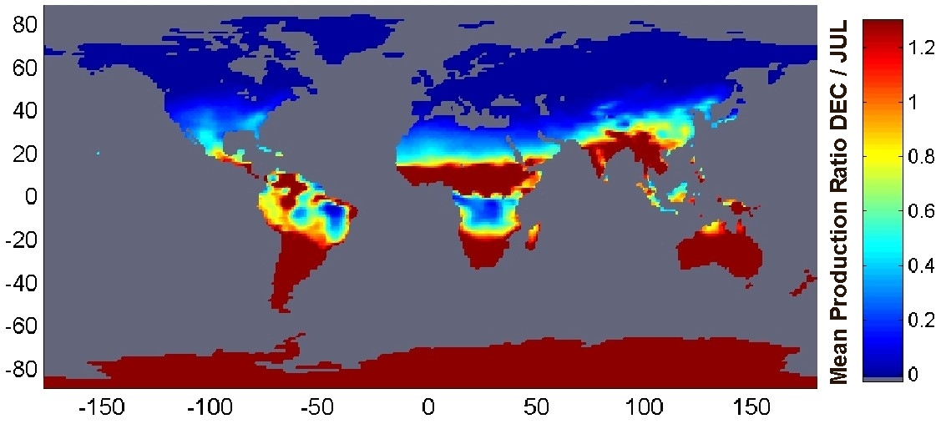

Figure 7 Seasonal comparison of average heat production by mirror arrays in concentrating parabolic power plants, quotient of average monthly values of December and July production 1983-1992; met. data: ECMWF and NCEP.

- 5 Costs of Electricity Production and Transmission

In the following considerations, the regions previously identified both within the EU and in the expansive surrounding areas have been examined with regard to the local costs of production. For certain distant locations, the expected transmission costs to the city of Kassel, which has been selected arbitrarily, have also been included. The costs are comprised of the capital investments in all components calculated at a real interest rate of 5%, the outlays for maintenance and repairs, as well as additional expenditures such as insurance and operating expenses.

- 5.1 Costs of Wind Energy

Wind turbines have been calculated using a specific cost of 1000 € per Kilowatt. The expected costs for offshore wind farms are currently about 1850 €/kW, whereby locations in the North Sea promise a yearly equivalent output of 3500 FLH (s. [Pla. 00], [SEAS 97] and [CHK 98]). An assumed turbine service life of 20 years is used to calculate the annuity, and the yearly operating costs are set at 2% of the total capital investment.

If the full potential of electricity generation from wind power in Germany were to be realized, an equivalent average generation of 1600 FLH with electricity costs of 6.3 €ct/kWh could be achieved according to the computational method mentioned above. The costs for electricity generated by offshore wind turbines may be estimated at 5 €ct/kWh. Equal distribution of wind power throughout all EU countries (according to the yield anticipated in [Gie 00]) would likely result in an average cost of about 5 €ct/kWh, as well. With the concentration on particularly good sites proposed above, about 3.7 €ct/kWh could be achieved. Table 3 gives the calculated local electricity costs for northern Russia with western Siberia, southern Morocco, Mauritania, and Kazakhstan as well as the transmission distances, costs, and losses. It should be noted that local measurements in southern Morocco [ER 99] clearly indicate the existence of sites capable of achieving 2.2 €ct/kWh locally, while the Egyptian sites previously mentioned promise generating costs of only 1.7 €ct/kWh owing to expectable yields above 6000 FLH. The transmission line losses would be greater because of the high level of output, but costs of delivered electricity below 3.5 €ct/kWh may be expected for the Moroccan high-yield sites and even less for Egyptian wind power reaching central Europe. If the electrical energy from Morocco were to be transmitted initially only as far as Spain, the cost would probably lie below 3 €ct/kWh. As soon as the high-yield predictions have been verified, wind energy imports from Kazakhstan could likewise be considered possible at costs of less than 4 €ct/kWh. Yet because of systematic underestimations, these particularly good sites are not represented in ECMWF data, which form the meteorological basis of the scenarios. They are consequently omitted in the scenarios and will be accorded no further discussion in this paper.

 | Wind power |  |  |  | Solar thermal electricity |  |  |  |  |  |  |  | PV
 |  |  |  |  | With St. |  |  | No St. |  | With St. ½ FK
 | EC | ECK | L | DK | EC | ECK |  | EC | ECK | EC | ECK | EK | EC | ECK | L | EK
 | [€ct/kWh] |  | [%] | [km] | [€ct/kWh] |  |  |  |  |  |  | [km] | [€ct/kWh] |  | [%] | [km]
Algeria & Morocco |  |  |  |  |  |  |  |  |  |  |  |  | 42 | 49 | 8.6 | 3100
Iberian Peninsula |  |  |  |  | 13.9 |  |  | 14.2 |  | 9.3 |  | 3000
Kazakhstan | 3.9 | 5.6 | 10 | 4300
Mauritania | 3.3 | 5.0 | 10.5 | 4900 | 7.2 |  | 9.4 | 9.1 | 11.2 | 4.8 | 6.5 | 5300 | 37 | 46 | 14 | 5600
N-Russia & NW-Siberia | 3.2 | 4.6 | 10.5 | 4200
S-Morocco | 2.9 | 4.4 | 10.5 | 4400 | 7.5 |  | 9.4 | 9.3 | 11.1 | 5.0 | 6.5 | 4400

Table 3 Anticipated local average costs of electricity (EC) and costs at arbitrary delivery point Kassel (ECK) for electricity generation from: a) land-based wind turbines, b) solar thermal electricity production with heat storage for 14 FLH (With St.), c) as b), but at half the current costs for the solar mirror field (With St. ½ FC), d) as b), but without storage (No St.) and e) PV. The transmission losses (L) include consideration of grid load variations with time due to changing infeed and the transmission distance to Kassel (DK) together with converter losses for the conversion from AC to HVDC.

- 5.2 Costs of Solar Electricity from Photovoltaic Generation

The calculated cost of photovoltaic electricity is based on an assumed total capital investment of 5500 € per peak kW generating capacity. This figure represents low-estimate currently achievable equipment costs for roof mounted PV (compare [Cre 00] [SFV 02]). The operating costs are set at 1.5% per year of the initial investment, and a service life of 20 years is assumed. The resulting average costs of electricity are 68 €ct/kWh in Germany and 61 €ct/kWh in EU countries overall. Optimum placement of the modules in locations unaffected by shadows allows generation costs to be reduced by about 18%. These lower cost assumptions apply also to the scenarios, since here the higher yield data form the basis of calculations. Electricity transmission from exemplary production regions with high solar irradiation (Morocco and Algeria) has been included into this consideration (s. table 3). The transmission costs of 6.5 €ct/kWh are due mainly to losses responsible for 4 €ct/kWh, while the remainder arises from the capital investment for the high-voltage DC grid. Photovoltaic electricity generation is significantly more expensive than wind power by about one order of magnitude. Even imported photovoltaic electricity with its significantly greater cost efficiency does little to change this relationship.

- 5.3 Costs of Solar Electricity from Concentrating Parabolic Trough Plants

Cost calculations for this case are more difficult than for the previously treated technologies, mainly because of the high variety of possible plant configurations. The use of a heat storage medium enhances the output characteristics, reducing the losses resulting from unused excess heat and thus increasing the efficiency of the power plant [EC 94]. Appropriate scaling correspondingly lowers the price of electricity. A worldwide generation capacity of more than 7 GW would reduce the costs of the collector array, the primary component, by about half [KMNT 98]. In table 3, representative calculations are provided that depict the electricity costs both locally and after their transmission to Germany at current and reduced costs of the mirrored troughs when storage is employed or not employed. A generous storage capacity insures that no heat will remain unused. This condition definitely does not lead to the most economical design, so that the cost data may be considered conservative. An additional assumption used for calculations of enhanced conservation is that 70% of the electricity has been generated from stored heat, resulting in relatively large average storage losses. The capital investments of very large solar power stations are 185 € per m2 of mirror array. (Concepts with more effective collectors are already envisioned that would reduce the costs of electricity by about 30 – 40%, and which are presently approaching the prototype stage [SM 01].) In a power plant without thermal storage, a mirror surface of approximately 6m² per kW of electrical power (kWel) is required, whereas the addition of a heat storage with 14 FLH storage capacity raises this value to approximately 15m²/kW_{el}. The cost of the storage itself lies at around 60 €/kWh_{el}. (This value is also used for the scenario, although recent research has indicated that it would thereby be overestimated by a factor of 3, since more expedient configurations would allow two thirds of the original storage volume to be avoided [LS 02].) The capital investment for the conventional part of the thermal power plant is 525 €/kW_{el}.

Since northern and central European regions are less suited for electricity generation using concentrating parabolic arrays, comparisons have been made between a region on the Iberian Peninsula in southern Portugal and areas both in southern Morocco and in Mauritania. The transmission line load has been assumed equivalent to full capacity operation of the solar power plant during a operating time necessary to produce half of the annual solar thermal electricity production, with the remaining 50% of the electrical energy divided in a power ratio of 2:1 over the rest of the operating time in order to approximate average transmission loss. The results are compiled in table 3. The cost of electricity from parabolic trough power stations for current component prices at good locations are comparable to the costs of electricity from wind power produced at locations capable of delivering about 1400 FLH. If the anticipated cost regression of 50% for the solar field can be realized, controllable solar power from concentrating solar power stations in northern Africa employing heat storage need not to be more expensive even after transmission to Germany respectively somewhere in the centre of Europe.

- 6 Scenarios: Cost-Optimised Electricity Supply Entirely with Renewable Energies

At the Institut für Solare Energieversorgungstechnik (ISET) in scenarios for a future electricity supply entirely with renewable energies have been developed (for detailed information see [Czi 05]). Various concepts have been studied for providing renewable energies to Europe and neighbouring regions. An extensive region (s. figure 8) with approx. 1.1 billion inhabitants and an electricity consumption of roughly 4000 TWh/a has been analysed to determine the available potentials for a future energy system. This process has taken into account ECMWF data as the meteorological basis and the population density as a restrictive factor for the wind energy potentials or estimated roof areas in all countries within the shown regions for determining the roof top photovoltaic potentials, combined with data on solar irradiation (ECMWF and NCEP/NCAR), wind speeds, and also temperatures used e.g. for photovoltaic electricity production and for solar thermal electricity production. Also other renewable resources such as biomass and hydropower have been investigated or included at the level of current knowledge. Mathematical optimisation routines have been applied to the question of which renewable resources with their individual temporal behaviour at different sites and with different yields should be used, and how selection should be made to achieve optimum cost performance. (A linear optimisation with roughly 2.45 million restrictions and about 2.2 million free variables was employed to find the best combination in each scenario.). The optimisation takes into account the temporal behaviour of the combined consumption of all countries within every individual region shown in figure 8 as well as all requirements imposed by resource-constrained production. Both sets of data, electricity demand and temporal behaviour of the possible production, have been compiled for optimisation (using time series with three-hour intervals) for all of the 19 regions to be supplied with electricity. The optimisation process ensures that supply will meet demand at any time, while determining if and to which extent any potential source is to be used, and how every part of the supply system will operate, including the dimensioning and operation of a HVDC grid that is superimposed on the current grid infrastructure. The criterion of optimisation is the minimization of overall annual costs of electricity when fed into the regional high-voltage grids, enabling these costs to be compared directly with those from regular power stations feeding into the conventional AC-high-voltage grid. However, the economic optimisation of all power plant operations for a time frame greater than, or equal to, three hours has simultaneously been included using sets of time series extending over one year.
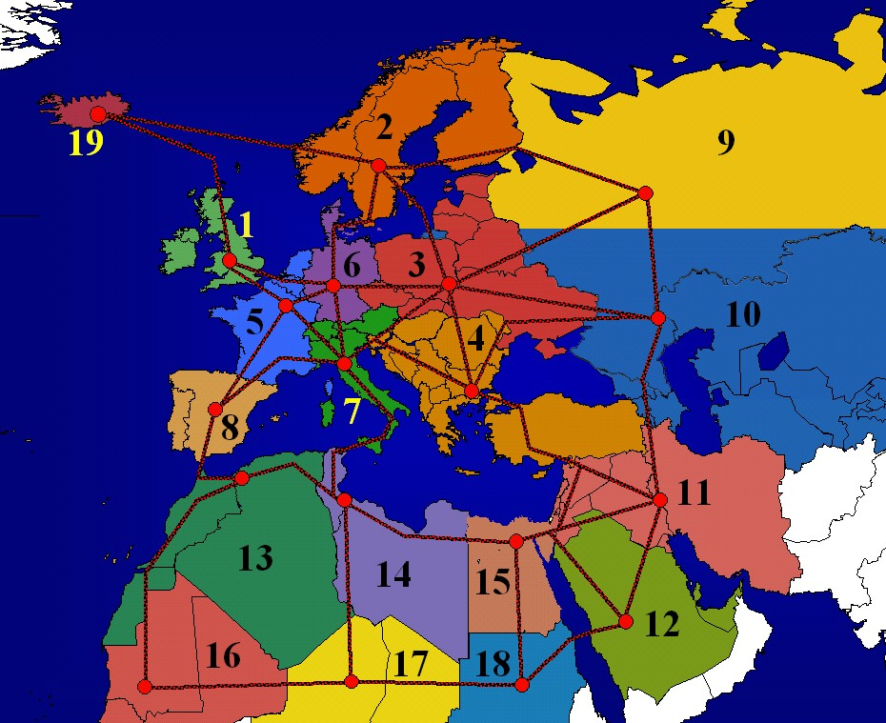

Figure 8 Possible electricity supply area divided into 19 regions with schematic representation of potential electricity transmission paths using HVDC to the geographic population centres of the regions

- 6.1 Base Case Scenario

The promising results for the base-case scenario – which assumes an electricity supply system implemented entirely with current technology using only renewable energies at today’s costs for all components (see [Czi 01] and [Czi 05] for detailed information on underlying assumptions) – indicate that electricity could be produced and transported to the local grids at costs below 4.7 €ct/kWh, which hardly differs from the case of conventional generation today. (At gas prices in 2002 of about 2.4 €ct/kWh for industrial consumers in Germany [EC 04], electricity from newly erected combined-cycle gas power stations had already reached significantly higher 5 - 6 €ct/kWh_{el}. Also the prices for cheap base load electricity e.g. at the EEX are higher than the costs of electricity in the base-case scenario and already reached more than 6 €ct/kWh [EEX 06].) In this scenario, nearly 70% of the power originates from wind energy produced from wind turbines with a rated power of 1040 GW. Biomass and existing hydroelectric power plants provide most of the backup requirements within the supply area, in which the individual regions are strongly interconnected via HVDC transmission lines. Electricity is generated from biomass at 6.6 €ct/kWh_{el} after proceeds from heat sales have been factored in. This result lies significantly above the average price level, yet the backup capability is essential to reduce the overall cost of the entire system. About 42% of the electricity produced is interregionally transmitted via the HVDC-System whereby the total transmission losses sum up to 4.2% of the electricity produced. Another 3.6% loss is production which neither can be consumed at the time it is produced nor be stored for later use within the pumped storage plants and therefore is produced in excess. These two losses may be considered quite acceptable for an electricity supply only using renewable energies.

- 6.2 Scenario with Transport Restrictions

By contrast, if interregional transmission is not allowed in a restrictive decentralised scenario, excess production increases significantly to 10% of the production, and additional backup power as well as backup energy employing other resources become necessary within individual isolated regions to meet the demand, leading to great additional expenses. In one scenario, fuel cells powered with renewable hydrogen produce electricity at about 20 €ct/kWh_{el} (which is already quite optimistic if the hydrogen is produced from renewable energies), raising the net electricity costs to over 8 €ct/kWh_{el} on the average. For Region 6 (Germany and Denmark), this restrictive “decentralized” (insular) strategy would lead to costs of electricity greater than 10 €ct/kWh.

- 6.3 Scenarios with Reduced Costs for Individual Components

The effect of cost changes for individual technologies and components was also investigated in particular scenarios. One aim was to find the costs at which PV could cost-effectively contribute to the supply. Therefore a series of scenarios has been calculated where the PV costs successively have been divided by two. As a result PV has not been chosen by the optimisation until costs have been halved three times. This major cost reduction for PV would enable this technology to provide a significant contribution to the electricity supply. If all other costs remained the same, a reduction to one-eighth of current PV costs would enable an economically viable 4% contribution to overall electricity generation to be provided. The generation would nevertheless be limited to the southernmost regions – particularly to regions 12,16, 17, and 18. If the cost were only one-sixteenth of present levels, PV technologies could account for about 22% of all electricity generation, reducing generation costs compared with the base case scenario by about 10% to 4.3€ct/kWh. Even in this case, however, photovoltaic technologies would not be used in the northern regions 1, 2, 3, 6, 9, and 19, because they could not contribute to overall cost reductions.

If the costs of the mirror fields of solar thermal power plants were reduced by half – as is anticipated in the near future – solar thermal power plants would already constitute about 13% of all electricity generation. In this case, the overall electricity costs lie at 4% below those of the base case scenario. Reducing the costs of the collector array to 40% and simultaneously lowering storage costs to two-thirds of current levels (still clearly above achievable storage costs according to the recent research mentioned above) would increase their contribution to 28% of the electricity produced, while the electricity generation costs would – compared to the base case scenario - fall by about 10% to 4.3 €ct/kWh. These examples illustrate that solar thermal generation presents an economically attractive perspective for the future that can be realized fairly easily in view of minimal cost regression factors.

- 6.4 Scenario with Hydropower at Inga in the Democratic Republic of Congo

The construction of a large hydroelectric power plant at an extremely favourable location in the Democratic Republic of Congo near Inga was also investigated for one proposed scenario (s. also [Kan 99]) The construction of a hydropower plant with a capacity of 38 GW was the decision resulting from computational optimisation. This would lower the costs of electricity by 5.3% compared to the base-case scenario due to more economic generation and incidental system benefits. A primary reason for the low costs of the electricity produced at Inga is the high average load of the hydropower plant of about 6900 FLH and the relatively low anticipated investment costs at this very advantageous site. Two-thirds of the electricity produced at Inga is transmitted over a HVDC system with 26GW capacity, connecting the generating station with Region 17, with the remainder conducted in equal amounts over two HVDC systems with a combined capacity of 12 GW, joining Inga with Regions 16 and 18.

- 6.5 Electricity Transmission within the Scenarios

In all scenarios – with the exception of restrictive and expensive insular configurations – electricity transmission is of significant importance. The necessary converter capacity (AC⬄DC) for the HVDC grid exceeds values of over 750 GW in some cases. (This level corresponds to about one-half of the installed generation capacity of all production facilities in the scenario regions.) The grid is used to achieve smoothing effects among different resource-dependent generation capacities using renewable energies, and to provide access to hydroelectric plants and to distributed biomass power plants both with associated storage capacity for wide-area backup applications. In the base case scenario, for instance, about 42% of the electricity generated is transmitted over the HVDC system between the regions within the supply area. Measured against the total electricity costs the cost of the transmission system amounts to 7% of which the main part of 5% is contributed by the transmission lines and cables. HVDC transmission has a higher intrinsic system stability than AC lines. Furthermore the transmission system of the base case scenario is highly redundant due to the fact that the thermal limit of the transmission lines is about twice the rated power and due to the fact that between almost all regions two or more systems are designed to be built parallel. But nevertheless if further redundancy was seen as desirable this could be relatively inexpensively achieved. A somewhat extreme idea would be to erect two whole systems of transmission lines in parallel. This would mean that the costs of transmission lines and cables would double but at the same time the losses would decrease and thus the overall cost increase would only be about 3% ensuring a degree of immunity against faults, which is by far higher than stipulated for today’s systems.

- 6.6 Transferability of the Results

It is highly probable that these results can be transferred to other world regions (see also [Czi 06]), since every continent has its own renewable resources with different temporal production characteristics within a radius connectable via HVDC transmission. In some continents or regions hydropower is not exploited to the comparably high degree it is in Europe. This could negatively influence the available storage capacity. Solar energy potentials can be detected quite well with the available low resolution data used for this scenario study, showing the good conditions in many regions world wide. However, some huge regions are characterised by very rugged mountainous terrain where the detection of good wind sites is much more difficult than in smooth terrain (see also [Czi 06]). This means that many very good wind sites might remain hidden if meteorological data with low spatial resolution are used to search for the potentials, as done for the scenario study described here. If this technical problem were overcome, a much more positive assessment of the wind energy potentials can be expected. In the light of such an assessment it is clear that the general result – a low-cost but nevertheless totally renewable electricity supply is possible if the renewables are used in a huge powerfully interconnected supply area – holds for most areas of similar size to the European/Trans-European example. Only the details would of cause have to be adapted to the local conditions. Furthermore there is no technical reason why, for example, southern Africa or eastern Asia should not be linked by a HVDC system to the supply area considered in the scenario study. So a future system might spread over some continents, gaining further advantages from further expansion.

- 7 Generel Conclusions Drawn from the Scenarios

The fundamental technical prerequisites for an electricity system realized entirely with renewable energies have already been fulfilled. The different scenarios show a broad range of various possibilities for a future electricity supply solely employing renewable energies and thus provide a sound basis for political decision. The following can be deduced:

- An entirely renewable and thus sustainable electricity supply is possible even if only current technologies are used.

- The costs of electricity don’t have to lie far above today’s costs even if very conservative assumptions are made. At today’s prices for all components, the costs of electricity don’t have to be higher than from a newly erected combined-cycle gas power plant and could be even lower than the current prices of electricity at the cheap base load electricity traded e.g. at the European Energy Exchange. The annual difference in cost compared with the current national bill for electricity, which typically may account for roughly 2 to 3% of the gross national product, would if at all only impose a few per mill of the gross national product as an additional burden on the industrial countries within the supply area of the scenarios, thereby constituting a highly rational alternative to the predictable consequences of climate change and declining fossil fuel resources. Foreseeable cost reductions – particularly for renewable energy technologies – make a comprehensive renewable energy system both conceivable and potentially more economic than all current means of providing electrical energy. However, the costs are dependent on the future system configuration, and could be reduced by ongoing technical progress, or be negatively influenced by wrong energy policies.

- A Trans-European renewable electricity system would simultaneously enable the realization of a combined strategy for developmental assistance and climate protection as a win-win arrangement for all participating states. This becomes obvious since on the one hand the investments necessary are relatively small compared to the gross national product (GNP) of the industrial countries but on the other hand they are quite large in comparison with the GNP of many countries at the periphery of the supply area which would be the source of the renewable electricity for the industrial countries involved. Therefore to follow such a concept of a joint renewable electricity supply for Europe and its neighbours would among other implications mean developing a form of development aid worthy of the name which may rather take the character of an economic cooperation, based on the needs of both sides.

- It is very reasonable to estimate that the general results of the scenarios can be transferred to other world regions even if in some cases some more detailed information – especially on the local wind conditions - would be welcome to reduce uncertainties (see also [Czi 06]).

The problem of converting our electricity system to one that is environmentally and socially benign is therefore much less a financial or technical issue, being instead almost entirely dependent on political attitudes and governmental priorities. There is more than enough evidence to justify a confident call for a comprehensive transition to a sustainable electricity supply, bearing in mind that a broad variety of solutions is possible. Responsible political decisions are now imperative for allocating the necessary technical, scientific and economic resources to achieve this goal.

- References

[ABB 01] ABB Power Transmission, HVDC Systems, ABB HVDC projects, Internet Publication http://www.abb.com/ (follow headword “HVDC Systems” and headword “ABB HVDC projects)”
[AWS 01] AWS Truewind, Wind Maps, Internet Publication , 2004
http://www.awstruewind.com/inner/windmaps/windmaps.htm
[BBB+ 03] Benhamou K., Bennouna A., Brügmann H.-J., Czisch G., Fell H.-J., Fischedick M., Haas A., Jischa M., Kabariti M., Knies G., Lehmann H., Lehmann K.-P., Metz P., Michaelowa A., Möller U., Nokraschy H., Satoguina H., Schönwiese C.-D., Trieb F., Trans-Mediterranean Renewable Energy Cooperation “TREC” - for development, climate stabilisation and good neighbourhood, Deutsche Gesellschaft Club of Rome und Hamburger Klimaschutz-Fonds, November 2003
http://saharawind.com/documents/trec.paper.pdf
[BDH+ 03] Berger F., Dany G. , Haubrich H.-J. , Luther M., von Sengbusch K., Auswirkungen der zunehmenden Windenergieeinspeisung auf die Übertragungsnetzbetreiber, Energiewirtschaftliche Tagesfragen, September 2003, p. 562-567
[BMW 87] Baltes K., Müller M. J., Werle D., Handbuch ausgewählter Klimastationen der Erde, 4. Auflage, hrsg. v. Richter G., Forschungsstelle Bodenerosion der Universität Trier Mertesdorf, Trier 1987
[BSH 04] Bundesamt für Seeschifffahrt und Hydrographie (BSH), Offshore-Windenergie, Hamburg 2004 http://www.bsh.de/de/Meeresnutzung/Wirtschaft/Windparks/index.jsp
http://www.bsh.de/de/Meeresnutzung/Wirtschaft/CONTIS-Informationssystem/nord_a4_wind2010.jpg
[CDHK 99] Czisch G., Durstewitz M., Hoppe-Kilpper M., Kleinkauf W., Windenergie gestern, heute und morgen, Vortrag auf der Kongress „Husum Wind 1999“
http://www.iset.uni-kassel.de/abt/w3-w/projekte/husum_czisch.pdf
[CE 01] Czisch G., Ernst B., High wind power penetration by the systematic use of smoothing effects within huge catchment areas shown in a European example, “Windpower 2001” “American Wind Energy Association” (AWEA), Washington, DC, 2001
http://www.iset.uni-kassel.de/abt/w3-w/projekte/awea_2001_czisch_ernst.pdf
[CHK 98] Cockerill T. T., Harrison P., Kühn M., van Bussel G. J. W., Opti - OWECS Final Report, Comparison of Cost of Offshore Wind Energy at European Sites, Delft 1998
[CGM 03] Czisch G., Giebel G., Mortensen N., Effects of Large-Scale Distribution of Wind Energy in and around Europe, International Energy Conference, Risø National Laboratory, Denmark, May 03, http://www.iset.uni-kassel.de/abt/w3-w/projekte/Risoe200305.pdf
[Cre 00] Creutzburg M., Solarthermie und Photovoltaik im Kostenvergleich, in: Sonne Wind & Wärme, 1/2000, S. 12-15
[Czi 99] Czisch G., Potentiale der regenerativen Stromerzeugung in Nordafrika - Perspektiven ihrer Nutzung zur lokalen und großräumigen Stromversorgung -. Vortrag auf der Frühjahrstagung der Deutschen Physikalischen Gesellschaft, Heidelberg 1999
http://www.iset.uni-kassel.de/abt/w3-w/projekte/Pot_Strom_Nordafrika.pdf
[Czi 00] Czisch G., Seebodenprofile in ausgesuchten Regionen in und um Europa
http://www.iset.uni-kassel.de/abt/w3-w/folien/Windenergie/offshoreflaechenauswahl_2.pdf
[Czi 01] Czisch G., Global Renewable Energy Potential - Approaches to its Use
http://www.iset.uni-kassel.de/abt/w3-w/folien/magdeb030901/overview.html
[Czi 05] Czisch G., Szenarien zur zukünftigen Stromversorgung - Kostenoptimierte Variationen zur Versorgung Europas und seiner Nachbarn mit Strom aus erneuerbaren Energien, Dissertation, University of Kassel, 2005
https://kobra.bibliothek.uni-kassel.de/handle/urn:nbn:de:hebis:34-200604119596
https://kobra.bibliothek.uni-kassel.de/bitstream/urn:nbn:de:hebis:34-200604119596/1/DissVersion0502.pdf
[Czi 06] Czisch G., Joint Renewable Electricity Supply for Europe and its Neighbours- Transfer to Other World Regions and China, Kassel, 2006
http://www.iset.uni-kassel.de/abt/w3-w/projekte/RenElSupEU_Trans_ot_WR+Ch.pdf
[DOE 02] World Total Net Electricity Consumption, 1991-2000, International Energy Annual, US Department of Energy, 2002 http://www.eia.doe.gov/emeu/iea/table62.html
[EC 94] European Commission, DG I, Assessment of Solar Thermal Trough Power Plant Technology and its Transferability to the Mediterranean Region, Final Report, Brussels, Belgium 1994
[EC 04] EC, Directorate-General Energy and Transmission, Energy & Transport in figures - Statistical pocket book 2003, Brussels, Belgium 2004
http://europa.eu.int/comm/dgs/energy_transport/figures/pocketbook/2003_en.htm
[EEX 06] European Energy Exchange, German-Power-Futures: Gesamtübersicht : Cal-07 base
http://www.eex.de
[EGH+02] Elliott D., Schwartz M., Scott G., Haymes S., Heimiller D., George R., Wind Energy Resource Atlas of Southeast China, 2002 http://www.rsvp.nrel.gov/pdfs/wind_atlas_china_CD.zip
[Enc 97] Encarta Weltatlas 1997
[ER 99] Enzili M., Rehfeld K., Auswertungen aus dem Wind Ressourcen & TERNA Projekt in Marokko, Deutsches Windenergie-Institut (DEWI), Wilhelmshaven 1999
[ERA-15] ERA-15, ECMWF Re-Analysis (ERA) Project, EZMW, Reading, United Kingdom 1996, http://www.ecmwf.int/research/era/
[EWEA 99] Windstärke 10, Studie von EWEA, fed, und Greenpeace, 1999
[Gie 00] Giebel G., On the Benefits of Distributed Generation of Wind Energy in Europe, Dissertation, Universität Oldenburg, 2000
[GMN 95] Garrad A. D., H. G. Matthies, C. Nath, T. E. Schellin, Scherweit M. u.a.; Study of Offshore Wind Energy in the EC, Joule I 1995, Natürliche Energie, Brekendorf, Editor.: Germanischer Lloyd / Garrad Hassan and Partners / Windtest KWK, Hamburg / Bristol / Kaiser-Wilhelm-Koog, 1995
[Gre 03] Aringhoff R., Brakmann G., Aubrey C. (editor), Teske S. (co-ordinator), Solar Thermal Power 2020 - Exploiting the Heat from the Sun to Combat Climate Change, ESTIA, Birmingham, UK and Greenpeace Amsterdam, Netherlands http://archive.greenpeace.org/docs/SolarThermalPower.pdf
[Gre 04] Sea Wind Europe, report by Greenpeace and Garrad Hassan http://www.greenpeace.org.uk/MultimediaFiles/Live/FullReport/6204.pdf
[Häu 99] Häusler M., Energietransport über Land und See mit Gleichstrom, in: Regenerativer Strom für Europa durch Fernübertragung elektrischer Energie, hrsg. v. Brauch H.-G., Czisch G., Knies G., AFES-PRESS, Mosbach (1999)
[IEA 03] IEA Wind Energy Annual Report 2002, International Energy Agency, Boulder, Colorado, USA 2003 http://www.ieawind.org/annual_reports.html
[IGW 01] Institut für Solare Energieversorgungstechnik (ISET), Germanischer Lloyd, Windtest KWK, Offshore-Windenergienutzung in der AWZ – Potentiale, Netzintegration, Stromgestehungskosten –, Kassel 2001
http://www.iset.uni-kassel.de/abt/FB-I/publication/Offshore-Windenergienutzung_in_der_AWZ.pdf
[Kan 99] Kanngießer K-W., Nutzung regenerativer Energiequellen Afrikas zur Stromversorgung Europas durch Kombination von Wasserkraft und Solarenergie in: Strom für Europa durch Fernübertragung elektrischer Energie, hrsg. v. Brauch H.-G., Czisch G., Knies G., AFES-PRESS, Mosbach (1999)
[KMNT 98] Knies G., Milow B., Nitsch J., Trieb F., Markteinführung solarthermischer Kraftwerke - Chance für die Arbeitsmarkt- und Klimapolitik, Energiewirtschaftliche Tagesfragen, 6/1998, S 392-397
[KNT 01] Knies G., Nitsch J., Trieb F., Strom und Trinkwasser aus solarthermischen Kraftwerken, Energiewirtschaftliche Tagesfragen, 51. Jg., (2001), Heft 6, S. 386-389
[LS 02] Laing, D. ; Steinemann W.-D.: Entwicklung Thermischer Speicher für Kraftwerke. in: VDI: Energiespeicher -Fortschritte und Betriebserfahrungen Bd. VDI-Berichte Nr. 1734. Düsseldorf: VDI Verlag, November 2002, p. 87-96
[NCEP 99] NCEP/NCAR CDAS/Reanalysis Project, 1999
http://wesley.wwb.noaa.gov/reanalysis.html
[NDN 01] Niedersächsische Energie-Agentur, Deutsches Windenergie-Institut (DEWI), Niedersächsisches Institut für Wirtschaftsforschung, Untersuchung der wirtschaftlichen und energiewirtschaftlichen Effekte von Bau und Betrieb von Offshore-Windparks in der Nordsee auf das Land Niedersachsen, Hannover 2001 http://www.mu.niedersachsen.de/pdf/offshore.pdf
[Nik 99] Nikitina E., Persönliche Mitteilung von Untersuchungsergebnissen, Almaty Institute of Power Engineering and Telecommunication, 1999
[Nor 97a] Nordel, Installed capacity on 31 Dec. 1996, Nordel, Oslo 1997, http://www.nordel.org/Content/Default.asp?PageID=157
[Nor 97b] Nordel, Water Reservoirs 1996, Nordel, Oslo 1997,
http://www.nordel.org/stat97/47.htm
[Pla. 00] Plambeck, Antrag für Offshore-Windpark, Pressemitteilung WKN 691 030, Plambeck Neue Energien AG
http://www.plambeck.de/Inhalte/Aktuelle_Informationen.htm#130600
[Qua 00] Quaschning V., Systemtechnik einer klimaverträglichen Elektrizitätsversorgung in Deutschland für das 21. Jahrhundert, VDI-Verlag, Düsseldorf, 2000
http://www.volker-quaschning.de/publis/klima2000/
[SEAS 97] Handlungsplan für Offshore-Windkraftanlagen in den Dänischen Küstengewässern, SEAS, Haslev, Dänemark 1997
[SFV 02] Solarenergie-Förderverein (SFV), Preisentwicklung bei PV-Anlagen, Aachen 2002 http://www.sfv.de/lokal/mails/wvf/auswertg.htm
[SM 01] Solarmundo N.V., Economic Assessment of Solarmundo Solar Thermal Power Plants, Internal Report, Liege 2001
http://www.solarmundo.de.
[UCTE 98] Statistisches Jahrbuch UCPTE 1998, edited by the UCTE-office, Wien, 1998
[UCTE 00] Speicherkapazitäten der Wasserkraftwerke innerhalb der UCTE, Stand 1997, Persönliche Datenweitergabe der UCTE, 2000
http://www.UCTE.ORG/
[Vec 03] Norwegian Wind Atlas, Vector, Tønsberg, Norway
http://windsim.com/wind_energy/wind_atlas/index.html
[Wan 03] Wanz O., Steiermarkleitung: 380 kV-Erdverlegung als Alternative?, VERBUND-Austrian Power Grid AG, Graz, Austria, 2003,
http://www.verbund.at/at/apg/netzausbau/steiermark/aktuelles/pdf/030917-folder.pdf
[WpM 03] Windpower Monthly, Windicator, Wind energy facts and figures from Windpower Monthly, Published on Internet, Knebel, Denmark, 2003,
http://www.windpower-monthly.com/spis/runisa.dll?WPM:WINDICATOR:871232

