ITER - the essential Step towards a Fusion Reactor

Günter Janeschitz
Forschungszentrum Karlsruhe, EURATOM Association, Karlsruhe, Germany

Introduction:

While the paper concentrates on ITER itself, in this introduction a brief description of the basics of fusion energy is given and how a machine like ITER was defined. This will help the non-expert reader to understand the following chapters better.

Fusion research has the aim to make the energy source which powers the sun available on earth. The first question which arises is: what is this process and why can one obtain so much energy out of it? The energy gain of fusion and fission is the result of different binding energies of the elementary particles (protons and neutrons) in the nucleus of the different elements in the periodic system. The largest binding energy per elementary particle is found around the element iron while heavy elements such as Uranium and light elements such as hydrogen have smaller binding energies (Fig. 1a). Therefore when a heavy element like Uranium is split in two lighter ones or when light elements like Hydrogen isotopes fuse to He a net energy gain results, i.e. the difference in binding energy is released in form of kinetic energy of the resulting nuclear particles.

 | 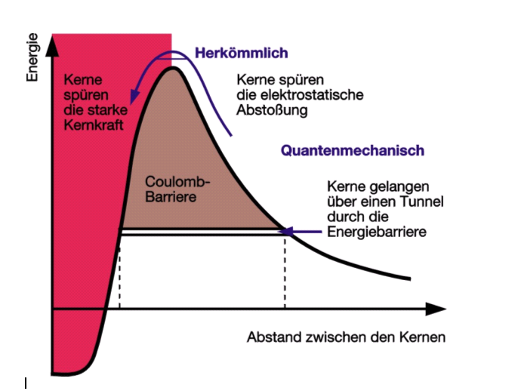
Fig. 1a: Binding energy versus atomic mass. One can see the large gain in binding energy between Hydrogen and Helium. | Fig. 1b: Coulomb barrier and area where the strong nuclear forces act. One can see that only part of the barrier has to be climbed in order to allow the tunnel effect.

In order to achieve fusion of light elements, such as Hydrogen to Helium, one has to overcome the Coulomb barrier to the point where the strong nuclear forces can act and a new element (e.g. He) is produced (Fig. 1b). In order to transverse the Coulomb barrier the two elements to be fused must have sufficient kinetic energy. However, the kinetic energy needed to go over the top of the coulomb barrier is very large and thus not reasonably achievable even not in our sun. The trick which nature provides is the quantum mechanical tunnel effect which provides a certain probability that nuclear particles can tunnel through the coulomb wall (Fig. 1b). This means that only a small percentage of collisions between Hydrogen isotopes will result in fusion reactions while the majority will just be elastic scattering. This is one of the reasons why it is not possible to use accelerators to shoot particles into each other in order to achieve a net fusion energy gain.

The means to provide the required kinetic energy together with a number of collisions per second which will result in enough fusion reactions to sustain the process and to obtain a net energy output is to confine a hot gas of Hydrogen isotopes in some kind of bottle. The temperature which is needed on earth to obtain these conditions is in the order of 100 million degrees or ~10 KeV average particle energy (in a Maxwell distribution) for magnetic fusion (see below) and somewhat less for inertial fusion. Magnetic- and inertial fusion describe the two possible “bottles” which can be used on earth and which can sustain the above extreme temperatures. The first one uses a magnetic field to confine the hot gas (see more details below), while the second one uses the inertia of a kinetic compression of a small Hydrogen pellet driven by fast evaporation of its surface. In this paper only magnetic fusion will be discussed because it is the basis of ITER and because in the opinion of the author it is the only reasonable way towards commercial fusion energy.

The fusion reactions which are achievable on earth with a possible net energy output can be seen in Fig.2, where it becomes immediately evident, that the reaction with the highest probability and with the lowest required temperature (kinetic energy) is the Deuterium (one proton + one neutron) – Tritium (one proton + two neutrons) to He₄ (two protons + two neutrons) + one neutron reaction. The energy of 17.5 MeV per fusion process in this reaction is distributed between the neutron and the He nucleus as 4/5 (14 MeV) and 1/5 (3.5 MeV), respectively. Thus the neutrons carry 4/5 of the energy. Due to the fact that neutrons have no electric charge and therefore are not confined by a magnetic field, they can exit the magnetic bottle. These neutrons will release most of their energy in a ~ 700 mm wide surrounding structure, called the blanket, by collisions resulting in a volumetric heat production there.

 | 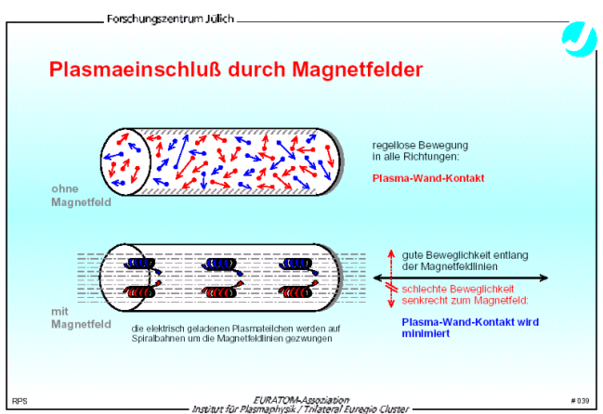
Fig. 2: Relative fusion power density versus plasma temperature in million degrees. It can be seen that the D-T reaction is the most promising fusion reaction to be achieved on earth. | Fig. 3: A hot plasma in a cylinder with and without magnetic field. A magnetic field confines the plasma to the fieldlines and thus isolates it from the cylinder walls.

However, one of the partners in the D-T reaction, namely Tritium, is a radioactive element with a half life time of 12 years and thus does not exist naturally on earth. Therefore Tritium (T) has to be produced by a nuclear reaction between a neutron and a Lithium nucleus resulting in He₄ and Tritium. Thus the neutrons produced in the above fusion reaction have a dual purpose, namely to produce T and to release their energy by collisions in the blanket structure (produce the heat to be transformed in usable energy, e.g. electricity). The hot gas confined in the magnetic bottle has therefore to be surrounded by a ~ 700 mm thick blanket structure which contains Li, where the neutrons exiting the magnetic bottle produce T and heat.

How can one confine a 100 Million degree hot gas, called a “plasma”. A plasma is the fourth state of matter because at this temperature the electrons (charge -) are separated from the nuclei (charge +, from now on called the ions) and thus form a mixture of two electrically charged gases (electrons and ions) mixed in such a way that the gas looks macroscopically neutral (otherwise electric fields would arise which would force quasi neutrality). The fact that the elements of the plasma (electrons and ions) are electrically charged, makes it possible to confine it in a magnetic field, because charged particles are bound to magnetic field lines around which they gyrate (Fig. 3). If one wants to bend the magnetic field into a torus, the fieldlines have to have a helical structure and a magnetic well (stellarator) or a vertical field (Tokamak) in order to confine the plasma. The helical fieldline structure averages out different drifts of electrons and ions in a non homogenous magnetic field, which would cause charge separation resulting in the generation of electric fields. A toroidal magnetic field and a vertical electric field would result in a radial force destroying the plasma confinement.

There are two ways of producing helical magnetic field structures which can confine a hot plasma:
- the stellarator where shaped coils produce a helical field with a magnetic well confining the plasma. Different stellarator configurations exist, of which some are very promising, but the development is not yet enough advanced to built a reactor class machine like ITER
- the tokamak where a toroidal magnetic field configuration is produced by coils plus a current (in the MA range) which is induced into the plasma by a transformer coil in the centre of the torus ( Fig. 4a). The magnetic field produced by the plasma current together with the toroidal field generated by the external coils result in a helical field structure. This is however not sufficient to confine a plasma because there is no magnetic well which prevents the plasma from expanding radially. Therefore an additional vertical field produced by so called poloidal field coils is required which keeps the plasma in the desired position. In a modern tokamak also other field components are produced by the poloidal field coil set. They shape the plasma, produce a divertor, and a radial field, which can control the vertical position of the plasma (see below for more details). The tokamak, a Russian invention at the end of the 60s, is far enough developed to be the basis for a reactor class machine and therefore ITER is a tokamak.

As already mentioned, a modern tokamak has a more complex magnetic configuration than shown in Fig. 4a. First of all the plasma cross section should be vertically elongated and bent in a kind of bean form (triangularity) as shown in Fig. 4b. Both shaping measures result in a higher shear of the magnetic fieldlines particularly at the plasma boundary and thus allow a plasma with high pressure to be contained by the magnetic bottle. In addition more current can be induced in an elongated- compared to a round plasma shape without causing MHD instabilities. Another important function of the poloidal field coils is the introduction of a divertor field, i.e. the nulling of the poloidal field in the so called X-point (Fig 4b) which creates an area at the plasma edge (outside a so called separatrix), where the magnetic fieldlines are no longer closed (going permanently around the torus in a helical pattern) but are “cut open” and end after ~1.5 toroidal turns in a separate chamber on the wall (divertor target). This divertor allows to concentrate the unavoidable plasma–wall interaction to take place separated from the hot plasma core and thus yields higher plasma edge temperatures which are important for good energy confinement. It also concentrates the plasma exhaust at the bottom of the machine where the He ash and other impurities can be easier removed. It would go too far for this paper to explain more details of the divertor physics which can be found in [1].

 | 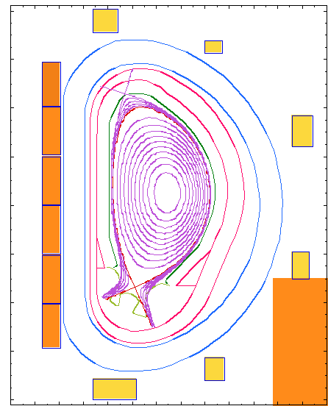
Fig. 4a: Principle of a tokamak. The toroidal field coils, the primary winding of the transformer in the centre (Central Solenoid) and the coils producing the vertical field can be seen. Also visible is the helical field structure in the plasma - the secondary winding of the transformer where a current is induced. | Fig. 4b: The cross section of a modern tokamak. The CS, the poloidal field coils and the shaped plasma can be seen. Also visible is the divertor at the bottom of the vessel.

As a last point in this introduction a brief explanation how a reactor class machine like ITER is sized and what are the driving parameters for this is given here. . The most important parameter which drives the size of a
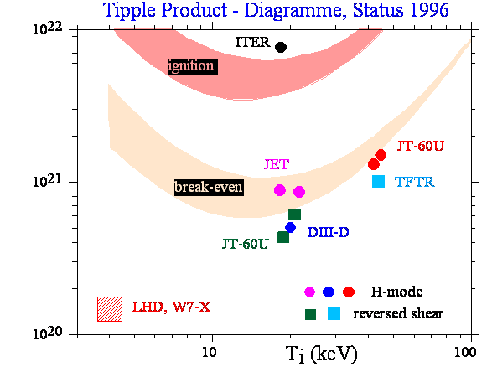 | reactor class machine is the energy confinement time in a magnetically confined plasma. The energy confinement time is the time in which the energy content of the plasma falls by 1/e and thus is a measure for the quality of the insulation which the magnetic field configuration provides. Energy and particle confinement in magnetically confined plasmas is not classical and also not “neo-classical” (a extension of classical physics for toroidal geometry) but is turbulent driven and thus much worse than based on classical physics.  The turbulence can be reduced by certain measures (e.g. plasma shaping, high plasma edge temperature, etc) and can even be suppressed in some areas of the plasma cross section, e.g. at the plasma edge in the so called H-mode by a combination of magnetic and electric field shear [2, 3]. In this brief explanation of machine sizing a scaling law for energy confinement derived from

Fig. 5: Tripple product diagram versus plasma temperature in keV. It can be seen that present day machines are about a factor of 10 away from the ignition domain.

experimental results will be used instead of turbulent physics in order to be simpler and to give the reader a feeling for the important parameters. The law for the energy confinement time is:

where R is the big radius of the machine (machine centre to plasma centre), I is the plasma current, P is the power used to heat the plasma to the required temperature, ε is the aspect ratio (ratio of R/a where a is the minor radius, i.e. the radius of the plasma) and κ is the elongation of the plasma.

In order to generate a commercially interesting net energy output, a plasma should be close to ignition meaning the energy of the He nuclei produced in the fusion reaction should be sufficient to keep the plasma temperature at the required 100 million degrees. The required parameters for this condition can be described by the so called triple product diagram as seen in Fig 5. The criterion for ignition says that the product of temperature (in keV), density (particles per m³) and confinement time (in sec) should be 6x10²¹ and the temperature has to be in the range of 10 to 20 keV.

Considering the required temperature and that the plasma density cannot be increased much above 10²⁰m⁻³ for instability reasons, an energy confinement time of ~ 6 sec has to be obtained in order to fulfil the above criterion. Considering the scaling law for energy confinement and some engineering rules (size needed for superconducting coils with a maximum field of ~ 12T at the coil, size of neutron shield (Vacuum Vessel and Blanket, etc) which are all imbedded in a so called system code, a machine with ~ 8 m major radius, 2.8 m minor radius and 5T on the plasma axis results. This machine would be ignited and produce ~ 3 GW of fusion power which would result in ~ 1.2 GW electricity production in case of a commercial reactor. In order to reduce the financial risk but nevertheless produce a reactor-relevant plasma a machine with 10 times the fusion to plasma heating power can be also considered. This type of machine would be only self heated by 2/3 and needs therefore some additional heating from outside but would provide all the answers required for half the cost. This type of machine has a major radius of 6.2 m, a minor radius of 2 m and a field of 5.5 T on axis and is the basis for the ITER design.

More information on the fusion basics and also some history can be found in [4]. More details on the layout of ITER as well as plasma wall interaction issues can be found in [5, 6]. The following part of the paper is to a large extend based on a paper given at the conference of the Kerntechnische Gesellschaft [7] in Düsseldorf in 2004, but was updated to contain the latest developments. However, due to the fact that the ITER process during the last few years was dominated by negotiations, no substantial changes happened in the technical field during this period.

The Path to Fusion Energy beyond ITER:

Before the ITER machine itself is described in more detail a brief description of how ITER is embedded in the rest of the program which has the aim to produce commercial fusion energy in ~ 30 to 40 years from now is given.
On May 24th 2006, the worldwide fusion energy research, in particular the seven nations (parties) who participate in the ITER project (EU, JA, RF, US, KO, CHINA, IN), have taken the crucial step towards a commercial fusion reactor, namely the decision to construct ITER. As already mentioned above the ITER machine [8] is a reactor class fusion device which is the most important element on the way to commercial fusion energy. However, as discussed in various publications, e.g. [9], ITER alone will not be sufficient to gain all the knowledge required for a commercial fusion reactor. Other elements like

Fig. 6: Road Map towards commercial fusion energy. The three major elements of research illustrated in the above figure, namely a physics program, a major facility program (ITER, IFMIF) and a fusion technology programme, have to be performed in parallel in order to generate the knowledge required for the construction of DEMO in 2025.

suitable structural materials, a He cooled breeding blankets, a He cooled divertor as well as High Temperature Superconducting coils are also essential elements to be developed before a commercial fusion reactor can be built. In addition, the conservative physics performance on which the ITER design is based, needs to be superseded in a fusion reactor. Judging from the results from existing fusion experiments gained over the last years, this seems achievable and is in fact one of the aims of the ITER research program. Therefore the anticipated successful integration of reactor physics and technology in ITER as well as the parallel development of breeding blankets and suitable structural materials will be the basis for the design and construction of a commercial demonstration reactor “DEMO” around 2025 (“Fast Track”). The operation of “DEMO” could then start around 2035 allowing commercial fusion power on a large scale to start around 2045. Figure 1 shows the roadmap to fusion energy consisting of several elements which are needed to develop the knowledge required for a commercial fusion reactor, namely:
- A plasma physics program using existing machines of the tokamak type (e.g. ASDEX-UP, JET, DIII-D, C-mod, JT60U, etc.) as well as machines studying an alternative magnetic confinement concept (e.g. Stellarators such as LHD, W7X etc).
    - A new, so called satellite machine to ITER, i.e. a large superconducting tokamak, must be constructed as a successor to JET which can help to develop plasma scenarios for ITER (e.g. JT60-SC or NCT planned in Japan).
- A major facilities program
    - ITER as the most important next step.
    - IFMIF, an International Fusion Materials Irradiation Facility, aimed at qualifying structural materials for DEMO with 14 MeV neutron irradiation at DEMO relevant dose rates.
    - An extended performance phase in ITER (around 2022) in order to test “in vessel components” (blanket, divertor) under conditions as close as possible to a reactor. This would require the installation of a full breeding blanket in ITER allowing a higher fluency and thus component tests in a 14 MeV neutron environment, albeit at a relatively low dose compared to a fusion reactor.
- A Fusion technology program which consists of three components:
    - A DEMO design team which produces a few conceptual but comprehensive design options for DEMO, which are the basis for a focused fusion technology development program (see next two items). Around 2015, the results of the fusion technology program together with advances in the physics understanding could then allow the focusing of the different options to one. In 2020, this option could be further improved based on the results from ITER and the technology program, allowing the start of a detailed design and the construction of DEMO around 2025.
    - Based on the above mentioned DEMO design, those technologies already used in ITER (i.e. the ITER relevant technologies such as SC-magnets, fuelling systems, high heat flux (HHF) components, remote maintenance, reactor relevant steady state plasma heating systems, etc) have to be advanced further for DEMO (e.g development of high temperature SC-magnets), regardless of the fact that they are already available for the construction of ITER.
    - Also based on the above mentioned DEMO design a fusion power technology program has to be pursued including the development of breeding blankets, of tritium extraction from the breeding blankets, of a He cooled divertor and, above all, of structural materials for the “in vessel components”, which are low activation and can withstand the intense 14 MeV neutron bombardment with acceptable mechanical properties.

All the above mentioned elements together are imbedded in the so called “Broader Approach to Fusion Energy” and have been agreed between the EU and JA in a supplementary agreement together with the ITER agreement. This will allow the Fast Track outlined in figure 6 to be realised and will result in commercial fusion power being available well before 2050.

As already stated, ITER is the most important element on this development path towards commercial fusion energy. The detailed design of ITER was started in 1992 resulting in a ignition machine as described in the introduction, however, in 1998 a redesign took place aimed at reduced size and cost. A final design report for the reduced size ITER machine was delivered in 2001 [8] allowing the start of construction negotiations between the participating parties. The construction agreement will be in place end of 2006 or latest at the beginning of 2007 when all the ITER parties will have ratified it.

Regardless of the extensive preparation during the design phase, where the ITER design was underpinned with a comprehensive R&D program, the construction of ITER remains a challenge, albeit a manageable challenge. In particular the step from R&D to a kind of serial production (within a given timeframe and with a continuous high quality), where many of the large components are manufactured by different ITER parties and where some of the components need to be licensed (similar to a nuclear license), will be a challenge for the ITER team, the domestic agencies and industry in each party, as well as for the participating laboratories.

In the following sections the ITER physics goals as well as the foreseen technology will be discussed. In particular an overview of the ITER design, of the major R&D projects and results as well as a short outlook towards the challenges ahead during ITER construction will be given.

ITER Physics Basis and ITER Physics Goals:

The ITER design is based on relatively conservative physics requirements [10] in order to ensure that the predicted performance in inductive operation (Fig.7) of Q = 10 (Q being the ratio of Fusion power to plasma heating power) can be achieved [11] (Fig.8). For any next step machine like ITER the achievement of Q = 10 is essential, because only then α particle heating dominates (Q = 10 means 2/3 α particle heating, i.e. self heating, and 1/3 external heating). A performance below Q = 10 would thus not allow to examine the behaviour of a reactor plasma. Besides the inductive performance (plasma current driven by the transformer, i.e. pulse length limited to 400 sec) ITER should also demonstrate stationary discharges at Q = 5 [10], i.e. discharges with non inductively driven current. In these discharges, which are called “Advanced Tokamak Discharges”, the plasma current consists of ~ 70% bootstrap current (driven by pressure gradients in the plasma) and a smaller part of the current (~ 30%, driven by external sources, i.e. heating and current drive systems).

External current drive is very expensive because the current drive efficiency is rather low (< 0.03 MA/MW) and thus a lot of the applied power is dissipated as plasma heating or inside the current drive system itself. Therefore, the ongoing plasma physics development with the aim to increase bootstrap current and energy confinement is very active and has shown significant success during the last years [12, 13]. By shaping the current profile inside the plasma towards a flat or even a hollow current distribution (Fig. 9) in the plasma core region by external current drive aligned with the bootstrap current, improved energy and particle confinement can be achieved. This higher confinement in turn yields an increase of the internal pressure gradient, resulting in higher bootstrap currents and thus more self driven current.

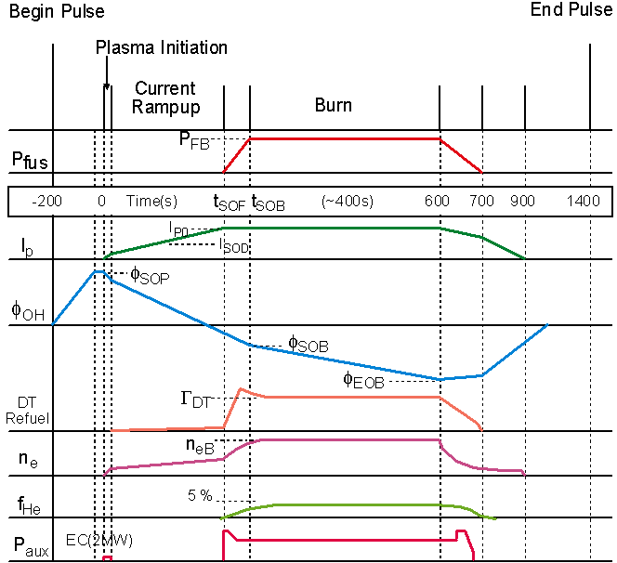 | 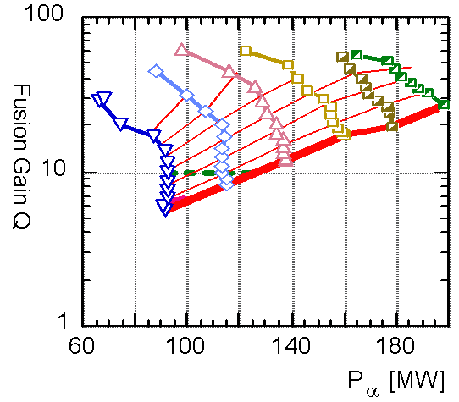
Fig. 7: Typical example of an inductive tokamak pulse. The curve labelled “OH” shows the transformer current, the curve labled I_{p} is the plasma current, other curves are: fusion power (P_{fuss}), density (n_{e}), external heating power (P_{aux}), etc. | Fig. 8: Predicted operation space (α heating power versus Q) using an integrated plasma model for inductive discharges in ITER. One can see that ITER will most likely exceed Q = 10 in a large part of its operation space.

If the current density profile is flat or slightly hollow (Fig 9) in the inner region of the plasma, the magnetic shear, i.e. the poloidal angle between neighbouring helical field lines, is small or even negative. In such a case the electron confinement is improved because of, among others, the reduced number of rational magnetic surfaces in close proximity. This in turn allows higher pressure gradients, which not only yield higher energy confinement and bootstrap currents, but also produce a radial electric field. This radial electric field is able to reduce ion turbulent transport by velocity shear (radial electric field together with the toroidal magnetic field produces a poloidal force and thus poloidal rotation of the plasma). Thus both transport channels, ions and electrons are improved in the above describe hybrid discharges, and also in other forms of Advanced Tokamak Discharges. In all these discharges so called internal transport barriers (ITB) develop spontaneously due to the reduction of turbulent energy and particle transport.

Either strong transport barriers with large but very localised pressure gradients develop, or an improvement of confinement over a significant part of the plasma radius. The latter type is probably caused by an increased magnetic shear in the plasma edge and thus a larger H-mode pedestal yielding an improved confinement in the core plasma and thus an increased pressure gradient over a large fraction of the plasma. This type of discharge is the basis for the above mentioned hybrid regime allowing long pulses (significant bootstrap current fraction of ~ 60%) and high performance (high fusion power and high fusion gain Q; Fig. 10) to be achieved in ITER. These discharges are therefore very promising regimes for the ITER high performance operation. Due to the higher external heating power (current drive) in the steady state discharges when compared to the inductive ones, the fusion gain in these discharges will be smaller (> Q = 5) but the fusion power in all of the above mentioned discharge types will be similar and will be in the order of 500 MW with a neutron wall loading in the order of 0.6 to 0.9 MWm⁻².

The family of “Advanced Tokamak Discharges” briefly described above is the basis for steady state operation of ITER and a future reactor. If the predicted conservative ITER plasma performance outlined above is compared with the one needed in a commercial fusion reactor, ITER’s performance has to improve in order to support the construction of a commercial tokamak type DEMO reactor in 2025, i.e. to support the Fast Track. Over the last years the fusion physics program has made significant progress in developing “Advanced Tokamak Discharges” and among those in particular very promising hybrid discharges [12,13].

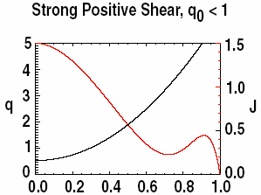  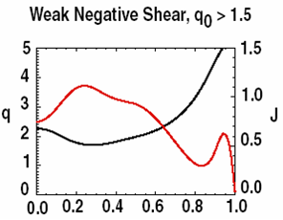 | 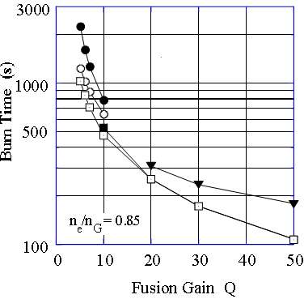
Fig. 9: The current density profiles (red) and the q profiles (black) for an inductive discharge (top) and an advanced tokamak discharge (bottom) versus the normalised plasma radius. As one can see, the current profile is hollow in the bottom picture labelled weak negative shear. The shear is the rate of change of the magnetic fieldline angle with increasing radius and is related to the q profile (q is 1/ the number of poloidal turns of a fieldline in one toroidal turn). | Fig. 10: Several curves representing the predicted pulse length of ITER discharges versus the fusion gain Q. One can see that when approaching Q = 5 the lines become almost vertical and thus the discharges become almost steady state. The predictions shown here are most likely conservative, because over the last years very promising results were observed on existing machines [12,13] which should transform into significantly better results in ITER, i.e higher fusion gain and fusion power in long pulses (> 1000 sec) or even in steady state.

.

If these recent developments would be directly extrapolated to ITER, the fusion gain and the fusion power in ITER during long pulses and in steady state could reach Q = 10 and up to ~ 800 MW fusion power, i.e. a DEMO relevant performance. Therefore, a fast track towards fusion energy seems feasible. However, more experiments on existing machines together with validated models for extrapolation are needed to firm up these extrapolations which at present have large error bars.

ITER Design and Technology R&D:

The development of the knowledge enabling mankind to design ITER has a long history. Already in the eighties conceptual designs of possible next step machines where started aiming at producing a reactor relevant plasma. It turned out very quickly that the development of several new technologies is required for such a project (e.g. superconducting coils with the relevant field and current density, high heatflux components, remote maintenance, etc.). These technologies were investigated in a base fusion technology program in all countries which later became ITER parties albeit with different intensity. When the international ITER Engineering Design Activity (ITER-EDA) was started by Europe, Japan, Russia and the United States in 1992, it became clear that the basic knowledge in many of the required technologies did exist, but in most cases only rudimentarily. However, to build a machine like ITER, significant technological advances were required. An additional difficulty was that only little new money was allocated for developing these technologies. Most of the development should be performed by utilising the existing fusion technology programs and reorienting them towards the ITER needs.

To this end, an international team of 160 scientists and engineers was established within 2 years after the start of the EDA, working at three sites (Garching – EU, San Diego – US and Naka- JA). Regardless of the initial difficulties arising from these three sites and different nationalities, soon an integrated team started to reorient the worldwide fusion technology and fusion physics program towards the ITER needs and to define the R&D projects to be performed in support of the ITER design.

The strategy was to underpin the design of the most challenging major machine components by 7 large R&D projects in full or representative size (CS- and TF-magnets, Vacuum Vessel, Blanket, Divertor, Remote Maintenance for Blanket and Divertor) accompanied by a large number of preparatory and small-scale R&D. In addition, R&D was also performed for other large components and systems, e.g. for the fuel cycle. While most results were available in 2001 when the final design report was written, further results of this large worldwide program became available until recently, allowing a further optimisation of the design. Starting from 1998 onwards the ITER design team decreased again and was finally shrunk to ~ 1/3 of the original strength after the design was finalised in 2001 (smaller ITER). The aim of the present ITER International Team during the last two years was to keep the ITER design coherent during the negotiation period, to conserve the know-how achieved for ITER construction and to further improve the design in terms of cost and reliability based on the R&D results. The following paragraphs briefly describe the main components of ITER and the R&D performed.

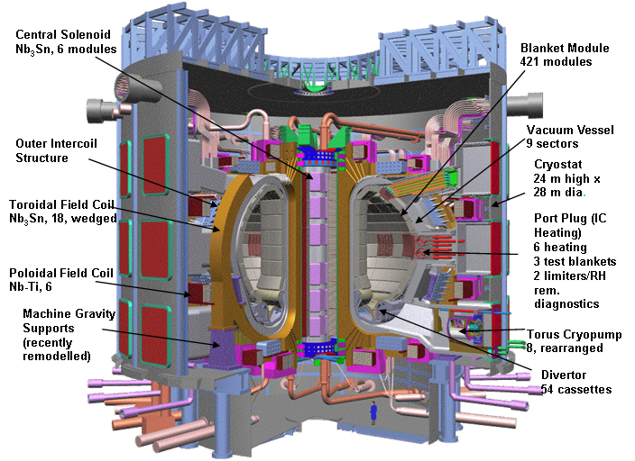

Fig. 11: A cut through the ITER machine and the cryostat, all the main components are labelled in the figure.

In this paper only the design of the tokamak itself and the major components is given. The buildings and the more standard technology of the balance of plant (e.g. heat transfer systems, cryo plants, etc) will not be discussed. In Fig. 11 a cut through the ITER machine and its cryostat can be seen with the location of the main components indicated. As shown in Fig. 11, the whole ITER machine is situated inside a cryostat which is under vacuum. Inside this cryostat a geometrically complex thermal shield (not shown in Fig. 11) protects all superconducting magnets (which are at a temperature of 4.5K) from too high thermal radiation input. One of the two large thermals shields is situated in a small gap (~ 70 mm) between the vacuum vessel and the toroidal field coils, the other shield is located outside the superconducting magnets (Fig. 11). These shields consist of several layers of thin metal cooled by 80K He. They are constructed in such a way that there are no gaps left which would allow thermal radiation originating from the room temperature cryostat wall or from the up to 200°C hot vacuum vessel to reach the superconducting magnets which are at 4.5K.

The cryostat itself consists of a ripped cylindrical wall structure able to withstand the atmospheric pressure of 0.1 MPa and of a lid supported by a bridge like grid structure again for withstanding the pressure of 0.1 MPA. The cryostat floor is supported by the building. The cryostat is permanently under high vacuum and is thus only vented if repairs on systems inside the cryostat are required. The high vacuum which is initially generated by large pumps is then maintained and further improved by the magnets which are at 4.5K and thus constitute very large cryo pumps.

The magnet assembly which is located between the two thermal shields mentioned above is the backbone of the ITER machine. It consists of the toroidal field magnets with its massive inter coil structures which are the mechanical backbone of the machine, the poloidal field magnets needed for plasma shaping and plasma position control and finally the central solenoid required to initiate and sustain the current in the plasma. The development of these superconducting coils was one of the most challenging jobs to be performed during the ITER EDA. Superconducting magnets of this size and performance in terms of current density and magnetic field did not exist prior to the ITER development program. For these coils a new type of superconducting cable had to be developed. Two types of these cables using Nb₃Sn superconductors had to be built, namely one with a thick rectangular jacket (Fig. 12; for the central solenoid – CS) and one with a thin cylindrical jacket (for the Toroidal Field Coils – TF).

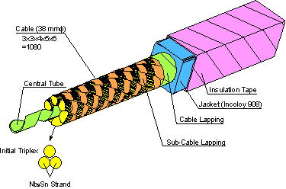

Fig. 12: Superconducting cable for the central solenoid. The central He channel and the helical structure of the superconducting sub-cables containing the strands can be seen.

The jacket material consists of stainless steel. The superconducting cables itself consist of thin strands of Nb3Sn and Cu twisted in a helical form around a central He cooling channel (Fig. 12). This central channel consists only of an open steel tape which allows Helium to flow also sideways through the conductor itself. A difficulty with Nb₃Sn superconductors is that once the NbSn₃ has been formed, it is brittle and cannot be wound into a coil anymore. Thus during manufacturing of the CS and TF magnets the cables have to be wound, then reacted at ~ 800°C, then taken out of the winding bed again to insulate the cable by epoxy stripes and finally put back again into their winding beds.

Both types of magnets (CS and TF) have to withstand very large forces on their superconducting cables and the whole magnet body. Due to these large forcesdesign measures had to be taken. An example of these forces is the radial force of 35000 tonnes exerted onto each TF magnet when the full field is switched on, which has to be taken by the coil housings through a wedge and shear keys. Of course this force originates in each conductor inside the TF coils and, if unmitigated, some conductors would see tremendous forces at their ground insulation. Therefore groves for the superconducting cables have been cut into the steel plates which are inside the very strong and thick coil housing of the TF magnets. Thus only the force of each cable itself is seen by the insulation, while the accumulated forces of the other conductors are channelled through the steel plates into the coil housing. Due to this construction the TF magnets consist mainly of stainless steel and weigh 380 tonnes each.

The test of a scaled down TF model coil in the TOSKA facility of FZK during 2002 and 2003 demonstrated the performance required for ITER [14]. In these experiments an 80 kA current was run through the coils with a background field of 10.8 T at the conductor, supported by a second prototypical coil which was produced during the 1980s for the so called large coil project. The current exceeded the one needed for ITER and the whole experiment demonstrated the successful development of the TF coils for ITER.

The CS coil prototype was manufactured by several ITER parties, namely the RF, EU, US and JA, with the US and JA having the lead and performing most of the work. This model coil was also produced and tested very successfully [15]. These two out of seven major R&D tasks demonstrated that the magnet design and the technological basis which also involved a large number of high tech industries throughout the world are ready for ITER construction.

Inside the TF coils and inside the inner thermal shield, described above, there are the vacuum vessel and the in-vessel components (blanket, port plugs and divertor). Figure 13 shows the vacuum vessel and the in-vessel assembly with the blanket modules (450 modules, ~ 4.5 tonnes each) mounted on the vacuum vessel and the divertor (on the bottom) consisting of 54 cassettes. Also shown are the equatorial ports and top ports which are used to get access to the plasma for diagnostic and heating systems as well as for test blanket modules aimed at developing tritium breeding. All the ports are filled with so called port plugs which weigh ~25 tonnes each in the top ports and ~50 tonnes each in the equatorial ports, respectively. The access to the plasma is realized through labyrinths inside these port plugs for neutron shielding purposes. The main purpose of the in vessel components is to shield the vacuum vessel from too high fast neutron irradiation (> 2.2 MeV) in order to control He production inside the steel. An additional function is the reduction of neutron irradiation in combination with the vacuum vessel to sufficiently low levels that the activation inside the cryostat allows short emergency human intervention (neutron flux inside the cryostat ~10⁸ neutrons sec⁻¹ m⁻² during discharges). Another critical factor is the heat load deposited inside the superconducting coils by the neutrons which must remain below ~15 kW. Besides these shielding functions the in vessel components must accept large heat loads from the neutrons (in the volume) and from electromagnetic radiation originating in the plasma as well as from direct plasma contact (mainly the divertor, see also below). In the following paragraphs a brief description of the different in vessel components will be given.
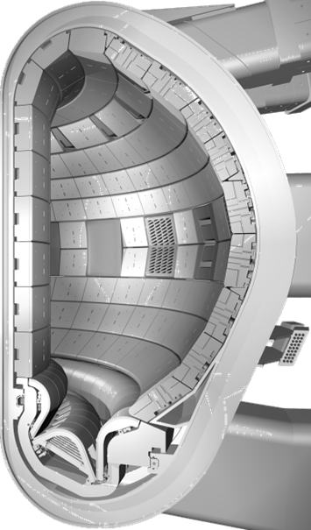 | 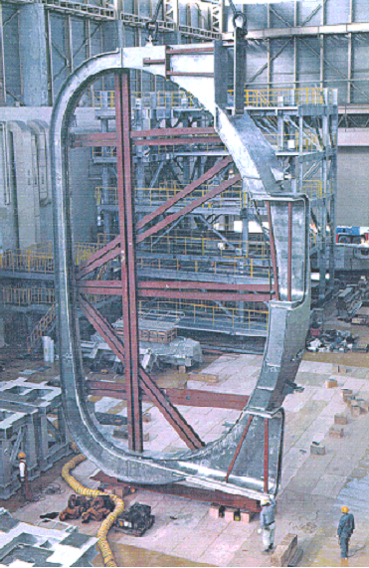 | The vacuum vessel has several very important functions, among others to provide a high quality vacuum. It is the first barrier for radioactive material, the second barrier to separate air from potential sources of hydrogen, it has to be able to remove the decay heat of all in vessel components in cases of a loss of coolant and it has to provide an efficient radiation shielding. In addition, it has also an important structural function because electromagnetic loads during abnormal operation conditions (disruptions, i.e. when the plasma current decays within 50 ms) on the in vessel components have to be ultimately taken by the vacuum vessel. In particular large vertical (> 10000 tonnes) and horizontal loads (> 3000 tonnes) can occur. The vessel is made of two shells consisting of 60 mm thick stainless steel plates and structural rips in between. The rest of the volume between the rips is filled with steel shielding plates enriched with boron.  In certain areas these shielding plates
Fig. 13: The vacuum vessel and the in vessel components (blanket and divertor). The blanket modules are mounted on the vacuum vessel and are supplied by water manifolds also mounted on the vacuum vessel. Also shown are the equatorial and top port plugs for diagnostic and heating system access. | Fig. 14: ½ of a vacuum vessel segment produced in Japan. This R&D was performed for the larger ITER machine but the technology remains of course valid for the present design. The tolerances after assembly of the whole vessel must not exceed 25 mm.

are from ferromagnetic material, in order to help to reduce the magnetic field ripple (produced by the discrete TF coils) which would cause enhanced fast plasma particle losses. Figure 14 shows a prototypical vacuum vessel segment manufactured in Japan for the larger version of ITER [16]. During this manufacturing R&D the tight tolerances and the automatic welding and cutting of neighbouring segments was demonstrated.

The neutron heat load into the vacuum vessel is very moderate, requiring only slow flowing water between the shielding and structural rips for cooling. In fact, natural convection is sufficient to cool the decay heat of all in vessel components and of the vacuum vessel itself if the cooling fails. In these cases the heat transfer from the in-vessel components to the vacuum vessel is performed by radiation only. Thus when no action is taken for many days, the temperature of the in vessel components would peak at ~ 500°C within a week, a temperature not compromising the mechanical properties of stainless steel.

The vacuum vessel has 3 levels of ports, one at the top, one at the equatorial plane and one at the divertor level. These ports and the port extensions partially have a similar double wall structure as the vessel itself in order to support the large electromagnetic forces which can occur during off normal operation conditions. While at the top and equatorial level there are 18 ports, only half this number of large ports exists at the divertor level. However, small openings to supply water to the divertor are present also in the location where no large port exists. The ports are either closed by a port plug (top and equatorial planes) or by large port flanges (divertor).

The blanket consists of 450 modules, each approximately 2 m x 1 m x 0.45 m with a weight of ~ 4.5 tonnes. The main purpose of the ITER shielding blanket is to absorb the majority of the fusion power transported by neutrons and thus to provide adequate shielding for the vacuum vessel and the coils. In a future reactor, the blanket will also have to breed tritium by a nuclear reaction between Li and the 14 MeV fusion neutrons. However, in the first ITER operation phase the use up of tritium is small enough to be supplied from the Canadian Candu reactors. Nevertheless, tritium breeding will be tested by test blanket modules mounted in three equatorial ports in order to further develop different breeding techniques and to eventually decide on the type of blanket to be used in a DEMO reactor. In addition, in a later operation phase (extended performance phase) ITER may need a breeding blanket. This would be the case if the physics program is very successful and frequent long pulses with high fusion power become possible. In this case, the tritium from external sources would not be sufficient anymore. A breeding blanket for ITER would be different from an optimum breeding blanket for DEMO because it has to be water cooled. This type of blanket will also be developed with the support of the test blanket module locations in the ITER equatorial ports.

The shielding blanket to be installed initially consist of a stainless steel box with radial water cooling channels and removable first wall panels which can be mounted and dismantled in the hot cell. This allows the repair of a damaged first wall and the re-use of the blanket box itself which will reduce radioactive waste. The blanket will be attached to the vacuum vessel by four flexibles, where the blanket box is bolted through a 30 mm diameter front side access hole to this flexible support. However, this is not the only mechanical support required. Due to the large eddy currents induced in the blanket modules during disruptions (when the plasma current decays within ~ 50 ms), large torques are induced by the interaction of the eddy currents with the toroidal magnetic field. These forces can not be withstood by the flexibles but need an additional support by large keys which are mounted on the vacuum vessel (at the outboard) and which do not allow any rotation of the blanket module. These keys are also used to position the modules in order that the flexibles do not see sideward loads in a particular direction by gravity. The electromagentic forces are in the > 100 MNm range and are in principle short circuited between two modules. A design option which is utilised at the inner wall, where forces are highest, is to mount these keys on the blanket modules and thus short circuit the forces directly between neighbouring modules without stressing the vacuum vessel. Further investigations and tests have to show if the accumulation of tolerances in such a connected row of modules allows to maintain the required tight gaps between the keys and the modules.

The water connection of the blanket modules to the manifolds is also performed from the front through 30 mm holes by welding and cutting with Yag lasers. In addition, two electrical connections capable of transporting the large currents in those cases where the plasma leans on the first wall are also fixed by front access. This occurs in abnormal operation conditions causing a part of the plasma current to flow as a so called “halo current” through the structures of the machine. Also in this case large forces are generated which can be expressed as a pressure onto the blanket module of up to 200 MPa to be taken by the flexibles.

The blanket segmentation is complicated by the port openings and by the fact that for remote maintenance the modules must weigh less than 4.5 tonnes. At the same time there must be enough space for all the attachments, thus the modules have only a limited flexibility concerning their size.

The plasma facing first wall of the blanket consists of up to 6 first wall panels, with a stainless steel body, mounted on the blanket boxes in the hot cell. The first wall has to withstand up to 0.5 MWm⁻² of electromagnetic irradiation in steady state and significantly larger heat loads as the ones already mentioned above for short times (60 MJ within 3 sec) in abnormal operation conditions. The first wall consists of a dense array of 10 mm diameter, 1 mm wall thickness stainless steel tubes embedded into a Cu matrix by hipping [17]. The plasma facing material also hipped to this Cu matrix is 10 mm thick castellated Be.

The divertor is the component located on the bottom of the machine and receives the highest peak heat fluxes of all components, namely up to 20 MWm⁻². As already mentioned the magnetic configuration of the divertor is generated by a special field configuration, where the poloidal coils are run in such a way, that the normally helical trace of the field lines around the machine is cut open at the boundary of the plasma and the field lines outside the so called separatrix are guided in approximately 1.5 toroidal turns down into a separate chamber, namely the divertor chamber. The aim is to localise the inevitable plasma wall interaction at a position away from the main plasma in order to reduce impurity contamination of the main plasma and to keep the plasma edge hot. All the energy created by the α particle heating and by heating the plasma from outside finally has to be absorbed by the first walls of the machine. While the blanket receives to a large extend only electromagnetic radiation loads distributed over its large surface of ~ 1000 m², the plasma interaction in the divertor is relatively localised (60% of the heat are deposited inside 10 m²). Due to the fact that only 30% to 40% are radiated onto the blanket first wall, ~ 60% of the power deposited into the plasma will end up in the divertor.

When plasma particles hit the divertor walls, they are neutralised, then re-enter the plasma and get ionised and exited again producing electromagnetic radiation which can spread the power in the divertor to a certain extent. This process causes also a high neutral density to occur inside the divertor chamber and is called the “high recycling regime” [1]. It allows relatively efficient pumping of the neutral gases, in particular of the He ash produced by the fusion process. Without being able to pump He, the plasma would be slowly poisoned and the fusion power would vanish after a relatively short while. In summary, considering the number of conditions to be met by the design (namely the high heat load and the plasma bombardment causing erosion of the divertor targets and at the same time providing efficient pumping), the divertor design was a difficult challenge.

The divertor consists of 54 cassette bodies made from stainless steel which form its structural backbone and distribute the coolant to the three different target modules in each cassette (Fig. 15). The cassette solution was mandatory because in contrast to the blanket no access holes can be permitted due to the large heatloads present in the divertor. Thus the cassettes are removed and installed by machines running on rails, which are also the mounting points for the cassettes during operation.
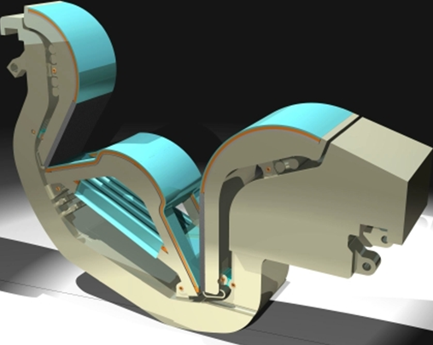 | 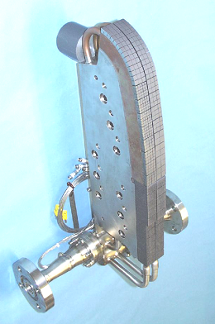 | The targets itself also have a steel backbone onto which the high heatflux capable heatsinks are mounted. The strong steel structures are required to withstand the electromagnetic loads already mentioned above. In the lower part of the vertical targets, a peak heat load of up to 20 MWm⁻² can occur while the normal peak heatflux is in the order of 10 MWm⁻². In the highest loaded area CFC monoblocks are mounted on a coaxial tube with helical turbulence promoters (swirl tubes). These CFC monoblocks are mounted by a technique called active metal casting, where groves are curved into the CFC surface inside the drilled hole by lasers, then Cu is
Fig. 15: Divertor cassette. Shown are the cassette body and the three target plates, namely the inner vertical target, the dome structure and the outer vertical target. The dome structure has large openings for neutral gas flowing from the inner to the outer target. It also has lamellas allowing pumping into the bottom of the dome. | Fig. 16: A medium scale mock up produced for testing the high heat flux components. CFC and W are used. This mock up withstood successfully 2000 pulses at 20 MWm-2 on the CFC part and 18 MWm-2 on the W-cladded part.

cast into the hole and drilled open again. This results in a Cu surface with a strong binding to the CFC through the groves mentioned above. In the next step, the CFC monoblocks prepared in this way are braced or hipped onto the CuCrZr tubes. At the upper end, the tubes transit into a rectangular CuCrZr block which does not need the turbulence promoter anymore because the heatflux at the upper end is only in the order of 1 to 3 MWm⁻². Onto this heatsink WLaO₂ is braced in the form of 4 mm square and 5 mm high cubes (Fig. 16). This arrangement is called a macrobrush. The CFC part of this arrangement is then mounted in a rail on the stainless steel target body while the curved CuCrZr rectangular block with the W is electron beam welded to the steel backbone. After finishing the targets in this way they are attached to the cassette body mechanically by a riveting system allowing some freedom for expansion but at the same time being rigid enough to withstand the electromagnetic forces.

The development of the above described high heatflux components was supported by an extensive R&D performed in the EU [18], JA and RF and to some extend also in the United States. An example of a successfully tested medium scale mock up is shown in figure 16. In the meanwhile also larger mock ups were tested and the development of a full W target was advanced in the area of high heatfluxes too. Certainly more R&D will be required, in particular to improve reliability and reproducibility in a series type manufacturing process during ITER construction in order to ensure reliable operation of this highly stressed component.

Remote maintenance is essential for reactor relevant fusion machines like ITER. Already after a few DD discharges and in particular after only one single DT discharge of a few hundred seconds duration, the machine will be so highly activated that no human being can enter the in vessel area. Therefore remote maintenance is required for all in vessel components including the port plugs. Due to the high activation of these components they have to be also remotely repaired in a hot cell. In order to avoid contamination with tritium and radioactive dust, all remote maintenance activities are based on casks (approximately 8.5 m long, 3.5 m wide and 4 m high). These large 20 tonnes devices which run on air cushions are docking onto the vacuum vessel ports. They are the platforms for specialised machines which pull out the port plugs or are the platforms for machines to enter the vessel itself. Once a component is stored inside the cask, a double door is closed, where one part of the door remains on the vacuum vessel port and one on the cask (with clean uncontaminated surfaces at the outside). The cask then moves to the hot cell, where the component is unloaded. In this paper only the remote maintenance of the divertor and of the blanket will be briefly explained and not the maintenance of other components such as port plugs, cryo pumps, etc.

As already mentioned, the divertor system is based on cassettes which are mounted on two strong rails. The rails are also used for the remote maintenance machines. The water cooling is supplied through radial pipes where always 3 cassettes are supplied by one divertor port (i.e. 6 pipes per port). The divertor maintenance is performed by opening three ports and inserting a tool (radial mover) which removes two cassettes, namely the one in front of the port and the neighbouring one on the left side. Then a second machine is introduced (the toroidal mover) which has the shape of a cassette body and can move the cassettes along the rail to the open remote handling port where the radial mover removes them from the vessel. Due to the fact that many installation actions are possible in parallel, the full replacement of a divertor takes less than 3 month, a time almost satisfactory for a fusion reactor where availability has to be maximised.

All divertor installation and maintenance operations were tested extensively in a remote maintenance platform in Brasimone, Italy, which is one of the large R&D tasks performed for maintenance [19]. This platform was built for the large ITER machine where each cassette weighs 25 tonnes, while the cassettes in the present design weigh only ~ 10 tonnes. The tests in normal and abnormal operation conditions were very successful. The system worked reliably from the very beginning and only small modifications were required to validate the design. However, in the present ITER design some changes have been made which have to be tested with a modified mock up in the near future (to be performed in a new platform in Finland), in order that the remote maintenance system is ready for in vessel component installation around 2014.

The remote maintenance of the blanket is more difficult than the one for the divertor because it has to be performed in 3-D. The solution found was to install a rail in the centre of the plasma chamber (Fig. 17) and to have up to 4 vehicles running on it which are able to grip blanket modules, to dismantle their mechanical, electrical and water connections and to transport them to two ports, where a transport platform takes the modules out into a remote handling cask. A difficult task is the installation of the rail, which has to be delivered to the different ports in pieces and then assembled automatically. This installation process is briefly described below.

The rail is supported at four points once it is installed (Fig. 17). During the installation process the corresponding four ports are opened and an installation machine, which is delivered in two parts, is mounted into each of these ports. Two of the ports are foreseen to receive all the parts of the rail for installation, while the other two ports are only foreseen for supporting the rail during installation and later during operation. For the installation, the rail is divided into hinged segments which are connected inside a special cask mounted in front of the two installation ports.

The installation machines which are mounted inside the ports have a long swing arm onto which one of the gripping machines, which will later perform the handling of blankets, is mounted. The gripping machines with two rail segments each are moved into the vacuum vessel centre by the swing arm at the start of rail installation. The gripping machines are now able to pull the rail forward with the same mechanism (rack and pinion) which they need to travel along the rail later. One hinged rail segment after the other is added inside the special installation cask and pulled forward by the gripping machine on the swing arm. Once a hinged rail segment enters a gripping machine, a bolting mechanism closes a large claw inside the rail and thus transforms the two hinged parts into a stiff structure. This process continues and thus more and more of the rail is shifted along the toroidal axis of the machine. After a quarter turn around the vacuum vessel, this rail meets the next support
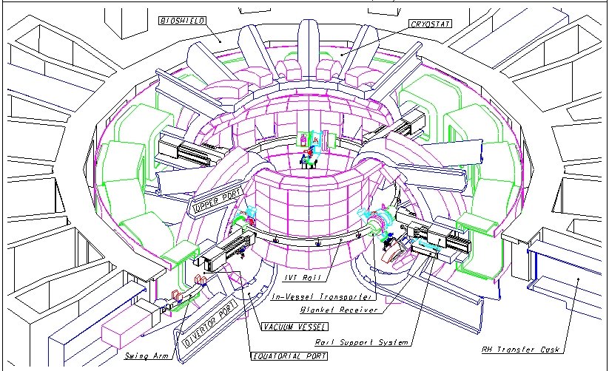 | which is also one of the gripping machines which helps to pull the rail further. Finally the circle is closed and the whole rail is supported by the installation arms and the gripping machines. The gripping machines are now released and the installation arms removed. In the location where the installation arms were, the blanket transport platforms are installed and the remote maintenance of the blanket can start.  As in the case of the divertor remote maintenance, a large R&D project was constructed in Japan in order to proof the feasibility of this concept [19]. Again the blanket remote handling platform was actually built for the larger ITER and will be somewhat simpler for the reduced size. Nevertheless, it worked well and showed that the blanket remote maintenance is doable. However, as for the divertor system, several

Fig. 17: Blanket remote maintenance system. It is based on a rail which is installed by the machines which are later running on it. Up to 4 machines can work simultaneously. The four locking supports can be also seen.

detailed improvements are required in the future to make the system reliable and to simplify as much as possible the installation process. In addition rescue operations have to be further developed.

Other ITER high tech components such as the heating systems, the fuel cycle and plasma diagnostics etc. can not be described within the scope of this paper. For these systems an extensive design and R&D process also took place during the ITER EDA phase and beyond until today. In contrast to the main components this R&D was performed to a large extend by the fusion laboratories which will have to play a significant role during the construction period. In Europe several laboratories are participating in consortia aimed at developing and constructing these peripheral components for ITER. Significant further R&D needs to be done for the heating systems and the fuel cycle before they can be procured and installed in ITER. Due to the fact that these components will be needed only later in the machine assembly there is adequate time left if the present intensive and successful work in these areas continues.

Summary and Outlook

As demonstrated in the sections above, from the technical point of view ITER is ready for construction. A political decision has been taken this year and thus one of the large challenges of this century could start soon. Presently 5 parties (RF, China, Korea, USA and India) have committed themselves to deliver components representing 10% of the value of ITER, while JA will deliver 20% (10% of which is paid by the EU) and the EU will procure the rest. The value of an ITER component is expressed in IUAs i.e. “ITER Unit of Account” representing 1000 $ in the year 1989. By defining such a currency independent value, fluctuations of exchange rates did not influence the cost sharing negotiations. The value of each ITER component was established by using industrial estimates, which were very detailed including manpower and cost of tooling and material. This allowed the ITER team to make an evaluation of the cost of each component in terms of IUAs which is based on world wide industrial estimates. These where normalised by using ITER personal costs and ITER tooling and material costs, which in turn were created based on the above industrial estimates by eliminating extreme low and extreme expensive estimates.

The procurement of ITER will be done “in kind”. That means that each party will deliver a number of components agreed during the negotiations for which the value in IUAs is equivalent to its share (e.g 10% or 20% etc) independent of the real cost of the components delivered. A small part of the procurement (~ 10%) will be done in cash by the ITER International Team. This cash fund will be provided by the parties according to their share. The in kind procurement was invented in order to ensure that each party will be committed to deliver the components it has signed up for and to allow each party to procure components it is interested in. Of course such a type of procurement will increase the required technical management and QA effort by the ITER International Team compared to a cash only procurement scheme.

The ITER International Team will be made up of approximately 500 professionals and will be located at the ITER site in Cadarache (central team: ~ 400 people) and in each of the parties (so called field teams; the rest of the staff). The main task of the field teams, which will mostly consist of nationals of the party concerned, is to follow contracts and to perform QA. The main task of the central team is to perform engineering support and to handle all the interfaces in close connection with the field teams. Each field team will work with a domestic agency, which will have the funds and which will make the contracts with industry. The ITER International Team will, however, be responsible for all technical questions and will be in charge of accepting components, QA, etc. The International Team will consist of staff from all the participating parties and it will certainly also be a challenge to form a coherent team. However, from the experience gained during the ITER EDA this will work very well.

It is clear that the construction of ITER will be a technical and organisational challenge unprecedented so far. But based on the experience gained in fusion research where world wide cooperation is being performed already for several decades, this challenge will be mastered and will bring mankind a large step closer to a basically unlimited energy source which will help to reduce greenhouse gases once ITER is in operation.

Literature

[1] P.C. Stangeby, “The Plasma Boundary of Magnetic Fusion Devices”, IOP Publishing Limited, 2000

[2] G. Janeschitz, et al., “A 1-D predictive model for energy and particle transport in H-mode”, Plasma Phys. Contr. Fus. 44 (2002) A459 – A471

[3] G. W. Pacher, et al., Plasma Phys. Contr. Fus. 46 (2004) A257

[4] G. McCracken, P. Stott, “Fusion: The Energy of the Universe”, ELSEVIER Academic Press, 2005

[5] G. Janeschitz, et al., “The Requirements of a Next Step large Steady State Tokamak”, Nucl. Fusion 40, No. 6 (2000)

[6] G. Janeschitz, et al., “Plasma Wall Interaction Issues in ITER”, Journ. Nucl. Materials 290-293 (2001) 1-11

[7] G. Janeschitz, et al., “ITER and its Technological Challenges”, KTG-Tagung, Düsseldorf 2004

[8] ITER Final Design Report, IAEA Vienna 2001

[9] F. Najmabadi, et al., “Recent Results from USA Magnetic and Inertial Fusion Power Plant Studies”, KTG-Tagung, Düsseldorf 2004

[10] ITER Physics Basis Editors, ITER Expert Groups, et al., “The ITER Physics Basis Chapter 9”, Nucl. Fus. 39 (1999) 2627 - 2638

[11] G. Pacher, et al., “Operating Window of ITER from Consisting Core Pedestal – SOL Modelling with modified MMM Transport and Carbon”, to be published in Plasm. Phys and Contrl. Fusion

[12] H. Zohm, et al., “Overview of ASDEX-Upgrade Results”, Nucl. Fus. 43 (2003) 1570-1582

[13] T. A. Casper, et al., “Recent DIII-D Experiments and Modelling of Double Barrier Discharges”, Bull. Am. Phys. Soc. 47 (2002) 225

[14] A. Ulbricht , et.al., “The Results of the ITER toroidal field model coil experiment in the TOSKA facility of the Forschungszentrum Karlsruhe”, Fus. Engin. And Design 66 – 68 (2003) 103 - 118

[15] H. Tsuji, et.al., “Progress of the ITER Central Solenoid Model Coil Program”, Nucl. Fus. Vol. 41, No 5 (2001)

[16] M. Nakahira, et.al., “ Progress and Achievements of R&D Activities for the ITER Vacuum Vessel”, Nucl. Fus. Vol. 41, No. 4, (2001)

[17] K. Ioki, et.al., “ Progress on Design and R&D of ITER FW / Blanket”, Fus. Engin. And Design 61 – 62 (2002) 399 - 405

[18] M.Merola, et.al., “European Contribution to the development of the ITER Divertor”, Fus &Eng Des. Vols 66-68 (2003), Proc of 22nd SOFT

[19] T. Honda, et. al., “Remote Handling Systems for ITER”, Fus. Engin. And Design 63 – 64 (2002) 507 - 518

