Human Induced Climate Change: A Perspective on the IPCC Fourth Assessment Report

Bill Hare
Potsdam Institute for Climate Impact Research (PIK); Potsdam

Introduction

The physical science component of the Intergovernmental Panel on Climate Change (IPCC) Fourth Assessment report (AR4) was concluded in Paris in February of 2007. In this short paper I will outline some of its key findings and offer a perspective on its sea level rise projections. First though some context and background on the IPCC and how the assessment reports are written and adopted. The IPCC Fourth Assessment report consists of four components, built around three disciplinary working groups and a synthesis report. IPCC Working Group I on the Physical Science Basis of Climate Change has produced the assessment of the physical science basis for understanding climate change. Working Group II assesses impacts, adaptation and vulnerability to climate change and Working Group III assesses mitigation of climate change. These reports were completed in Brussels in April 2007 and Bangkok in May 2007 and all can be downloaded in pdf format from the respective working group web sites. The IPCC AR4 Synthesis Report is to be adopted in Valencia, in November 2007, which will then complete the fourth assessment of the IPCC.

IPCC Assessment Reports are written by leading scientists in each disciplinary area and subject to at least three rounds of review – expert, government and expert, and final government review. The reports themselves are distilled into summaries for policy makers (SPMs), which are initially drafted by the co-chairs of the working groups and teams of lead authors of the main assessment report and then subject to review by experts and governments. SPMs are approved line by line by IPCC member governments meeting in Plenary session under the Chairmanship of the Working Group Chairs, are always eminent scientists themselves who command the respect of the scientific community and governments alike. Governments propose changes to the SPMs which must be agreed with the scientists representing the working group writing teams and with the approval of the WG Chairs. In this way the SPMs reflect a commonly owned assessment of the state of scientific understanding of climate change and its effects, and of the opportunities for mitigation and adaptation. The main reports and their chapters are not subject to negotiation and are adopted as a whole by the IPCC.

In this very schematic overview of the AR4 WGI assessment I will give a perspective on improvements in understanding of:

- The causal chain from emissions of greenhouse gases and other forcing agents to climate response
- Climate sensitivity to forcing
- Global and regional projections of climate change in the 21st century
- Coupled climate-carbon cycle interactions
- Sea level rise

In what follows references are made extensively to the IPCC Working Group I report (IPCC, Solomon et al. 2007). It can be found at http://ipcc-wg1.ucar.edu/ and the reader is encouraged to follow the links to the underlying report and its summary for policy makers.

Emissions to climate response

Compared to earlier IPCC assessments there is significantly improved understanding of the relationship between emissions of GHGs and other climate forcing agents (short lived aerosols, air pollutants of various kinds), the effects of these gases and of land use changes and other factors on the response of the climate system at global and regional levels. Figure 1 shows the overall causal chain from emissions to atmospheric concentrations, to radiative forcing of the climate system and on to climate response. On this figure I have highlighted four broad areas of improved understanding which will be covered in this overview.

Figure 1 Emission to climate response chain. Based on IPCC AR4 WGI Figure 10.1 with added schematic indication of areas of improved scientific understanding since the Third Assessment Report in 2001.

Increases in greenhouse gas concentrations lead to a change in the earth’s energy balance and a forcing of the climate system into a perturbed state (compared to preindustrial) (Arrhenius 1897; Peixoto and Oort 1992). The effects of these gases and other forcing agents are often quantified in terms of their radiative forcing of the lower atmosphere (troposphere) in W/m². The simple zero dimensional equation describing the energy balance of the perturbed climate system induced by a radiative forcing is shown in Box 1. The sensitivity of the climate system to radiative forcing is often summarized in terms the climate sensitivity, which is defined as the global mean surface temperature change at equilibrium resulting from a doubling of CO₂ concentrations, usually above the pre-industrial state.

Box 1 Radiative-forcing climate response relationships.

Quantitative understanding of the past and present radiative forcing of the climate system is quite crucial to understanding past climate changes, attributing these to specific causes and for predicting future changes in climate. Whilst the forcing of well mixed greenhouses gas (CO₂, N₂O, CH₄, fluorinated gases etc) has been reasonably well understood for some time, the radiative forcing of aerosols, land use changes and air pollutants (e.g. tropospheric ozone) are not as well quantified. This is important as the cooling effects of certain species of aerosol can be quite large and outweighs a significant fraction of the positive forcing effects of the well mixed greenhouse gases. As a consequence of advances since the Third Assessment Report (TAR) there is now “very high confidence that the globally averaged net effect of human activities since 1750 has been one of warming, with a radiative forcing of +1.6 [+0.6 to+2.4] Wm⁻².” (IPCC AR4 WGI SPM). Whilst the quantitative uncertainty remains large, there has been a considerable narrowing of this in the six years since the TAR was completed.

The direct radiative forcing effect of the increase in all of the well mixed GHGs is substantial. CO₂ itself has increased in concentration to around 379 ppmv in 2005 (ca 1.7 Wm-²) and the total CO₂ equivalent concentration of the well mixed GHGs (including CO₂) was estimated to be around 455 ppm CO₂-equivalent (around 2.7 Wm-²). The effects of aerosol and land use changes reduce the net radiative forcing so that the net forcing of all human activities is around 1.6 Wm-² (311 -435 ppm CO_{2-eq}, with a central estimate of about 375 ppm CO_{2-eq}.)

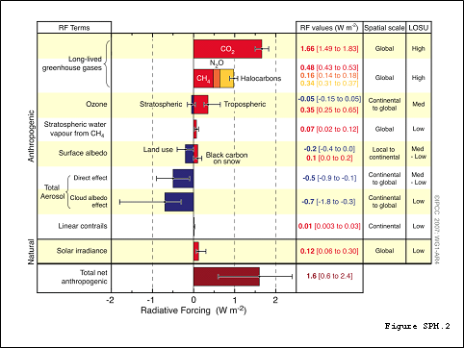
Figure 2 IPCC AR4 Radiative forcing estimates in 2005 (from IPCC AR4 WGI Figure SPM.2).

The AR4 has also found some improvement in understanding of the sensitivity of the climate system to forcing (see Box 1 above). Since the First Assessment Report in 1990 the IPCC had estimated the climate sensitivity, dT2x, to be in the range of 1.5-4.5°C, with a best estimate of 2.5°C. In the AR4 the best estimate has been raised to 3°C and a “likely” range of 2 to 4.5°C, with it being “very unlikely” to be less than 1.5°C. It was not possible to attach a formal likelihood of a dT2x above 4.5°C and it was assessed that values higher than 4.5°C cannot be excluded. Understanding the sensitivity of the climate system is clearly very important in assessing the risks from emission of greenhouse gases, and has quite profound effects for policy responses. As can be seen from Figure 3, which shows cumulative density functions for climate sensitivity from four different methods and a range of different studies, there remains a large uncertainty around this quantity. For estimates based on 20th century observations, the main uncertainty in narrowing estimates of dT2x relates to the uncertainty in aerosol and volcanic forcing. Cloud feedbacks remain the largest source of uncertainty in AOGCM (Atmospheric Ocean General Circulation Model) based estimates of the climate sensitivity.

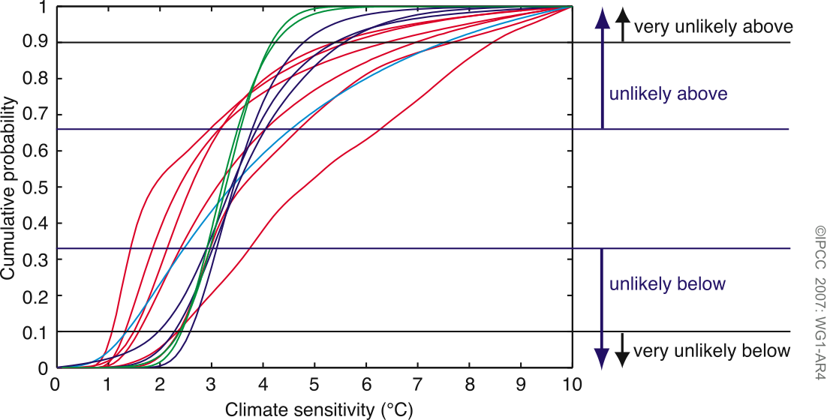
Figure 3 Climate sensitivity estimates -cumulative probability distributions. This figure shows the large range of estimates of climate sensitivity assessed in the AR4. Red lines show estimates based on observed 20th century climate system changes, blue lines show estimates from model climatology, and the cyan coloured lines estimates based in proxy climate records of the past, and the green shows the range from present AOGCMs. After IPCC AR4 WGI Figure TS.2 Technical Summary.

Improved climate change projections in AR4

Projections of climate change over the 21st century in response to different emission scenarios are of key interest to policy makers and stakeholders in assessing risks, mitigation and adaptation options. Whilst the question of the equilibrium climate sensitivity is very important, the regional patterns, magnitude and timing of changes to climate are more relevant in the medium term. On decadal timescale the actual warming experience by the climate system is related also to the rates and patterns of ocean heat uptake.

Comparison of the projections made with climate models for the period since 1990 with observations over the period 1990-2005 has strengthened scientific in confidence in near-term projections for the next few decades. In particular, for the next two decades, the AR4 projects a warming of about 0.2°C per decade for the range of IPCC SRES emission scenarios. The inertia of the climate system, principally due to the enormous heat capacity of the oceans, means that even with radiative forcing held constant at contemporary levels, a further warming of about 0.1°C per decade for several decades would be expected.

Compared to earlier assessment the AR4 had a larger number of climate simulations and projections available from a broader range of models, which provided a quantitative basis for estimating the likelihood of changes in many climate variables of interest. Global mean projections and ranges are shown in Figure 4 and Figure 5. Table 1 below provides a rough comparison of the projections made in the AR4 compared to earlier assessments. Global mean temperature projections in the AR4 are comparable in range to those made using the same IPCC SRES scenarios in the TAR in 2001.

Projected climate changes of interest however are not limited to global means and the AR4 provides insight into effects on a wide range of climate system properties at global and regional scale such as precipitation, sea ice, snow cover and changes in weather extremes,
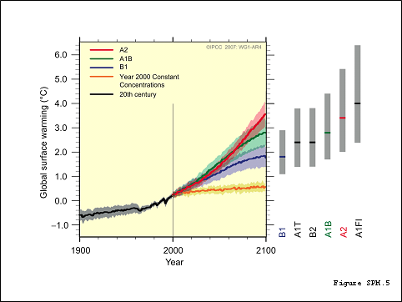
Figure 4 AR4 Projections of warming for 21st century relative to 1980-1999 period for the IPCC SRES scenarios and constant 2000 radiative forcing experiment. The solid lines are the global averages of the models assessed. The grey bars on the right show the best estimate and likely ranges for the IPCC SRES marker scenarios estimated from the AOGCM projections, simpler models and observational constraints. From IPCC AR4 WGI Figure SPM.5-.
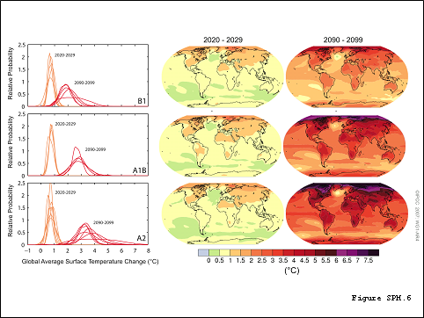
Figure 5 AR4 Projections of warming for 21st century relative to 1980-1999 period for 2020s and 2090s. Model range is shown on the left hand side and the on the right are averages of the models assessed. From IPCC AR4 WGI Figure SPM.6-

Table 1 PCC Assessments 1990-2007
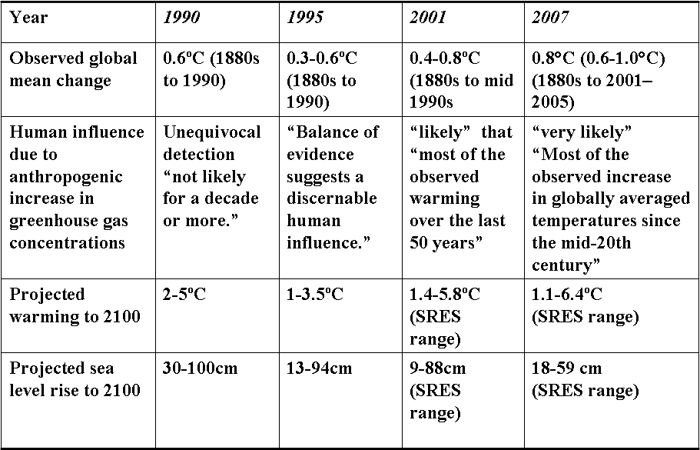

Sea Ice Changes

An important component of the climate system and the underpinning of arctic and Antarctic ecosystems is sea ice. The AR4 reported that Arctic sea ice annual average and summer extent has declined since satellite observations began in 1978 at 2.7 [2.1 to 3.3]% per decade and 7.4 [5.0 to 9.8]% per decade respectively to 2005 (WGI SPM). Sea ice extent is projected in the AR4 report to reduce under all of the IPCC SRES scenarios and “in some projections, arctic late-summer sea ice disappears almost entirely by the latter part of the 21st century” (WGI SPM).

Since the AR4 cut off date for peer reviewed literature to be included in the assessment (around mid 2006) further analyses have been published, finding that the rate of ice loss projected by the AOGCMs participating in the AR4 assessment for the period 1953-2006 have substantially underestimated the reduction in late summer ice extent (Stroeve, Holland et al. 2007), and that in general the reliability of these models in this area is low (Eisenman, Untersteiner et al. 2007). Observed September ice extent loss rates from 1979-2006 were 9.12 ± 1.54%/decade with modeled losses less than half this (4.26 ± 0.25%/decade) and for the most recent decade observed loss were 17.91 ± 5.98%/decade, as opposed to modeled losses of 6.65 ± 0.59%/decade. If the models do indeed underestimate the sensitivity of sea ice to warming in the Arctic it seems likely that the transition an ice free Arctic ocean in summer will occur much sooner than projected in the AR4 (Stroeve, Holland et al. 2007). Summer ice extent in the Arctic in summer 2007 was at record low levels (Kerr 2007) continuing the trend found in the AR4 assessment.

Precipitation projections

Significant improvements have occurred in projections of precipitation changes compared to earlier assessments. Warming will intensify the hydrological cycle increasing water vapour content, evaporation and precipitation. Precipitation is projected to increase in the moist tropics and in high latitudes and generally decrease in the subtropics. Figure 6 shows projected changes in precipitation for the 2090s for the SRES A1B emission scenario.

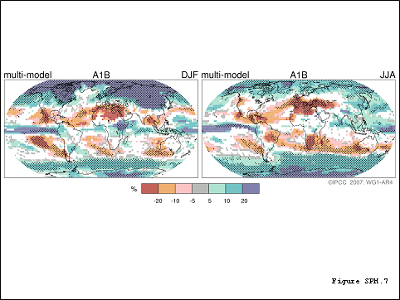
Figure 6 Changes in precipitation 2090–2099 compared to 1980-1999. Multimodel averages are shown for the IPCC SRES A1B Scenario, with the white areas demarking where model agreement is low, with less than 66% of models agreeing in the sign of the change. Stippled areas demark where more than 90% of the models agree in the sign of the change. From IPCC AR4 WGI Figure SPM.7.

Warming is projected to result in reduced snow cover as melting dominates over increased snow fall in most regions.

Projections of extreme weather events

Many extreme weather events are predicted to increase in frequency and/or intensity with warming (see Table 2). In most subtropical and midlatitude regions, although precipitation is projected to decrease, the intensity of precipitation events is also projected to increase. Associated with this is a tendency for increased periods of no rain. Owing to summer warmth and drying in mid-continental regions there is a likelihood of increased drought.

As background, it is to be noted that the mass of water held by the atmosphere is expected to increase with temperature; hence a global increase in precipitation is projected. Under the Clausius-Clapeyron equation the saturation water vapour pressure increases exponentially with temperature, so that the water holding capacity increases at 7%ºC⁻¹ (Trenberth, Dai et al. 2003; Trenberth and Shea 2005). Increases in global precipitation are limited however by the energy balance of the atmosphere and AOGCM projections indicate global increases in the range of 1-3%ºC⁻¹ (Allan and Soden 2007). Increases in extreme precipitation rates can however be expected to follow the amount of water in the atmosphere hence is likely to increase faster than the mean.

Warm temperature extremes (eg heatwaves) are also projected to increase (see Figure 7),

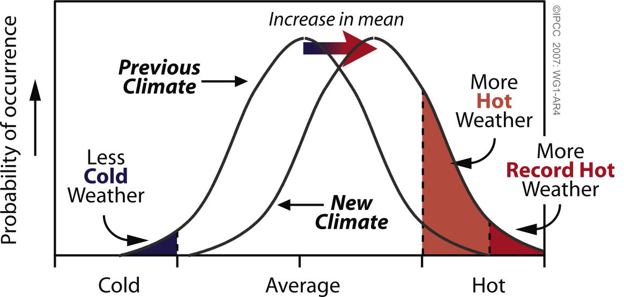
Figure 7 Schematic diagramme showing effect of an increase in the mean temperature in frequency of extreme temperatures. IPCC AR4 WGI Box TS.5,

Table 2 Observed and projected changes in extreme weather events.
Phenomenona and direction of trend | Likelihood that trend occurred in late 20th century (typically post 1960) | Likelihood of a human contribution to observed trend b | Likelihood of future trends based on projections for 21st century using SRES scenarios
Warmer and fewer cold days and nights over most land | Very likely c | Likely d | Virtually certain d
areas
Warmer and more frequent hot days and nights over most land areas | Very likely e | Likely (nights) d | Virtually certain d
Warm spells / heat waves. Frequency increases over most land areas | Likely | More likely than not f | Very likely
Heavy precipitation events. Frequency (or proportion of total rainfall from heavy falls) increases over most areas | Likely | More likely than not f | Very likely
Area affected by droughts increases | Likely in many regions since 1970s | More likely than not | Likely
Intense tropical cyclone activity increases | Likely in some regions since 1970 | More likely than not f | Likely
Increased incidence of
extreme high sea level (excludes tsunamis) g | Likely | More likely than not f, h | Likely i
Source: IPCC AR4 WGI Table SPM.2. Original footnotes to this table refer to WGI Chapters and are retained here; a See Table 3.7 for further details regarding defi nitions.; b See Table TS.4, Box TS.5 and Table 9.4; c Decreased frequency of cold days and nights (coldest 10%); d Warming of the most extreme days and nights each year; e Increased frequency of hot days and nights (hottest 10%); f Magnitude of anthropogenic contributions not assessed. Attribution for these phenomena based on expert judgement rather than formal attribution studies. g Extreme high sea level depends on average sea level and on regional weather systems. It is defi ned here as the highest 1% of hourly values of observed sea level at a station for a given reference period.; h Changes in observed extreme high sea level closely follow the changes in average sea level. {5.5} It is very likely that anthropogenic activity contributed to a rise in average sea level. {9.5}; i In all scenarios, the projected global average sea level at 2100 is higher than in the reference period. {10.6} The effect of changes in regional weather systems on sea level extremes has not been assessed.

Regional projections

A major improvement since the TAR is the higher confidence in projected patterns of climate change at the regional level. This is important for projecting impacts and designing adaptation responses to projected climate change. Figure 8 illustrates the broad consistency between observations and projections of temperature in six world regions.
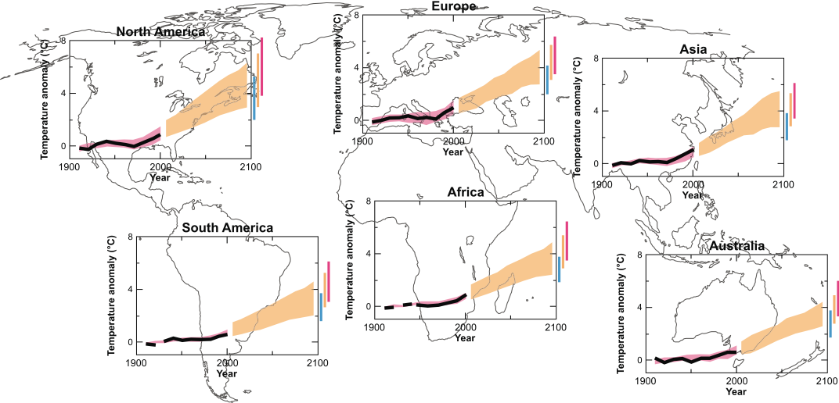
Figure 8 Projected regional changes in temperature compared to observations. Black line is the temperature anomalies fopr for the 1906-2005 period relative to the 1901-1950 period. The envelopes to the right of this are the model projections to 2100 for the A1B scenario. The bars at the end are the ranges for 2091-2100 for the SRES B1 (blue –lowest), A1B (orange – middle) and A2 (red –upper) scenarios. IPCC AR4 WGI Box 11.1,

Carbon cycle climate coupling

The coupling between the carbon cycle and climate is important for determining the response of the climate system to the added greenhouse gases, including fossil CO₂. The AR4 has confirmed the assessment made in the TAR that warming tends to reduce land and ocean uptake of atmospheric carbon dioxide. This increases the fraction of anthropogenic emissions that remains in the atmosphere and can also add CO₂ if warming leads to release of carbon from soils. The magnitude of this feedback remains uncertain.

The overall stronger climate-carbon cycle feedbacks found in the AR4 assessment increases the upper range of temperature increase projected for each emission scenario. For example the global average warming at 2100 for the IPCC SRES A2 scenario is increased more than 1°C. Another way of looking at the implications of a stronger coupling of climate and the carbon cycle is in relation to the emissions required for stabilizing CO₂ at specific levels. A stronger feedback from warming decreases the CO₂ emissions that are allowed to limit increase to a particular CO₂ stabilization level. In the case of a 450 ppm CO₂ stabilization level stronger climate-carbon cycle feedbacks reduce the cumulative allowed emissions over the 21st century from approximately 670 GtC to approximately 490 GtC,

Oceanic acidification

Whilst much of the emphasis in contemporary debates about climate change has been on changes in climate variables such as global mean temperature, extremes in precipitation and heatwaves etc, added CO₂ to the atmosphere has significant direct effects on the climate system. One of these effects is the increasing acidification of the ocean, which was previously overlooked and which is projected to have negative effects on marine shell forming organisms and species and ecosystems dependent on them. The increase in CO₂ from preindustrial times to the present has deceased the ocean pH by about 0.1 Projections using the IPCC SRES emission scenarios show a further reduction in pH of 0.14-0.35 to 2100 (Figure 9).

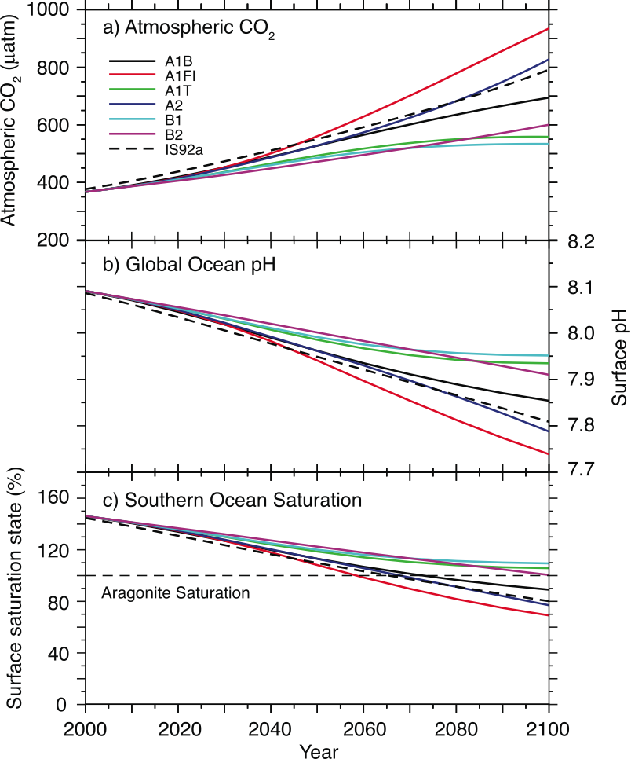
Figure 9 Projected changes in average surface pH for IPCC SRES emissions scenarios and the IS92a scenario. From IPCC AR4 WGI Figure 10.24.

IPCC sea level projections: increasing uncertainty

Over the course of the four main IPCC assessments, from the first in 1990 to the AR4, projection of sea level rise has been a difficult subject, not least because of the question of the response of the ice sheets of Greenland and Antarctica to warming. If melted Greenland and the West Antarctic ice sheets would raise sea level (over many centuries to millennia) by about 6 and 5 metres respectively. Unlike earlier assessments the AR4 does not however have a chapter devoted to this issue. Whereas in the earlier parts of this review I have essentially summarized the findings of the AR4, the sea level rise projection are sufficiently uncertain to warrant a different and more critical approach.

Sea level rise under global warming is essentially due to the response of four main terms: Thermal expansion of the oceans due to warming, the melting of mountain glaciers and small ice caps, and the response of the Greenland and Antarctica ice sheets. Thermal expansion is modeled using AOGCMs or EMICs (Earth System Models of Intermediate Complexity) and in principle is reasonably well constrained, although significant uncertainties remain surrounding heat uptake by the oceans. The response of glaciers and ice caps is also reasonably well bounded, although debate remains on the total volume if ice in these and the rate at which it may be lost (Meier, Dyurgerov et al. 2007). The response of the ice sheets is projected with continental ice sheet models which at present do not describe the fast ice dynamics of ice streams, which are likely to play a major role in the response of ice sheets to warming (Bamber, Alley et al. 2007). Observations of ice sheet changes in recent decades and model base projections appear to be diverging. Table 3 compares observational and model estimates of each of the terms with the total observed sea level rise for the period 1993-2003. The sum of the observational estimates of each term and the observed total SLR are in broad agreement given the overall level of uncertainties: 2.8±0.7 mm/yr vs 3.1± 0.7 mm/yr respectively.

The sum of the modeled estimates of each term and the observed total SLR appear to be quite divergent: 2.0 ± 0.8 mm/yr vs 3.1± 0.7 mm/yr. The main source of this divergence appears to lie in the ice sheet contributions. The Greenland ice sheet observed losses appear to be bigger than the modeled losses, and for Antarctic the observed loss is of the opposite sign to the modeled mass increase. For Antarctica, present continental ice sheet models predict an increase in mass (sea level lowering) with moderate warming due to increased precipitation over the continent, which remains too cold for significant melting. Ice sheet models for Greenland on the other hand predict a negative surface mass balance for this ice sheet at a global average warming above pre-industrial over 1.9°C to 4.6°C.

The ice sheet models used in this assessment at present predominantly estimate surface mass balance changes, with little ice dynamic effects. Observed losses in Greenland have a substantial dynamical component due to accelerated flow of ice streams. In the case of the West Antarctic, which dominates the mass balance of Antarctica, the negative mass balance is essentially due to accelerated ice stream flow (Bamber, Alley et al. 2007).

Table 3 Observed and modelled sources of sea level rise 1993-2003.
Source of sea level rise  1993-2003 | Observed  mm/yr | Modeled  mm/yr
Thermal expansion | 1.60± 0.50 | 1.5± 0.7
Glaciers and ice caps | 0.77± 0.22 | 0.6± 0.3
Greenland ice sheet | 0.21± 0.07 | 0.1± 0.1
Antarctic ice sheet | 0.21±0.35 | -0.2± 0.4
Sum of contributions | 2.8±0.7 | 2.0 ± 0.8
Observed total SLR | 3.1± 0.7
Difference (Observed SLR less sum of contributions | 0.3 ± 1.0 | 1.1 ± 1.1
Sources: The observed column is from IPCC WGI AR4 Table 9.2 and the entries under the modelled column for thermal expansion and glaciers and ice caps are also from this table for all the data that includes all forcings. The entries for the ice sheets are from the estimates reported in Chapter 9 for the 1993-2003 period from models, although not the same model set ups as for the other modelled terms.

The AR4 sea level rise projections are summarized in Table 4 and expressly are described as not including rapid dynamical changes in ice flow. Figure 10 shows each of the terms of the sea level rise projections for the SRES scenarios and added to it is a line added to show the consequence to 2100 if the rate of sea level rise remain unchanged at the 1993-2003 levels. The range of sea level rise projections for the IPCC SRES scenarios is, at its high end, substantially lower than in the earlier assessments (see Table 1) and as can be seen from Figure 10 not greatly outside the rate of rise that is estimated for 1993-2003. If this could be considered a robust finding it would result in a lowered risk assessment for sea level rise impacts compared to earlier assessments. The state of the science does not however permit this conclusion.

Table 4 AR4 Sea level rise projections
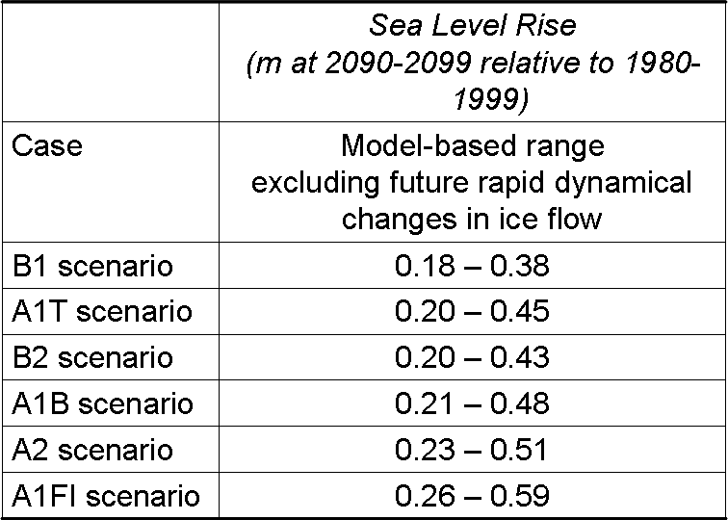
Note that the projection includes the part of the present ice sheet mass imbalance that is due to recent ice flow acceleration and assumes that this will persist unchanged. Source: From IPCC AR4 WGI Table SPM.3.

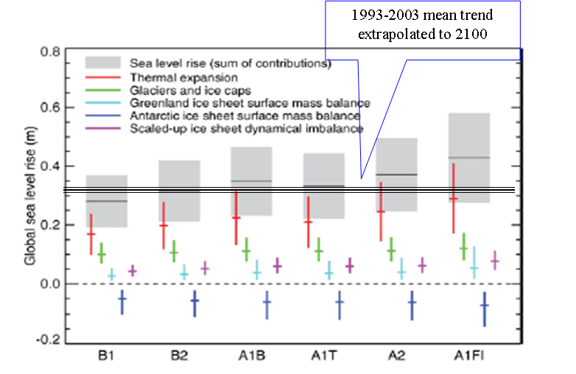
Figure 10 AR4 Sea level rise projections. Projections for total sea level rise for each of the components of sea level rise. Note that the AR4 projection shown in Table 4 does not include the scaled up ice sheet dynamical imbalance shown in this figure. The added line shows the 1993-2003 trend extended for a century unchanged. Adapted from IPCC WGI AR4 Figure 10.33.

A recent attempt to project sea level rise using a semi empirical method based on recent observations of surface temperature and sea level change, using the SRES scenarios, has estimated the likely sea level rise to 2100 to be 0.5-1.4 m (Rahmstorf 2007) A sea level rise in this range and for these emissions scenarios would require only that the observed linear relationship over the last century between SLR rate and temperature persist for the next century (Rahmstorf 2007). The lower end of this range for the same scenarios is very close to the top end of the AR4 range, implying that the uncertainty in sea level rise projections is much larger than would be inferred from the AR4 sea level rise assessment,

The possibility of accelerated ice flow in the 21st century from Greenland and West Antarctic ice sheets (or parts of the East Antarctic ice sheet) cannot be excluded and cannot at present be reliably quantified. For both ice sheets recent accelerations in ice flow have contributed significantly to recent observed sea level rise but this is not included in the models used in the AR4 assessment. Recent advances in ice sheet modeling (Schoof 2007) tend to support theories advance in the 1960s and 70s that the West Antarctic ice sheets may be unstable to warming (Mercer 1968; Weertman 1974; Mercer 1978). It is to be hoped that by the time of the next IPCC assessment sufficient advances have been made in this are to permit a robust assessment of the risks of sea level rise from the Greenland and Antarctic ice sheets.

Conclusions

The IPCC is a unique international scientific assessment body that has produced consistently high quality state of the art assessments of all aspects of climate change since its inception in 1988. The Fourth Assessment Report is a milestone achievement in this context for the scientific community as whole, involving as it has hundreds of working scientists over several years. The issues raised in this overview and perspective on the AR4 point to necessary developments in the scientific understanding of climate change, particularly here in relation to sea level rise. They also point to ways in which the IPCC can learn so as to guarantee the scientific quality and policy relevance of its next assessment reports,

References

Agrawala, S. (1998). "Context and Early Origins of the Intergovernmental Panel on Climate Change." Climatic Change 39(4): 605-620.
Allan, R. P. and B. J. Soden (2007). "Large discrepancy between observed and simulated precipitation trends in the ascending and descending branches of the tropical circulation." Geophys. Res. Lett. 34(18): 1-6.
Arrhenius, S. (1897). "On the Influence of Carbonic Acid in the Air upon the Temperature of the Earth." Publications of the Astronomical Society of the Pacific 9(54): 14.
Bamber, J. L., R. B. Alley, et al. (2007). "Rapid response of modern day ice sheets to external forcing." Earth and Planetary Science Letters 257(1-2): 1-13.
Eisenman, I., N. Untersteiner, et al. (2007). "On the reliability of simulated Arctic sea ice in global climate models." Geophys. Res. Lett. 34(10): 1-4.
IPCC, S. Solomon, et al., Eds. (2007). Climate Change 2007: The Physical Science Basis. Contribution of Working Group I to the Fourth Assessment
Report of the Intergovernmental Panel on Climate Change. Cambridge, United Kingdom and New York, NY, USA, Cambridge University Press.
Kerr, R. A. (2007). "CLIMATE CHANGE: Is Battered Arctic Sea Ice Down For the Count?" Science 318(5847): 33a-34.
Meier, M. F., M. B. Dyurgerov, et al. (2007). "Glaciers Dominate Eustatic Sea-Level Rise in the 21st Century." Science 317(5841): 1064.
Mercer, J. H. (1968). Antarctic Ice and Sangamon Sea Level. Commission of Snow and Ice: Reports and Discussions, Bern, International Association of Scientific Hydrology.
Mercer, J. H. (1978). "West Antarctic Ice Sheet and Co2 Greenhouse Effect - Threat of Disaster." Nature 271(5643): 321-325.
Peixoto, J. P. and A. H. Oort (1992). Physics of Climate, Amer Inst of Physics.
Rahmstorf, S. (2007). "A Semi-Empirical Approach to Projecting Future Sea-Level Rise." Science 315(5810): 368-370.
Schoof, C. (2007). "Ice sheet grounding line dynamics: Steady states, stability, and hysteresis." J. Geophys. Res. 112(F3): 1-19.
Stroeve, J., M. M. Holland, et al. (2007). "Arctic sea ice decline: Faster than forecast." Geophys. Res. Lett. 34(9): 1-5.
Trenberth, K. E., A. Dai, et al. (2003). "The changing character of precipitation." Bull. Amer. Meteor. Soc 84(9): 1205-1217.
Trenberth, K. E. and D. J. Shea (2005). "Relationships between precipitation and surface temperature." Geophys. Res. Lett. 32(14): 1-4.
Weertman, J. (1974). "Stability of the junction of an ice sheet and an ice shelf." Journal of Glaciology 13(67): 3-11.

http://www.ipcc.ch/
IPCC, 2007: Climate Change 2007: The Physical Science Basis. Contribution of Working Group I to the Fourth Assessment Report of the Intergovernmental Panel on Climate Change [Solomon, S., D. Qin, M. Manning, Z. Chen, M. Marquis, K.B. Averyt, M. Tignor and H.L. Miller (eds.)]. Cambridge University Press, Cambridge, United Kingdom and New York, NY, USA, 996 pp.
http://ipcc-wg1.ucar.edu/
http://www.ipcc-wg2.org/
http://www.mnp.nl/ipcc/pages_media/outreachTAR03.html
See Agrawala, S. (1998). "Context and Early Origins of the Intergovernmental Panel on Climate Change." Climatic Change 39(4): 605-620. for background on the IPCC.
The climate system is defined in the IPCC glossary as “the highly complex system consisting of five major components: the atmosphere, the hydrosphere, the cryosphere, the land surface and the biosphere, and the interactions between them. The climate system evolves in time under the influence of its own internal dynamics and because of external forcings such as volcanic eruptions, solar variations and anthropogenic forcings such as the changing composition of the atmosphere and land use change”. http://ipcc-wg1.ucar.edu/wg1/Report/AR4WG1_Print_Annexes.pdf
Radiative forcing’ is the net change in upward and downward irradiance at the tropopause due to the effect of an external climate forcing agent such as a greenhouse gas increase, change in solar irradiance, volcanic eruption or land use change. It is expressed in W/m2 and here at the global mean annual level. A positive warms the surface and a negative forcing tends to cool it. By convention radiative forcing values are for changes relative to a pre-industrial background in 1750 in W/m². More details can be found in the IPCC Glossary at http://ipcc-wg1.ucar.edu/wg1/Report/AR4WG1_Print_Annexes.pdf
This means a 9 out 10 chance of being correct. See IPCC AR4 Uncertainty Guidance note at http://ipcc-wg1.ucar.edu/wg1/Report/AR4_UncertaintyGuidanceNote.pdf
Very similar to the range estimated by Charney in the 1970s {Charney, 1979 #55572}
http://ipcc-wg1.ucar.edu/wg1/Report/AR4WG1_Print_TS.pdf and see the footnote Error: Reference source not found for link to AR4 Uncertainty Guidance for likely range definitions.
This refers to the standard set of IPCC non-mitigation (e.g. reference) emissions scenarios in use for the AR4. See http://www.grida.no/climate/ipcc/emission/
This comparison is approximate owing to different approaches taken in each set of projections for emission scenarios and reference period and end periods for projections.
See IPCC Glossary http://ipcc-wg1.ucar.edu/wg1/Report/AR4WG1_Print_Annexes.pdf
See IPCC WGII AR4 report at http://www.ipcc-wg2.org/ Technical Summary and Chapter 4.

