Fusion as a Future Energy Source

David J Ward
EURATOM/UKAEA Fusion Association
Culham Science Centre
Abingdon, UK

Introduction to Fusion

In the universe as a whole, fusion is the most important source of energy and of course it is the origin of the solar power that sustains the Earth. It is, as yet, untapped as a terrestrial energy source although experimental devices now exist that can produce many megawatts of fusion power, enough to provide the energy needs of a small town if the power were captured appropriately.

In the Sun, the main source of energy is the fusion of hydrogen generating helium and large amounts of energy. The Sun is very large and it takes billions of years to fuse its fuel. On Earth we cannot allow either of these conditions to hold so it might seem that fusion is beyond us. However, Nature has been very kind and whilst it takes billions of years to fuse normal hydrogen, there are isotopes of hydrogen, deuterium and tritium, which can undergo radically faster fusion reactions and this makes fusion on Earth feasible.

Figure 1 compares the fusion cross-section for 4 fusion reactions, Deuterium/Tritium (DT), Deuterium/Deuterium (DD), Deuterium/Helium³ (DHe3) and proton/proton fusion (pp). The fact that the easiest fuels to fuse (DT) are 10²⁴ times more likely to fuse than pp is the single most important factor in achieving fusion on Earth. The cross-sections in Figure 1 are given at the typical operating temperature of present fusion devices (10keV or approximately 100 million Celsius).

Figure 1: At the temperature of modern fusion devices, the cross-section for DT fusion is 10²⁴ times higher than it would be for pp fusion, which powers the Sun.
The need for temperatures of approximately 100 million Celsius could, in the past, have seemed prohibitive but such temperatures are now achieved routinely. Using magnetic fields to insulate the fuel against heat loss, the application of high power naturally leads to high temperatures. Modern magnets allow insulation properties around 30 times better than the insulating materials used in a house, the insulation is 1 metre thick (around 10 times thicker than in a house) and the power is 1,000 times higher than typically used in a house. Taken together, these three factors lead to a temperature of around 100 million Celsius.

Present day machines, particularly JET – the European experiment located in the UK –have brought fusion energy much closer by producing large amounts of fusion power. JET can produce 16 MW of power, although it requires a similar power to heat it up. The next generation of machine to be built is ITER, a wide international collaboration between the EU, Japan, US, Russia, India, China and South Korea, to be constructed in Cadarache in France. ITER is designed to produce 500MW of fusion power, 10 times greater than the power needed to heat up the fuel.

After ITER, assuming it is successful, it is intended to build a fusion power station, demonstrating the large scale production of electricity. The subject of this paper is primarily an analysis of the properties of fusion as an energy source, once such fusion power stations are working routinely.

The Energy Challenge

A key question for the future of energy use and supply is “how can the world continue to develop and poor economies grow, without excessive cost, whether economic, environmental or other?” The potential for growth in energy demand is illustrated in Figure 2 which shows the enormous growth in energy consumption in China and, to a lesser extent in India, compared to the more steady energy consumption in a typical developed country; here Germany is given as an example.
Figure 2: Primary energy consumption (million tonnes of oil equivalent) in China, India and Germany over 40 years. Source: BP

The data shows that in only 2 years, the growth in China’s energy consumption can exceed the total consumption of Germany, in spite of which the consumption per population is still quite modest. As an illustration of where mankind’s energy supply comes from, the breakdown of China’s fuels is shown in Figure 3. China is almost entirely supplied by fossil fuels, primarily coal.

Figure 3: Breakdown of China’s energy supply by source. Source: BP.

There are many examples of where energy use can have an excessive cost; 2 are given here. The first is illustrated in Figure 4 which shows the mortality and pollution observed during one of the London smogs of the 1950’s, following which the burning of coal in major urban areas was banned in the UK. Shortly before Christmas 1952, the atmospheric conditions in London were such that pollution could not escape. Very high levels of pollution were observed with correspondingly high mortality rates. The link between pollution and mortality was very clearly demonstrated. Overall many thousands of people were killed in a single pollution episode.
Figure 4: Pollution and mortality rate from a major pollution event in London in 1952. Source: Wilkins.

Although such episodes are now rare in developed countries, there are similar levels of pollution in countries where rapid industrialisation is occurring, and large numbers of deaths still occur each year around the World. These examples are caused by industrialisation but there are also examples where lack of industrialisation causes large problems. The use of biomass, particularly for cooking, in many developing countries is carried out indoors often with insufficient ventilation, with enormous consequences for health. The WHO estimates approximately 1.5 million deaths per year are caused by this practice making it by far the most hazardous component of the World’s energy supply.

Although these aspects of pollution are often overlooked, there is another large driving force behind the need to drastically change our energy supply system; climate change. The dominance of carbon based energy sources (providing around 80% of world’s energy needs) is in sharp contrast to the perceived need to limit the rapid increase in carbon dioxide concentration in the atmosphere. This is an enormous challenge both because of the dominance of fossil fuels in the existing energy supply, and the enormous increase in energy use globally that is needed to bring many people out of poverty. We must find non-carbon energy for the majority of the existing energy supply and perhaps all of the increased supply. Even stopping the growth in CO₂ emissions looks extremely challenging. To reduce emissions in the face of large increases in energy demand looks a gargantuan task.

We now see some of the motivation to develop a new energy source such as fusion. There are not the large pollution issues associated with combustion technologies nor the climate change issues associated with fossil fuel combustion. In the following we will look at the actual properties of fusion, starting with resource availability.

Resource Availability

One of the main reasons for pursuing fusion as an energy source is the potential access to enormous reserves. As presently foreseen the main fuels for fusion are deuterium, which is readily available in water, and lithium, to generate the tritium needed for the DT reaction. The deuterium supply is essentially infinite, sufficient for billions of years of energy supply. Lithium is more constrained with the present land based resource sufficient for around 1000 years of energy supply. There is also lithium in sea water at a concentration that would make extraction worthwhile, as well as further land based resources in lower grade ores.

Figure 5 illustrates the number of years that different energy sources could supply the total present energy needs of mankind. The bar labelled “New Resource” includes non-conventional oil, methyl hydrates for gas, a higher estimate for coal reserves, and uranium and lithium from sea water. Unless the methyl hydrates are successfully developed, the large energy sources are coal, uranium (especially in breeder reactors) and fusion. Of course solar power also has the potential to supply enormous amounts of energy, particularly in favourable regions.

Figure 5: Estimates of total energy supply from different sources. Sources: WEC, BP, USGS, WNA.

Although this is rather a detailed picture, the issue for fusion can be illustrated by considering the concentration of lithium in water and rocks. The average value for lithium in the Earth’s crust and in sea-water makes each tonne of rock equivalent (in energy terms) to 20 tonnes of coal and each litre of sea water equivalent to 0.1 litres of oil.

Emissions

The main issue that we must keep track of in fusion is radioactivity. Fusion is the opposite of nuclear fission, but is still a nuclear process and involves a radioactive element, tritium, although only small quantities of such fuel are needed. Conceptual designs of fusion power stations have been carried out in sufficient detail to allow estimates of possible release of materials to the environment. Figure 6 shows the results of such estimates for fusion, fission, coal, geothermal and gas power, along with estimates for other human activities to give an idea of the relative importance.

The data in Figure 6 is given in terms of the radioactive dose for each GWyear of energy supplied. Food supplies our individual energy needs, and is naturally radioactive so can also be put on the same scale. It is not clear whether this is a useful thing to do since we cannot really replace food intake with nuclear power, however it does give a background to the other values. It is important to notice that the column for food has been cut off at the value of 100 even though the true value (written above the column) is 2000, otherwise the other values would not be visible. The same is true of the column labelled double glazing, which refers to the measured increase in radon content of a home when the windows are improved. Again the radioactive dose is cut off as it would otherwise be too large. Here of course there is the option to introduce energy saving or provide more energy so the radioactive doses can be directly compared.

Figure 6: Relative radiological hazard of different source of energy. Sources: UNSCEAR, NRPB

The data in Figure 6 is not intended to show how harmful double glazing and food are, but to show that the radiological hazard of energy sources is very low in the context of our everyday lives. To put this in a broader context, Figure 7 shows these hazards in the context of other hazards, particularly atmospheric pollution. Even though coal looks quite high in Figure 6, Figure 7 shows that its radiological hazard is negligible compared to the other hazards of coal air pollution, even for the modern plant considered here. Coal air pollution hazards are themselves very small compared to the inappropriate use of biomass, as described earlier.

Figure 7: The radiological hazards of Figure 6 are put in context of the corresponding hazards of air pollution. Sources: WHO, UNSCEAR, NRPB, EC (ExternE)

In this context, the hazards of expected emissions from fusion power stations are extremely small, comparable to those from radiological emissions from a geothermal plant.

Safety

The safety of fusion relies primarily on the lack of sufficient energy to drive a severe accident and the lack of hazard inside the machine to cause major problems even if released. It is common in fusion to study bounding accidents, rather than merely severe accidents. This entails considering accidents that are implausibly severe (by combining the worst possible outcomes in all areas) and which exceed the consequences of any plausible accident. The advantage of this conservatism is to obviate the need to show the consequences of many accident scenarios, but rather to provide an outer envelope to the harms that are, even in principle, possible. An example of this is taken from the PPCS which assumes a complete loss of cooling, no active safety system and no other intervention for a long period. The results for the theoretical highest dose to the most exposed individual for two plant models are given in Table 1. The lower number is less than a normal annual background dose and even the higher number is comparable to the annual background dose received by people in many areas. It should be emphasised that there is no identified plausible accident scenario that could lead to these doses; this is the worst possible outcome of even implausible accidents. The calculated dose is below levels where evacuation would be considered as the expected health effects would be extremely small.

Model | Dose
A | 1.2 mSv
B | 18.1 mSv

Table 1: The radiological dose to the most exposed individuals in a bounding accident analysis of PPCS power plant concepts A and B. Source: PPCS

Although the fusion hazards are small, the main contribution is from tritium. Although the fuel use is very small with only 1g of fuel in use at any one time, there will be larger amounts of tritium on site. Assessments of the worst that can happen in an accident driven by internal events, that is excluding external events such as a very large earthquake, only a few 10’s of grammes of tritium could be released which would not be sufficient to motivate an evacuation of the local populations. An enormous earthquake could release more but the consequences of the tritium release would be small compared to the direct consequences of the earthquake itself.

Waste

An area of considerable interest in fusion power plant studies is the level of radioactivity in the machine structures. Although there is no nuclear waste in the conventional sense, there is radioactivity of the structure and ways of minimising this have been intensively studied, primarily through optimisation of the materials assumed for a power plant.

The reason for the interest in the activation of fusion materials is that it is possible, with a sensible choice of materials, that no use of a repository would be needed, because there would be no need for permanent disposal of radiological waste. Fusion plant designs are at the point where, depending on the details of the design and the geographical location of interest, this may or may not be achieved, so it could be very beneficial to improve matters by even a small amount.

Figure 8 shows the total radiotoxicity associated with fusion power plants and all their decommissioning material after the end of life, compared with fission plants and with coal plants. This figure only shows the total potential hazard from ingesting the waste materials; it does not consider how the materials could actually be ingested. The conclusion from such studies is that whilst fission waste needs repository disposal, fusion waste probably does not.

Figure 8: The total radiotoxicity of materials arising from a lifetime operation of a range of fusion power plants, a range of fission power plants and a coal fired power plant, for the same integrated power output. Source: PPCS

Costs and Investment

There are two approaches taken to determining the costs of fusion power plants. One is to look at the actual costs of present day fusion devices and costs of other similar technologies which already exist. The other is to determine the design of the fusion power station in sufficient detail that the costs can be estimated using conventional costing tools. Figure 9 shows an empirical approach in which the specific capital cost (the capital cost per Watt of fusion power that the devices could produce) is given for existing machines and for ITER, along with an older design of ITER (ITER98) and a power plant conceptual design. Two things can be seen: firstly there is a reassuring consistency between the actual numbers for existing devices and the estimates for future devices, and secondly as the fusion power increases to the GW scale, the specific costs fall to the $/W scale that must be achieved for fusion to be comparable to other energy sources.

Figure 9: As the size of fusion devices increases, the specific capital cost falls, suggesting a GW scale device will lie in the same range as other capital intensive power plants. The 4 smallest plants all exist, the 3 larger ones are based on costings of designs.

There is much more involved in estimating the future costs of a fusion power station of course since the costs of multiple plants will be less than the costs of one-off experimental devices. On the other hand the need for electrical generating equipment in the power station pushes the costs up. This is all included in the point labelled “power plant” in Figure 9 so the comparison is not as direct as it may seem. Nonetheless it is indicative of the future direction, and the great importance of scale. At least at present, we do not know how to make a small (<<1GW) fusion station with reasonable efficiency.

Apart from the scale of the plant, which Figure 9 shows to be very important, the effect of technological learning will be very important in a new technology such as fusion. This is the cost reduction observed as technologies mature, illustrated in Figure 10 using PV cells as an example. Over 30 years, the cost of PV cells fell by approximately a factor of 10. Although this is an extreme example, a very large part of the cost of a first-of-a-kind fusion power station will be the superconducting magnets, as these are presently a novel and expensive technology. It is almost certain that these costs will reduce, both with their increased use in fusion and also through the increased use of superconductors in other technologies.

What we have done in studying the costs of fusion is to look at a range of possibilities, using a range of materials from steel to sophisticated materials such as silicon carbide composite materials. This gives a range of costs which then diminishes as the technology matures. This is the total range given in Figure 11 where these estimates are compared with projections for a number of other energy sources. Of course such projections, not least the future price of natural gas, are extremely uncertain – the purpose is only to show how the economics of fusion, if it is successfully developed, may compare with other sources.
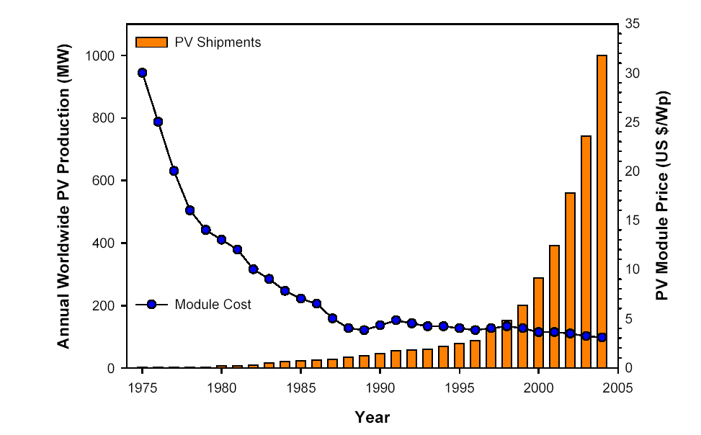
Figure 10: Historical data showing the increase in production of PV cells and the corresponding reduction in cost. This behaviour is observed across a wide range of technologies.

Figure 11: Comparison of the assessed future cost of electricity range for a selection of energy sources. Source: PPCS, OECD.

There is one other aspect to costs that is important and that is the cost of development. Figure 12 shows the breakdown of the world energy market (obviously uncertain as the variation with time is very great) including the expenditure on renewable sources and on public sector R&D. The most striking aspects are the low spend on renewables (only around 1.5% of the world energy market), and on public sector R&D (approximately 0.3%). The right hand side of Figure 12 shows the breakdown of the public sector R&D which is broadly spread, with fusion attracting approximately 7% of the total funding. However it seems clear that this level of expenditure is not likely to be sufficient to transform a market of this size.
Figure 12: Total world energy market (left hand side) and the breakdown of world public sector R&D spending (right hand side)

It is apparent that public sector R&D is too low to substantially impact on the world energy market. There is a specific aspect of fusion that relates to this and that is the need for a large scale demonstration because it is only at the GW scale that efficient electricity production is possible. The implication is that a first of a kind demonstration plant will be quite expensive, even if the expected cost of electricity, once for instance 10 plants are built, is not expected to be unreasonably high. With present day R&D budgets it seems unlikely that any one world region alone will fund such a demonstration plant. This will change if many partners work together, as is being done with ITER, or if the energy R&D budgets increase. This is probably something that will have to happen if we are to achieve a transition in energy supply technologies.

Conclusions

- World energy consumption is likely to more than double even if OECD countries cap their energy consumption.
- Continuing business as usual implies a large increase in CO2 emissions and other pollutants globally.
- There is an enormous potential market for low pollution, low carbon energy sources, such as fusion.
- Fusion has very large benefits in terms of resources, environmental impact, safety and waste materials.
- We must focus on demonstrating fusion as a power source, ensuring these benefits are optimised, at the same time ensuring costs are reasonable.
- The world is not putting sufficient effort into energy R&D if we are to achieve the transformation in energy markets that is needed.

Acknowledgements

This work was funded jointly by the United Kingdom Engineering and Physical Sciences Research Council and by the European Communities under the contract of Association between EURATOM and UKAEA. The views and opinions expressed herein do not necessarily reflect those of the European Commission. This work was carried out within the framework of the European Fusion Development Agreement.

Bibliography.

Many references supporting this work can be found in D.J. Ward, ‘The contribution of fusion to sustainable development’, Fusion Engineering and Design (2007) in press.

The EU fusion power plant studies (PPCS) are described in ‘A Conceptual Study of Commercial Fusion Power Plants’, D Maisonnier et al, EFDA(05)-27/4.10 available from http://www.efda.org/eu_fusion_programme/scientific_and_technical_publications.htm

Data on world energy markets can be obtained from the BP Statistical Review of World Energy http://www.bp.com and energy R&D data can be found at http://www.iea.org/

