Effects of the 11-Year Solar Cycle on the Atmosphere from the Surface to the Lower Thermosphere

Marco A. Giorgetta⁽¹⁾, Hauke Schmidt⁽¹⁾ and Guy P. Brasseur⁽²⁾
⁽¹⁾ Max Planck Institute for Meteorology, Hamburg, Germany
⁽²⁾ National Center for Atmospheric Research, Boulder, USA

Abstract
The solar irradiation on Earth is the driving force for the circulations in atmosphere and oceans on Earth. Weather and climate are sensitive to variations of the solar irradiation, occurring for different reasons. This presentation focuses on changes in the atmospheric circulation and composition caused by variations in the solar irradiation at the top of the atmosphere, as resulting from the variations in the solar emission associated with the 11-year sun spot cycle. A numerical model is used to study the differences in temperature and ozone in the middle atmosphere between maximum and minimum insolation conditions of the 11-year cycle. The model successfully reproduces the major increases in temperature and ozone in the stratosphere for solar maximum conditions, showing that the major processes for this problem are included in the model. The analysis of the processes in the simulations leads to a better understanding of the occurrence of a secondary maximum in temperature and ozone in the lower tropical stratosphere.

Introduction
Solar energy absorbed by the Earth system is the main source for the circulations in atmosphere and oceans, the distribution of ice and the existence of life. The insolation at the top of the atmosphere and the local availability of solar energy on the planet varies for a number of reasons: variations in the solar emission, variations in the sun Earth distance, variations in inclination and direction of the Earth rotation axis with respect to the orbital plane, the rotation rate of the planet, the scattering and absorption in the atmosphere and at the Earth surface. Such variations happen over many time scales. This work focuses on the effects of changes in the solar emission, in association with the 11-year sun spot cycle, on the circulation and composition of the atmosphere, specifically of the stratosphere and mesosphere. Sunspots, visible as dark spots on the bright solar disk, were discovered after the invention of telescopes and the time series going back to the early 17th century clearly shows a variation in sun spot number with an 11-year period along with other longer-term changes (Figure 1). The well-known Maunder minimum is a period in the 17th century when sunspots were apparently absent from the sun surface. The occurrence of the Little Ice Age, which approximately paralleled this period, hence motivated the hypothesis that sunspot numbers and climate on Earth correlate.
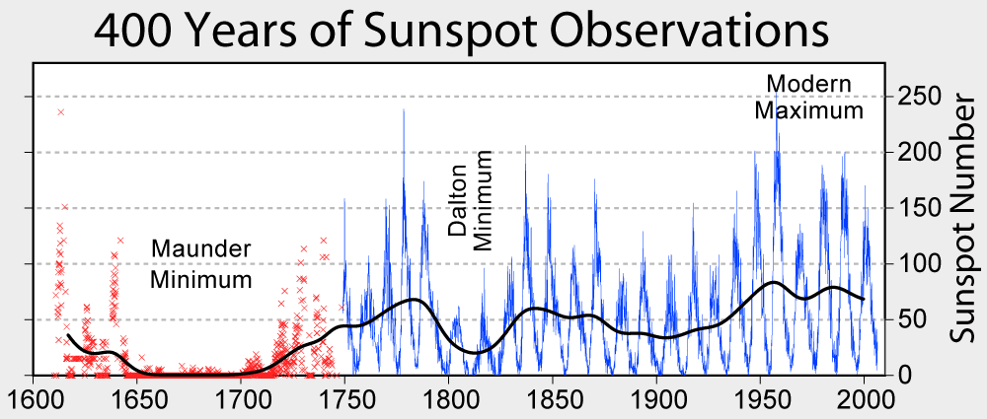
Figure 1. Sunspot number observed from the year 1610 to the present. Source: http://en.wikipedia.org/wiki/Image:Sunspot_Numbers.png

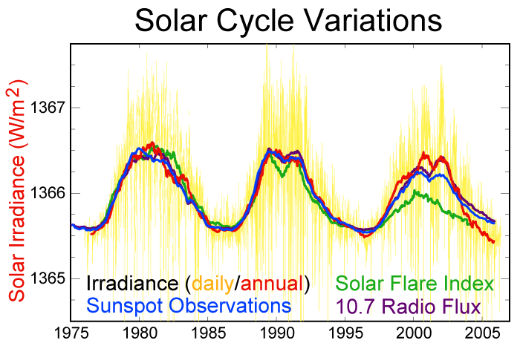
Figure 2. Total solar irradiance (daily: yellow, annual: red) and for comparison indices for sunspot number (blue), solar flares (green), and 10.7 radio flux (purple) scaled to the amplitude of the annual solar irradiation. Source: http://en.wikipedia.org/wiki/Image:Solar-cycle-data.png

Direct measurements of the solar irradiation at the top of the atmosphere became available with satellite-based radiometers (Froelich, 2006: Figure 1; Rottman, 2006: Figure 2). The time series, as produced from the different instruments employed over time, shows an average of total solar irradiation of 1366 W/m² (Froelich, 2006: Figure 9), the so-called solar constant, and an oscillation over 11 years with a peak to peak amplitude of ~1.3 W/m² or 0.1% of the solar constant. This 11-year cycle in top-of-the-atmosphere solar irradiation correlates positively with the 11-year solar sun spot time series and some other indices of solar variability (Figure 2). The correlation between dark sunspots and the solar emission, and hence irradiation on Earth, is positive because the decrease in solar emission in sunspots is overcompensated by more intense emission from other features on the sun surface. Whether and how such small fractional changes of the total solar irradiation can explain climate variations on Earth on timescales of decades is an issue of current research. An important feature of the 11-year variation in solar irradiation is, however, its spectral dependence, which in combination with atmospheric chemistry may lead to larger effects than expected otherwise.
Spectrally resolved observations of the solar irradiation show that the 11-year changes are small in the near infrared and visible range, about 0.1%, but much larger in shorter wavelengths in the UV and extreme UV (Rottman, 2006:Figure 6), where however only little energy is transported to Earth. The irradiation at the Lyman alpha wavelength (121 nm) is for example more than 60% larger in solar maximum conditions than in minimum conditions. Such large fractional changes in spectral irradiance become important at wavelengths where the radiation photolyses atmospheric molecules, and hence drives atmospheric chemistry. The well known ozone layer results from such photochemical processes, which are sensitive to changes in UV irradiation. In general, the shorter the wavelength, the lower the spectral power and the higher the altitude in the atmosphere, where the wavelength can be important for heating or photolysis. Chemical changes of the atmosphere then change the radiative properties of the atmosphere also for longer wavelengths, leading possibly to larger modifications in the temperature distribution and in the circulation, which can feed back to the chemistry of the atmosphere. Thus, atmospheric chemistry can potentially amplify the effect of the 11-year solar cycle on the atmosphere due to the much-intensified spectral solar signal in the photolytically important UV and extreme UV radiation.
An excellent collection of papers resulting from the 2005 ISSI workshop on “Solar Variability and Planetary Climates” in Berne, Switzerland, has been published in Space Science Reviews, 125, 2006. This special volume presents the current state of knowledge on the effects of variations in solar emission on the climate variability on Earth, including also results of this study (Schmidt and Brasseur, 2006).

The HAMMONIA model
To test the feasibility of such amplifying mechanisms, numerical models have been developed. This study makes use of the HAMburg MOdel of the Neutral and Ionized Atmosphere (HAMMONIA). The HAMMONIA model is a general circulation model (GCM) developed specifically to study the effects of the spectrally resolved variations in the solar irradiation and of particle fluxes on the atmosphere from the surface up to the lower thermosphere (Schmidt et al., 2006). The HAMMONIA GCM is based on the ECHAM5 GCM, which is a GCM for studies of the tropospheric climate and its middle atmosphere extension MAECHAM5. Hence HAMMONIA includes all processes of ECHAM5 and MAECHAM5 and additional atmospheric processes, which are considered at the time to be important for the investigation of 11-year solar cycle effects. In particularly noteworthy is the atmospheric chemistry coupled by transport and radiation to the general circulation and the high spectral resolution in the UV and extreme UV, down to 5nm, for the computation of photolysis and heating rates.
The HAMMONIA model resolves horizontally structures up to total wave number 31 in spherical harmonics. The associated Gaussian grid, on which non-linear terms of the dynamics equations and physical processes are computed, has a resolution of 3.75°x*~3.75° in longitude and latitude. In the vertical, the model resolves the atmosphere in 119 layers from the surface to 1.7e-7hPa, which corresponds to ~250km for solar minimum conditions and to ~350km for solar maximum conditions. (This altitude difference develops mainly in the lower thermosphere, where temperatures differ up to 500K between solar minimum and maximum conditions.)
The use of a high vertical resolution allows simulating the quasi-biennial oscillation (QBO) in the equatorial stratosphere (Giorgetta et al., 2006). The QBO is the main mode of variability in this region of the atmosphere and has effects on the circulation in higher latitudes, as discussed also for the 11-year solar cycle. Interferences of the influences of the QBO and the solar cycle have been discussed (Labitzke, 1987). The HAMMONIA model allows such interferences since the QBO is simulated internally.

Experiments
The experiments consist of two simulations over 35 years each, which differ by the spectrally resolved solar irradiation given as upper boundary condition at the top of the atmosphere. The first simulation, MIN, is driven by a solar spectrum as observed in September 1986, which is typical for solar minimum conditions. The second simulation, MAX, is driven by a solar spectrum as observed in November 1989, typical for solar maximum conditions. Thermospheric NO production is increased by 33% for solar maximum. Sea surface temperature and sea ice is specified from an observed climatology of 1979-1996. The spin-up periods of the integrations are discarded. This experimental design has the following main characteristics:
- The boundary conditions are free of interannual variations. Interannual variations in the simulated circulation, in temperature or in chemistry must therefore result from the modeled system itself.
- Using constant solar irradiance conditions, for solar minimum and solar maximum, the solar effects can be investigated as differences between the maximum and minimum simulations in the annual or seasonal means of the 35 years of simulation. (A much longer and more expensive simulation would be necessary to draw statistically robust conclusions if a spectral solar cycle is prescribed as upper boundary condition instead of constant spectra.)

Results

Ozone
The ozone layer in the stratosphere and lower mesosphere has a photochemical origin and creates the necessary heating for a positive upward temperature gradient, thus defining the stratosphere. An increase in ozone concentration in this layer is expected for higher solar irradiation because of the increase in UV radiation and hence more photolysis. A comparison of the zonal and annual mean ozone distribution in both experiments shows indeed an increase of ca. 3% in ozone mixing ratio in the upper stratosphere between 10 and 1 hPa in MAX compared to MIN (Figure 3). This positive change is statistically significant at the 95% level (gray shading). Some larger relative changes are found at higher levels, where however the absolute volume mass-mixing ratio is much smaller than within the ozone layer in the upper stratosphere. Soukharev and Hood (2006) have analyzed ozone changes observed by different in satellite-based instruments: SBUV, SAGE and HALOE. They found statistically significant changes of similar amplitude in the upper tropical stratosphere, but there is some disagreement between the different observations as well as between the observations and the model simulations. Possible reasons for the disagreement between the different instrumental observations are the different lengths of the records, and possible contaminations by the effects of major volcanic eruptions of Pinatubo in 1991 and El Chichon in 1982. Effects of major volcanic eruptions and El Nino influences are entering the observations, but they are present in the model simulations, where climatological lower boundary conditions are used for sea surface temperature.
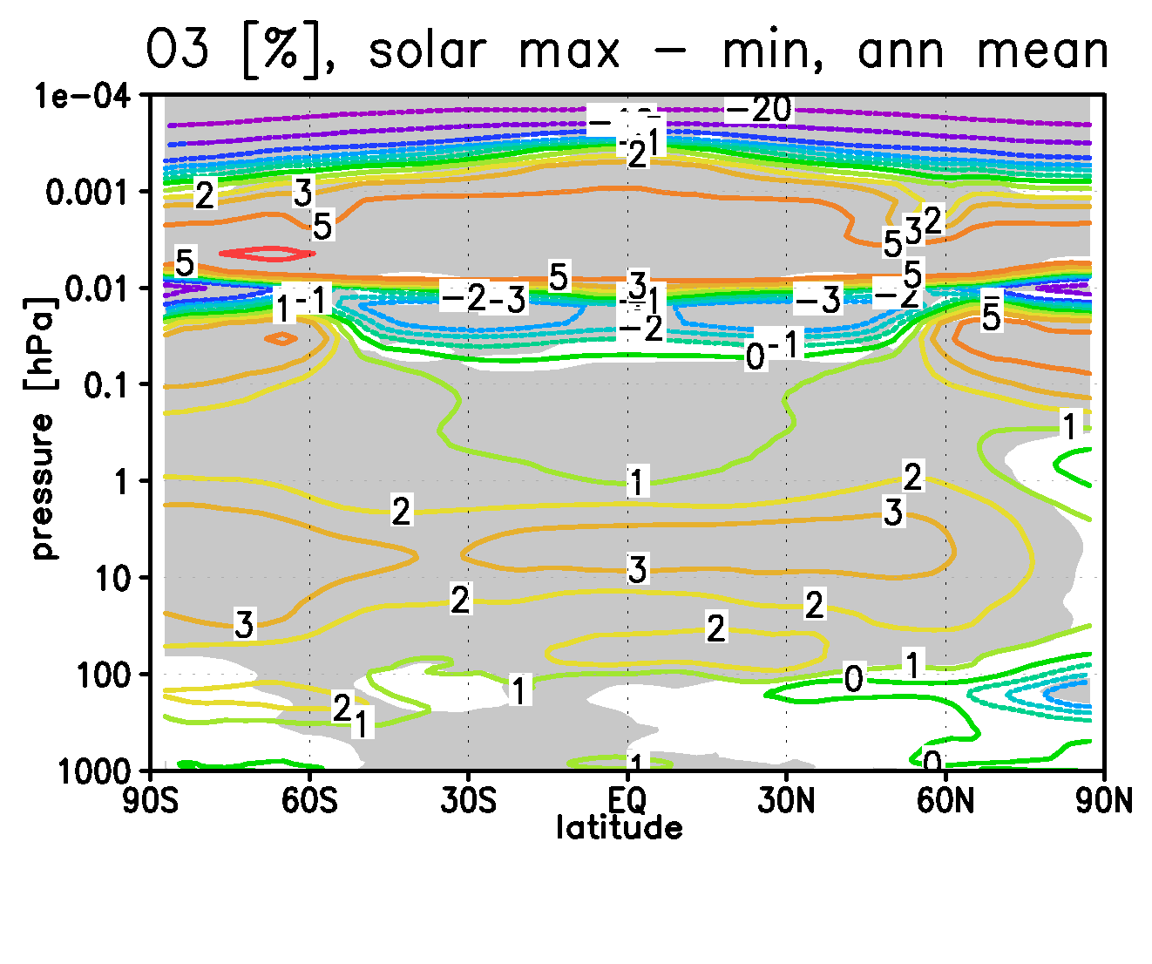
Figure 3. Percent change in annual and zonal mean ozone volume mixing ratio in the MAX simulation with respect to the ozone distribution in the MIN simulation. Grey shading indicates that the difference is statistically significant at the 95% confidence level following a t-test.

In the lower mesosphere, relative changes are nearly 0, but positive changes of up to 5% occur in the mesopause region, between about 0.01 and 0.001 hPa, or 80 to 95 km. These features correspond well to observations from the HALOE instrument on the UARS satellite (personal communication G. Beig, Puna, India). Negative changes are simulated in a transition layer below 0.01 hPa, and larger negative relative changes occur above the mesopause region, where however the ozone mixing ration is very small.

Temperature
The zonal and annual mean temperature is increased in MAX compared to MIN by up to 1 K at the stratopause. Higher temperature changes are found in the mesopause region, and much higher signals occur in the lower thermosphere above the displayed region. Temperature changes are statistically significant in most places except for the equatorial stratosphere, where the high temperature fluctuations caused by the QBO in zonal wind mask the solar signal, and in the higher Southern latitudes, where again the high natural variability renders the differences insignificant. The high Northern latitudes show a significant warming at the stratopause, vertically aligned with a significant cooling in the lower stratosphere. This signature is characteristic for a change in the interaction of planetary scale waves with the zonal mean flow, and further interactions with gravity waves. A further consequence of these dynamical effects is the secondary warming of about 0.3 K in the annual mean found above the tropical tropopause. The temperature signals in the high Northern latitudes and above the tropical tropopause are related to dynamical processes in the wintertime circulation, but they are visible and statistically significant even in the annual mean.
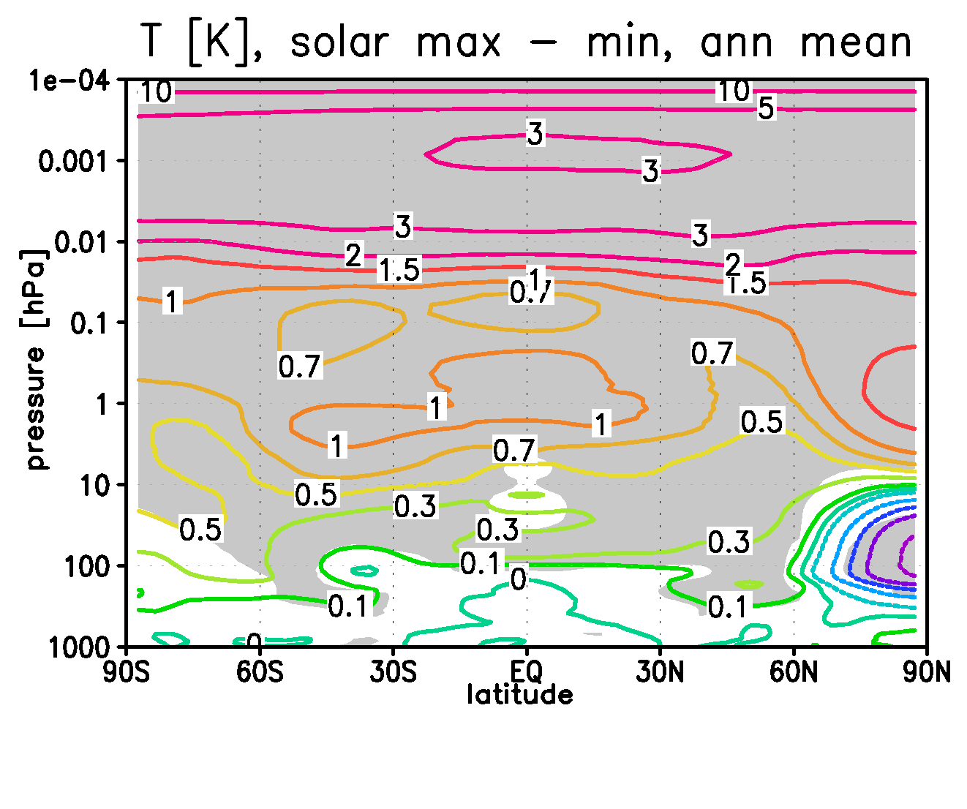
Figure 4. Difference in annual and zonal mean temperature in K between the MAX and the MIN simulation. Grey shading indicates that the difference is statistically significant at the 95% confidence level following a t-test.

The overall positive solar signal in stratospheric temperature is confirmed by observational studies, based on instruments (Scaife, 2000: SSU/MSU) or the ERA-40 reanalysis of the ECMWF (Crooks and Gray, 2005). These studies find increases of >2K and 1.75K, respectively, in the upper tropical stratosphere, where the model shows a signal larger than 1K. The secondary maximum above the tropical tropopause is also found in the ERA-40 data.
The secondary maximum in the solar temperature signal, found in the annual mean, is primarily a signal existing in the winter months of the Northern hemisphere. From November to March, the temperature increase amounts to 0.6 to 0.9K and is statistically significant. Its occurrence in the Northern winter is indicative of a mechanism involving extratropical planetary waves and their interaction with the winter mean circulation, which is an important process in the Northern hemisphere. (In the Southern hemisphere, extratropical planetary waves are weaker and, for most of the time, cannot propagate into the stratosphere.) Kodera and Kuroda, 2002, proposed a hypothesis for the solar influence on this wave mean-flow interaction in the stratosphere and lower mesosphere and the resulting temperature effects above the tropical tropopause. Important steps are: (a) The temperature gradient between the tropical upper stratosphere and the high northern latitudes is increased in early winter in MAX vs. MIN because of the increased solar heating in the tropics; (b) the polar vortex can develop stronger; (c) planetary waves excited in the winter troposphere are less able to propagate into the stronger vortex, so that planetary wave breaking is less intense; (d) because of the reduced wave breaking, the Brewer Dobson circulation is weaker, i.e. the tropical upwelling and the high latitude sinking of air is reduced; (e) the reduced tropical upwelling becomes results in a reduced adiabatic cooling, hence a net warming in the lower tropical stratosphere, above the tropopause, where timescales for radiative cooling or heating are long. This hypothesis can be confirmed by the analysis of the simulated processes in the HAMMONIA simulations. The reduction of the tropical upwelling also produces the secondary maximum in ozone above the tropical tropopause due to a reduced upward advection of air with low ozone (Figure 3). This secondary ozone maximum has only a minor effect on the temperature.

Summary
Variations on the sun surface, visible as dark sunspots, are known since the 17th century. The 11-year sun spot cycle is the most prominent feature together with a period of minimum sunspot counts in the second half of the 17th century, the so-called Maunder minimum. The occurrence of the little Ice Age in the 17th century, apparently at the same time as the Maunder minimum, started early discussions on a possible connection between sun spot number and solar emission, and the climate on Earth. This study makes use of a specifically adapted numerical model, the HAMMONIA whole atmosphere model, for studies of solar cycle effects on the Earth atmosphere. Model simulations for solar minimum and maximum conditions are compared with respect to ozone and temperature structures in the stratosphere and mesosphere. It is found that the model can reproduce the main features of the observed solar cycle signals confirming that the model includes the relevant processes. Further the simulations allowed confirming a hypothesis for the explanation of a secondary temperature signal above the tropical tropopause, which is observed only during Northern winter.

References
Crooks, S. A., and L. J. Gray, Characterization of the 11-year solar signal using a multiple regression analysis of the ERA-40 dataset, J. Climate, 18, 996-1015, 2005.
Froehlich, C., Solar irradiance variability since 1978, Space Sc. Rev., 125, 53-65, 2006.
Giorgetta M. A., E. Manzini, E. Roeckner, M. Esch, and L. Bengtsson, Climatology and forcing of the quasi-biennial oscillation in the MAECHAM5 model, J. Climate, 19, 3882-3901, 2006.
Kodera K., and Y. Kuroda, Dynamical response to the solar cycle, J. Geophys. Res., 107, 4749, doi:10.1029/2002JD002224, 2002.
Labitzke, K., Sunspots, the QBO, and the stratospheric temperature in the North polar region, Geophys. Res. Lett., 14, 535-537, 1987.
Rottman, G., Measurements of total and spectral solar irradiance, Space Sc. Rev., 125, 39-51, 2006.
Scaife, A., J. Austin., N. Butchart, S. Pawson, M. Keil, J. Nash, and I. N. James, Seasonal and interannual variability of the stratosphere diagnosed from UKMO TOVS analyses, Quart. J. Roy. Meteor. Soc., 126, 2585-2604, 2000.
Schmidt, H. and G. P. Brasseur: The response of the middle atmosphere to solar forcing in the Hamburg Model of the Neutral and Ionized Atmosphere. Space Sc. Rev., 125, 345-356, 2006.
Schmidt, H., G. P. Brasseur, M. Charron, E. Manzini, M. A. Giorgetta, T. Diehl, V. I. Fomichev, D. Kinnison, D. Marsh, and S. Walters, The HAMMONIA chemistry climate model: Sensitivity of the mesopause region to the 11-year solar cycle and CO₂ doubling, J. Climate, 19, 3903-3931, 2006.
Soukharev, B.E., and L.L. Hood, The solar cycle variation of stratospheric ozone: Multiple regression analysis of long-term satellite data sets and comparisons with models, J. Geophys. Res., 111, D20314, doi:10.1029/2006JD007107, 2006.

