Power to Gas – an economic approach for energy storage?
Manfred Waidhas
Siemens AG
91058 Erlangen

The reduction of CO₂ emissions is clearly linked with the extension of renewable energies (RE). However, due to the volatile character of related power generation there will be an increasing mismatch between generation and demand. The storage of excess energy will become essential in the future in order to prevent increasing curtailment of wind and PV installations and to enable an economic integration of renewables into the future energy scenario.

It is very clear that grid extension and demand side management will come prior to energy storage. But the estimated storage demand in a 85 % RE scenario – as targeted for Germany in 2035 - will be in the multi-TWh range.

There are many concepts and technologies to store electric energy. Among the three options for large- scale storage – pumped hydro, compressed air and hydrogen - hydrogen is the only viable option to address capacities >10 GWh (fig 1). A key component for hydrogen storage is the electrolyzer converting electrical energy into hydrogen (Power-to-Gas, P2G).

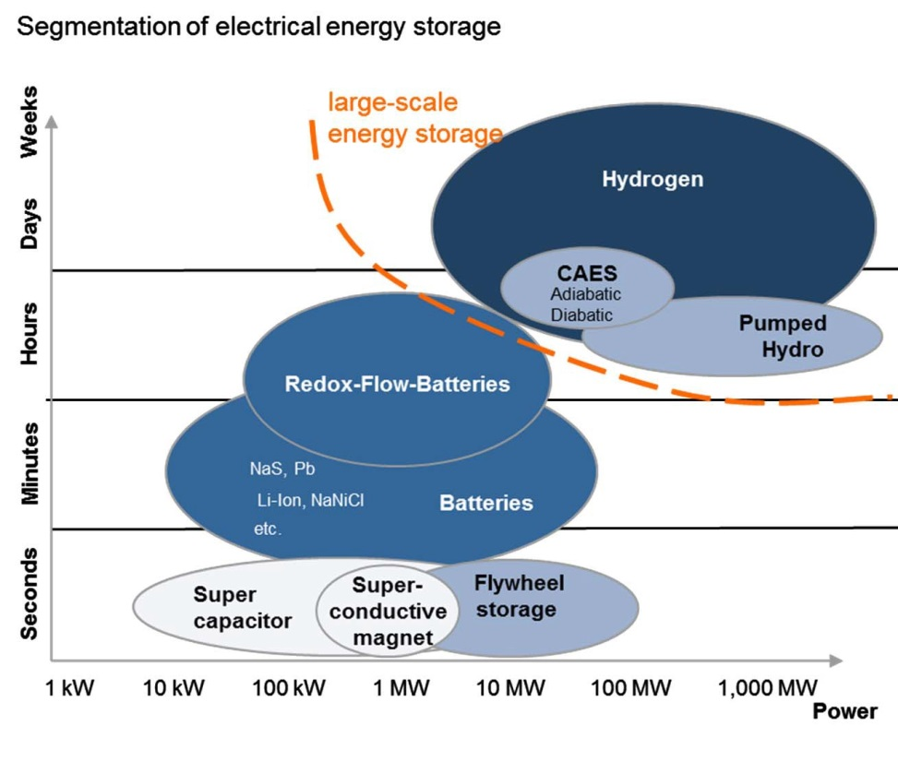
Fig. 1: Segmentation of electric energy storage technologies regarding power and discharge time

In this context ‘Power-to-Gas’ requires a clear definition. Some people associate this approach with the conversion of electricity to hydrogen, others with the subsequent injection of H₂ into the natural gas grid, some are including the conversion to synthetic natural gas (fig 2). As economy of these different interpretations and related business cases differ strongly, a clear definition of P2G is necessary. ‘Power-to-chemicals’ (leading to methanol, etc.) is not separately mentioned in figure 2, it is a subsequent process to P2H.

Fig. 2: Different routes of ‘Power to Gas’

Figure 3 illustrates the integration of electrolyzer technology into the volatile power generation and the different routes of H₂ utilization and applications. It makes clear that hydrogen enables the convergence of the energy market with the mobility and industry markets: instead of curtailment ‘excess’ production of green electricity can be shifted to mobility or industry applications and secure CO₂-savings there.

Fig. 3: The “big picture of hydrogen” – hydrogen as a multifunctional energy vector

The use of hydrogen in the applications ‘mobility’, ‘industry’ and ‘energy’ follows a merit order principle. In all cases where simply heating value is required (re-electrification via gas turbines, process heat or house heating) hydrogen with respect to price competes with natural gas. A preceding conversion to SNG tightens this economic challenge due to additional conversion losses and mandatory capital invest.

Compared to re-electrification (“power to power”) the use of hydrogen in industry or mobility as a valuable material leads more easily to a positive business case.
Due to described merit order the three use cases have different market entry points, market potential and consequently different maturity.

The question, whether P2G is economically viable depends on a number of different parameter and thus can´t be answered in one single sentence. For this reason several calculations with extreme assumptions are illustrated in the following.
Figure 4a outlines that it is not likely that electrolytic hydrogen can compete now and in the next years with the price of conventional natural gas. For instance, even if the costs of future electrolyzer technology diminishes down to zero the electricity must be purchased at prices below 2.5 ct/kWh over the whole year to reach cost competitiveness to conventional natural gas (fig. 4a). The same figure illustrates on the other hand, that electricity can be purchased even at higher (and more realistic prices) the competition is trailer delivered H₂.

Fig. 4a: Theoretical production costs of hydrogen generated via electrolysis
– main assumption: invest costs of electrolyzers are zero

In a second step it was assumed that electricity costs are zero. This situation is not unlikely as curtailed electricity is already at this stage reality.
Fig. 4b: Theoretical production costs of hydrogen generated via electrolysis
– main assumption here: electricity costs are zero

Figure 4b clarifies that the utilization of the electrolyzer must be higher at roughly 3000 hours under these conditions to yield prices competitive to natural gas. The situation is even less stringent if the application is onsite use in hydrogen consuming industry.
Further assumptions for the calculations (fig 4a-4c) are as follows:
- efficiency electrolyzer system = 70 % HHV
- for 4b,c: depreciation: 20y; interest rate: 5 %; maintenance: 3% of capex;
- natural gas prize: 3 ct/kWh

The assumptions used for figure 4c are reflecting reality, as electricity prizes of ≤ 50 €/MWh can be found at the EEX for more than 4000 h per year.

The main key findings of graphs 4a-c outline that all applications where only the heating value is relevant – for instance the injection into the NG grid - do not reveal a positive business case (even with capex=0) under given assumptions. They further illustrate that H2 production via electrolysis may be an attractive alternative to steam-reforming in particular when the electrolyzer system has access to “cheap” electricity.The business cases will be more attractive by additional offering of grid services (e.g. secondary control power).

But it clearly has to be pointed out that fees (grid fees and in particular the ‘EEG-Umlage’ in Germany) mostly ruin positive business cases . This is a general hurdle for grid-scale energy storage and will require a clear regulatory framework.

It is important to note that all price ranges given (e.g. for natural gas or H₂-delivery) are estimates. Real conditions, in particular for smaller quantities may lead to notably higher prices.

Fig. 4c: Theoretical production costs of hydrogen generated via electrolysis under reasonable assumptions for capex and opex

Outlook – The scenario 2035+:

The situation described above could consolidate the conclusion that power to SNG and H₂-injection into the NG grid does not make sense. However, the circumstances will change. Main reason is that the CO₂-reduction targets will require a link of power generation with industry and mobility. This scenario is summarized in figure 5, which clearly indicates, that on a mid- and long-term perspective the thermal use of H₂ and also SNG is a reasonable approach to buffer CO₂-free energy in the TWh-range for re-electrification and heating..

Fig. 5: The long-term perspective of P2G

